Strabismus: More Than Just an Eye Turn

Elizabeth Walsh
4th year
Illinois College of Optometry

October 8, 2014
Strabismus is a disorder described as the misalignment of the eyes. It has been reported that between 2-5% of the world’s population have this diagnosis¹. There are 3 common types of strabismus: esotropia, exotropia, and hypertropia. Each term describes how the eye is pointed, compared to the aligned eye (Table 1).

Table 1. Types of Strabismus
Type | Alignment | Photo¹
Esotropia (ET) | Eye turned in | 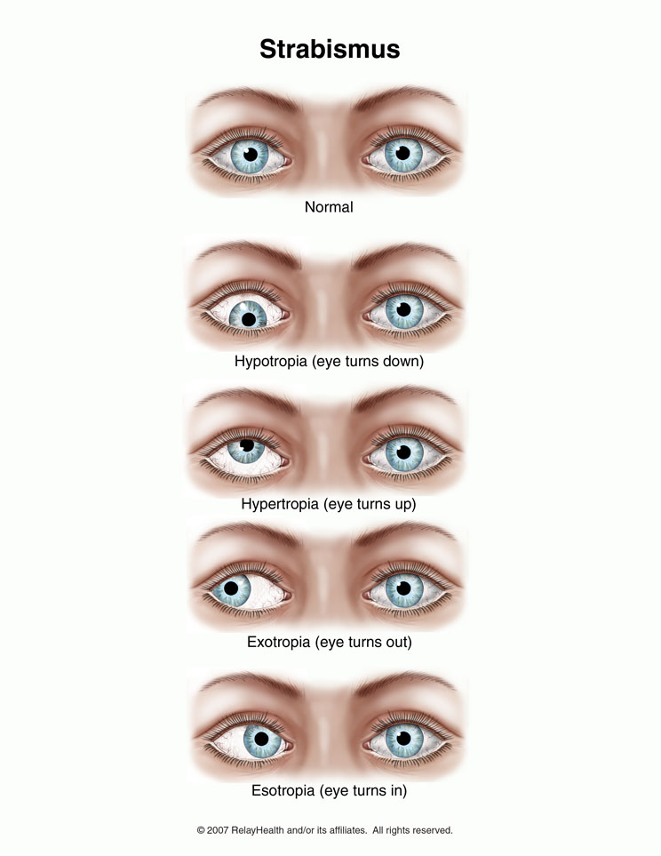
Exotropia (XT) | Eye turned out
Hypertropia (HT) | Eye turned up

The size or magnitude of the eye turn is measured in prism diopters and is referred to as the “angle” of strabismus. The larger the angle, the more obvious the eye turn will be to the layperson. Persons with strabismus can suffer from blurry or double vision, which can lead to suppression and finally amblyopia, or decreased vision. Not only do they suffer from the functional consequences of strabismus, but the appearance of the eye turn can cause many other problems. The psychosocial issues of strabismic patients are felt in early childhood and continue throughout their life. Surgery is usually an option for many eye turn patients, but even surgical correction may not be enough to reverse the emotional facets felt being a strabismic patient.
It has been reported that it takes a mere 150 miliseconds to evaluate a person’s attractiveness². When judging facial attractiveness, it has been theorized that there are four major categories used: averageness, symmetry, sexual dimorphism and youthfulness². Strabismus causes a face to appear asymmetric, and therefore may cause someone to immediately be considered unattractive. Judging based on appearance starts at a very young age. In a study by Paysse, et. al., it was shown that at the age of 4, children were able to discern differences between strabismic toys and non-altered toys, as well as picking non-strabismic playmates over children with eye turns. The psychosocial aspects of strabismus can have a debilitating effect on a patient’s life. It was reported in 1993 that patients with strabismus struggled with the following aspects of their life: sports, education, self-image, job prospects, and relationships. It has also been shown that young adults with strabismus have problems with creating and keeping relationships, due to a lack of confidence and low self-esteem². One hypothesis includes the fact that strabismus leads to a loss of eye contact, which might hinder typical socialization⁴.
An important psychosocial issue within this population is social phobia. Social phobia is defined as the fear of being ashamed or humiliated in various social settings, such as speaking in public or participating unfamiliar people⁵. This is prevalent within the strabismic population. In a study by Bez, et. al., 53.1% of patients with strabismus reported social phobia⁶. The number was much lower in the control group, with only 17.4% experiencing social phobia. The sampled population completed questionnaires of various tests regarding anxiety, depression, psychological symptoms, and disability. The strabismic group was found to have significantly greater social fear, social avoidance, performance fear, performance avoidance subscores, total fear and total avoidance scores, as well as greater disability scores for social life, family life, and work. As compared to the controls, the patients with strabismus had greater depression scores.
The psychosocial aspects can also have an effect on the people closest to the patient, specifically their parents. One study by Eustis, et. al. questioned the parents of children enduring strabismic surgery⁴. Their results show that close to 50% thought their child’s self-esteem was lower because of the ocular misalignment. Of those 41%, less than 20% of parents believed that the cosmesis was the biggest obstacle in the child’s life. In 2005, there was study conducted by researchers Akay, et. al. that explicitly surveyed mothers of children with strabismus⁴. All mothers, including controls, completed four different questionnaires to assess their psychological profile. When compared to controls, mothers with strabismic children scored higher in the depression scale, which correlates with sensibility, pessimism, a sense of failure, guilt and psychological complaints. They also scored lower in democratic attitude, or “to be an equalitarian and to be in a friendship relationship with the child based on sharing”. Lastly, it was found that these mothers scored higher on the scale that looks at rejection of maternal role. The researchers thought that this result showed that mothers of strabismic children were “nervous, distressed and angry” in their relationship with their kids. This study proved that having a child with strabismus can cause abnormal functioning within a family unit.
Recently, there has been more research devoted to strabismic patients and their state of mental health. In China, an ocular health exam and a survey were completed on about 4000 children between the ages of 10-17 years⁷. The survey contained questions inquiring about the child’s alcohol use, anxiety and depression. Of the sample population, 6.8% were found to have strabismus. The majority was diagnosed with intermittent exotropia. For those students, they reported a higher rate of alcohol use, depression, and anxiety than students without strabismus. A large retrospective study on medical records of children diagnosed with strabismus completed in Olmsted County, Minnesota looked at the prevalence of mental illness within this population. Within the study years of 1985-1994, there was 627 strabismic children were diagnosed with a mental health disorder, but only 407 met their inclusion criteria⁸. It was found that 41.3% of those patients with a history of strabismus was identified as having a mental illness, whereas only 30.7% of control subjects were diagnosed. Children with strabismus, as compared to those without an ocular misalignment issue, were found to be more likely to “have a greater number of psychiatric disorders, to use psychotropic medications, to require psychiatric hospitalizations, and to have suicidal or homicidal ideation.
The authors of the previous study also considered the differences between the types of strabismus and their chances of being diagnosed with a mental illness in their lifetime. Exotropes, or patients with an eye turned out, were 3.1 times more likely to be diagnosed with a mental illness, specifically dysthymia and major depression, as compared to control subjects⁸. Dysthymia is defined as a chronic form of depression with symptoms lasting more than two years⁹. Esotropes were found to have a 2.6 times risk of developing a mental illness¹⁰. Exotropes were also found to suffer from “ADHD, adjustment disorder, drug use, major depression and learning disorders,” which is different than esotropes, or when the eye turns in⁸. Esotropes suffered more from eating disorders.
Both XTs and ETs report that their strabismus has a negative impact of many aspects of their life, including “self-esteem, academic performance, interpersonal relationships, athletic achievement, and gainful employment,” which would show that both are equally detrimental to their psychosocial status. However, authors McKenzie, et. al., found that male intermittent exotropes had the highest risk of developing mental illness by age 30, as compared with normal controls¹¹. In their sample of 183 males, 97 or 53.0% were diagnosed with a mental health disorder, as compared with 30.1% of controls. Overall, it was found that children with IXT were 2.7 times more likely to be diagnosed with a mental illness. Surgery in this population did not change the risk of developing a psychological illness¹².
Along with the high rate of mental illness, a genetic marker was discovered that linked ocular misalignment with schizophrenia. When a patient is diagnosed with schizophrenia, minor physical anomalies (MPAs) are present. MPAs are “slight, dysmorphic features representing subtle alterations in the development of various ectoderm-derived bodily structures in the mouth, eye, ear, global head, hand and foot areas”¹³. The protein PMX2B has many functions within the body. It is found within the nuclei of cranial nerve 3 and 4, which control eye movements. Also, it regulates processes responsible for the biosynthesis of dopamine and noradrenaline. If this process does not correctly happen, schizophrenia can occur. Researchers Toyota, et. al. found a high association between strabismus and schizophrenic cohorts. From their results, they determined that for a constant exotrope, the odds ratio for developing schizophrenia was 20.6. Searching through the genetic code of their sample population, three mutated alleles on the PMX2B gene were found in the schizophrenic patients. When there was a specific allele deleted from the sequence, there was a high number of schizophrenic exotropes that displayed this characteristic genome. The researchers found that the overall rate of strabismus in the schizophrenic population was 13%, with a rate of 6.9% of constant XTs. Their results “suggest an overlap of genetic etiology and developmental trigger for constant XT and schizophrenia”¹³. Due to this fact, the researchers stress that strabismus should be added to the criteria of the MPAs used in the diagnosis of schizophrenia. In other studies, it has been shown that the rate of strabismus and schizophrenia is closer to 75%, but a difference in sample population could be attributed to this discrepancy¹⁴.
In conclusion, patients with strabismus face many obstacles in life. The psychosocial aspects, family matter, and overall mental health of these patients are challenged on a daily basis. Therefore, as health care providers, optometrists cannot take the diagnosis of strabismus lightly. We must take into consideration their patient’s overall mental status and educate, within reason, all of the challenges ahead. By being an advocate for healthy eyes, healthy body, healthy minds, we can help patients with strabismus lead a normal and happy life.

References:

- Eyes Turn Outward [Internet]. RelayHealth. [Modified 2011 Oct, Accessed 2014 Oct]. Available from:
http://www.drpachadharma.com/pa_topiccontent?src=alphaindex&srcparam=E&htmfile=pa_exotropi_oph.htm
- Durnian, J., et. al. The Psychosocial Effects of Adult Strabismus—A Review. Brit J of Ophth. 2010;95(4):450. doi:10.1136/bjo.2010.18842534
- Akay, A., et. al. Psychosocial Aspects of Mothers with Strabismus. J AAPOS. 2005;9:278-273. doi:10.1016/j.jaapos.2005.01.008
- American Psychiatric Association. Diagnostic and statistical manual of mental disorders. 4th ed. Washington (DC): American Psychiatric Association; 1994.
- Bez, Y., et. al. Adult Strabismus and social phobia: A case-controlled study. J AAPOS. 2009;13(3):249-252. doi:10.1016/j.jaapos.2009.02.010
- Lin, S., et. al. Alcohol Use and Positive Screening Results for Depression and Anxiety are Highly Prevalent Among Chinese Children with Strabismus. Am J Ophth. 2014;157(4):894-900. http://dx.doi.org/10.1016/j.ajo.2014.01.012
- Mohney, B., et. al. Mental Illness in Young Adults who had Strabismus as Children. Pediatrics. 2008;122(5):1033-1038. doi:10.1542/peds.2007-3484.
- Diseases and Conditions: Dysthymia [Internet]. http://www.mayoclinic.org/diseases-conditions/dysthymia/basics/definition/con-20033879
- Olson, J., et. al. Congenital Esotropia and the Risk of Mental Illness by Early Adulthood. Ophthalmology. 2012;119(1):145-149. doi:10.1016/j.ophtha.2011.06.035.
- Mckenzie, J., et. al. Prevalence and Sex Differences of Psychiatric Disorders in Young Adults who had Intermittent Exotropia as Children. Arch Ophthalmol. 2009;127(6):743-747. doi:10.1001/archophthalmol.2009.68.
- Kilgore, K., et. al. Surgical Correction of Childhood Intermittent Exotropia and the Risk of Developing Mental Illness. Am J Ophthalmol. 2014;158(4): 788-792. doi:10.1016/j.ajo.2014.06.008
- Toyota, T., et. al. Association between Schizophrenia with Ocular Misalignment and Polyalanine Length Variation in PMX2B. Hum Mol Gen. 2004;13(5):551-561. doi:10.1093/hmg/ddh047
- Nodlovu, D., et. al. The Prevalence of Strabismus in Schizophrenic Patients in Durban, KwaZulul Natal. S Afr Optom. 2011:70(3): 101-108.

