2017
June
TRUE LIES
The Stuart Rod & Reel Club Newsletter
The Stuart Rod and Reel Club is dedicated to improving local fishing through by increasing angler knowledge, encouraging conservation and maximizing the fun involved in light tackle fishing in the Stuart Florida area. We hold monthly meetings on the second Thursday of each month, year round. Please join us or contact any board member for more information on how you can become a member of the Stuart Rod and Reel Club.
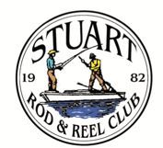

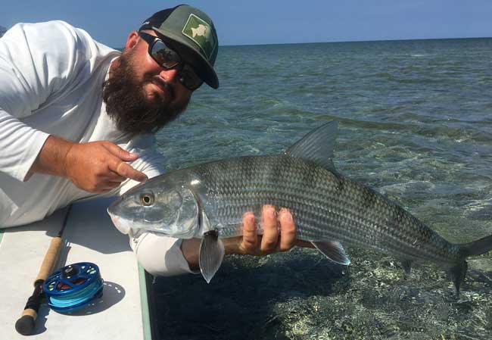
Captain James Cronk with a large bonefish caught in Biscayne Bay on a fly. Even with all of the fishing and boating pressure on Biscayne Bay, some of the largest bonefish still live there. These fish have seen just about every saltwater fly known and it takes luck, skill and perseverance to catch and release one this size. Look at the reflection above James’ fingers to understand why the fish is called the “Silver Ghost of the Flats”.
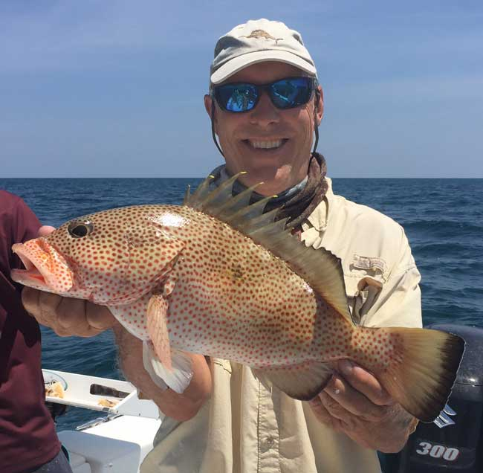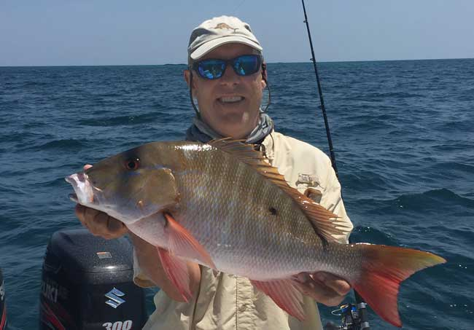

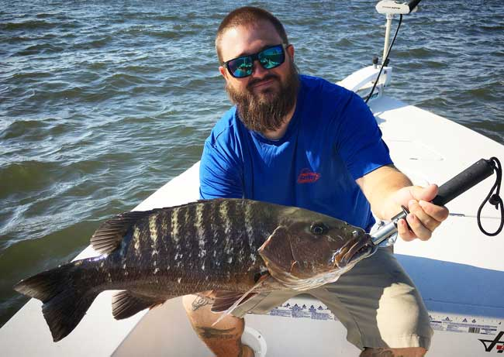
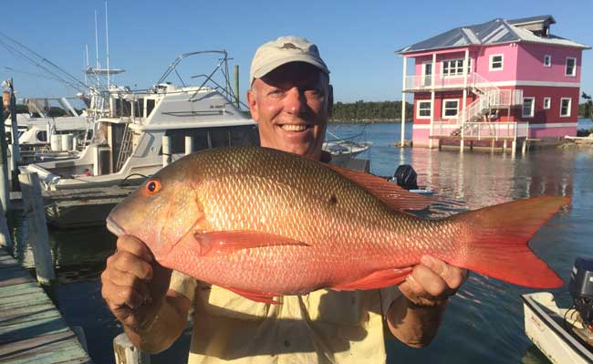
Time to get onto the open water as the seas should be calming. After a long windy season, it is time to take advantage of summer’s calmer weather.
Top: Bill Lalone with a Bahamian Red Hind grouper and Mutton snapper.
Bottom Left: Bill Lalone with a Bahamian snapper dockside with a colorful island home in the background.
Bottom Right: Capt. James Cronk with a Cubera snapper.

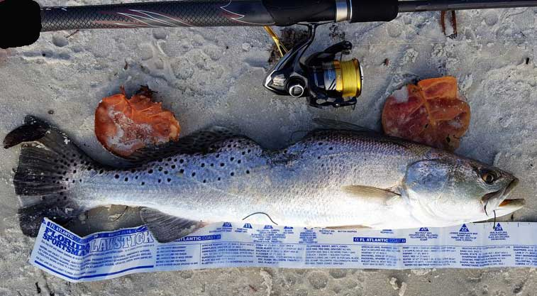
An interesting photo of a trout, submitted by member Richard Raybuck. This fish had a nasty bite on its dorsal fin area that healed nicely and recovered well enough to grow to about 25 inches long. Could the bite have been caused by a porpoise or Spanish mackerel? It is hard to tell. It was caught near Hobe Sound.

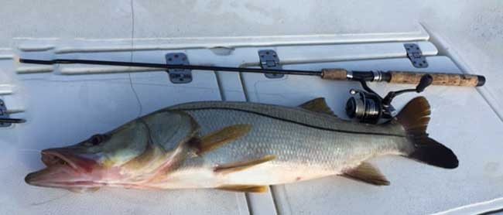
Jim Harter caught and released this nice snook landed in the South Fork.
Vicki, a guest on Keith Palant’s boat, caught this pretty snook.
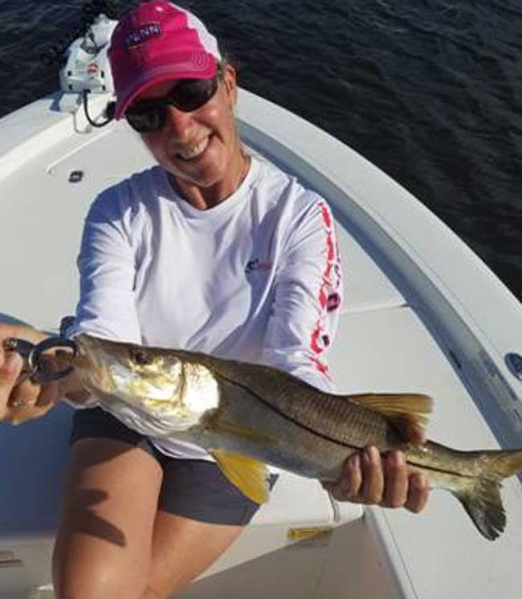
Reminder: Snook season closes on June 1st on the Atlantic side of the state. You are still allowed to catch and release snook, but please keep them horizontal and release with extreme care. Be sure that you have a snook stamp/endorsement on your license.
Tournament Winner for May Event
Richard Matteson caught a 26 inch snook and three sea trout to win the May top water lure event. He was wading at the time, making good presentations to fish near shore.

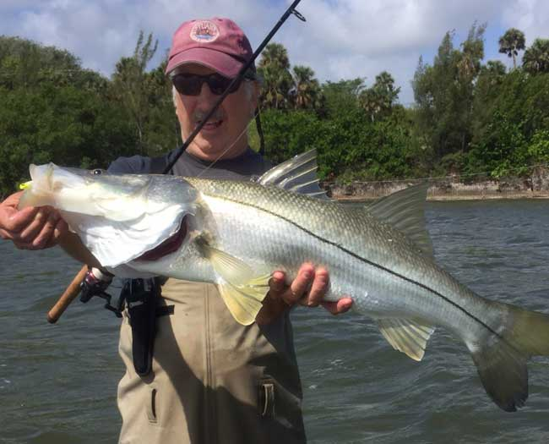
There are snook, and then there are SNOOK. Richard Matteson caught and released this massive fish while wading with Eric Rosenberg. Richard is proudly wearing his SRRC cap, of which he has won several. This is a fish to remember.

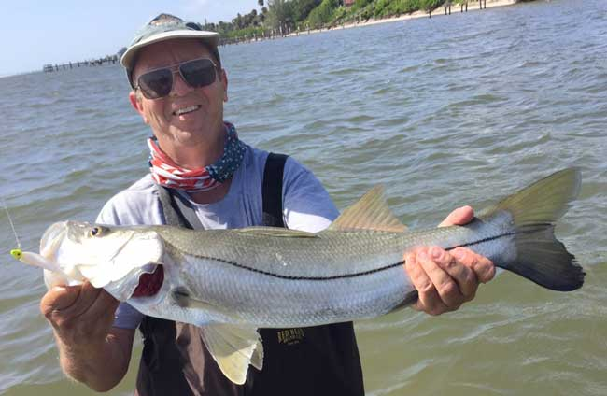
Eric Rosenberg with a fine snook caught when wading with Richard (above). Eric was very proud of this beauty until Richard’s monster appeared. It is still a great fish. Note that they both used C.A.L. jigs in the same color scheme.
MARK NICHOLS OF D.O.A. LURES WILL BE OUR GUEST SPEAKER FOR THE JUNE GENERAL MEMBERSHIP MEETING
Mark is both an extremely experienced fisherman and a very entertaining speaker. You will learn a lot about fishing in his presentation. Please join us on June 8th at Flanigan’s on US-1. Dinner begins at 6PM and his presentation begins at 7 PM.

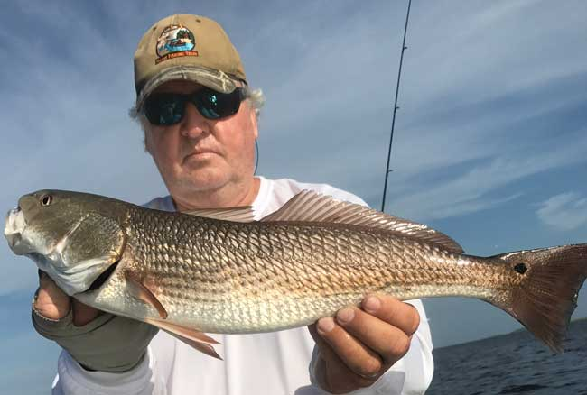
Another happy trip to Steinhatchee for Dave McClure and Jim Bohrer. Both men are pictured with two of the fine redfish that make this area home. If you get a chance to make a Steinhatchee trip, you will have a memorable time.

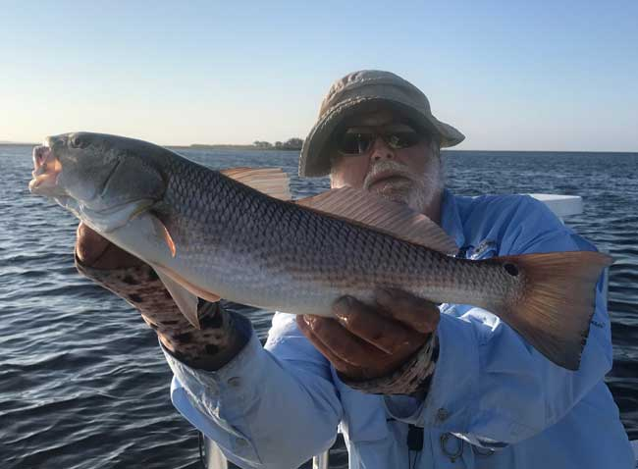

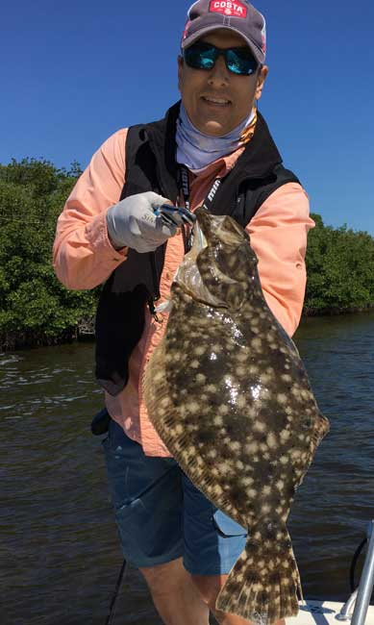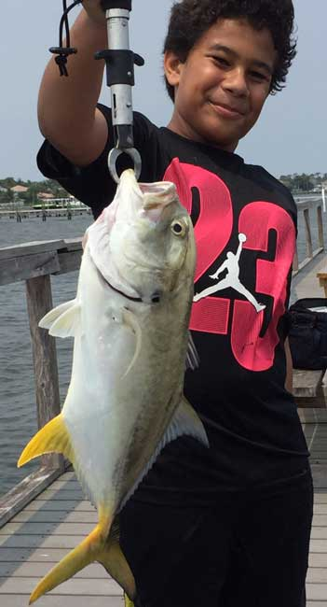

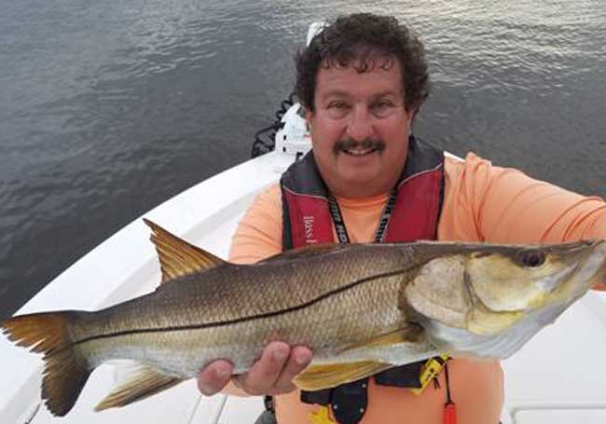
Top Left: Juan Giachino Jr with a true doormat size Southern Flounder.
Above: Jayden Rosenberg with a nice Jack Crevalle.
Left: Keith Palant with a fine snook.

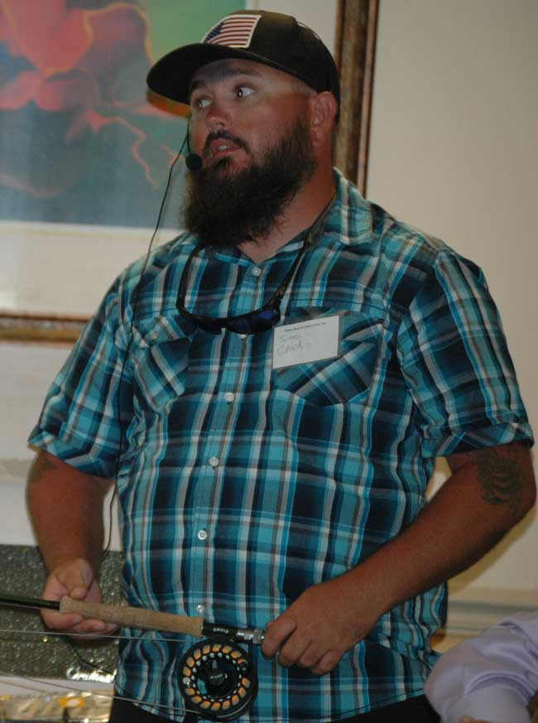
Capt. James Cronk provide a lot of great fishing information at our May membership meeting. James is a snook specialist, with extensive knowledge of our area. He recommends natural color DOA C.A.L. jigs, with the front of the lure body shortened for an overall length of about 1 ½ to 2 inches. For shrimp fishermen, he recommends small # 2 Gamagatsu hooks for the best natural presentation. Careful side arm skipping casts near lighted docks and lighted bridge abutments and pilings provide good action at night. Fly fishing calls for a sink tip 7 to 9 weight presentation and slow stripping action.
Capt. Cronk will be in Alaska guiding this summer, but he can be booked for Fall fishing.

 |  |  | Club Officers
President | Jim Bohrer |  | halieutics@gmail.com | 301-648-2052
Vice President | Jim Bowdish |  | jlsb@crarybuchanan.com | 772-475-5068
Treasurer | Pete Noll |  | mpnoll@aol.com | 772-223-2136
Secretary and Newsletter Editor | Fred Bartlett |  | fredbart@aol.com | 913-909-9326
 |  |  | Board of Governors
Director |  | Roy Buckley | rlbuckley007@aol.com | 772-871-7008
House Committee |  | Jerry Hoge | jhoge@hogeengineering.com | 772-485-7267
Angling Committee |  | Frank Miller | frmiami2@gmail.com | 305-469-4654
Membership Comm. |  | Eric Rosenberg | erosen1031@aol.com | 772-210-5563
Meeting Speakers |  | Jim Bohrer | halieutics@gmail.com | 301-648-2052
Raffle Chairman |  | Jim Harter | pjharter@comcast.net | 772-223-0648
Conservation Coordinator |  | Jim Harter | pjharter@comcast.net | 772-223-0648
Events Coordinator |  | Bob Ruggeri | bob.ruggeri@yahoo.com | 772-285-4264
E-mail all newsletter copy and photos to Jim Bohrer at halieutics@gmail.com or to Fred Bartlett at fredbart@aol.com. Closing date for photos and copy is the 25th of the month preceding publication.

All Stuart Rod and Reel Club Outings are based purely on the Honor System. All scheduled Club Outings will be “Daylight Outings”. You can fish any of the dates listed above. Event will begin at the first safe light in the morning with lines out of the water by 1PM. Scores must be turned into the Angling Director or other board member by email, phone or verbally by 2 PM local time on the day after the event.  Natural Bait (alive or dead) is allowed except for March, May and July. Bait restriction is in effect for September.  Guests and spouses are invited to attend the food services on Saturday at Sandsprit Park. For food at restaurants, guest and spouses will be charged for their meal and beverage costs. | Family members under the age of 18 must be accompanied by a parent or legal guardian to participate in an outing. While guests are always welcome to join members during our outings, you must be a paid member of the Stuart Rod and Reel Club to be eligible to win an outing. Outing scores shall be published in the Club’s Newsletter following the Outing. Outings cancelled due to weather shall be rescheduled for the following weekend. Outing result disputes shall be settled by the Angling Director.  OUTING SCHEDULES AND RULES MAY CHANGE DURING THE YEAR.  FISHING BOUNDARIES  Boundaries will extend from the south shore of the Jupiter Inlet to the North Vero Beach Bridge.

Date | Outing/Event | Details | Host/Food Service | Rules
June 9, 10, 11 | Most Species Caught-Must be legal size fish | Any species of fish caught. Snook must be 24” plus. Combination of one fish per species wins. | Sandsprit Park 1:00 PM  June 10th | One fish of each species.
July  14,15,16 | Local Tarpon Outing | Most Tarpon: 3 Points for angler touching the leader, 1 point for a jumped fish. One point per jumped fish only. No natural bait allowed. | Shrimper’s Restaurant, Port Salerno 1:00PM, July 15th. | Three points for caught fish, one point for each jumped fish.
August  11, 12, 13 | Local Trout and Redfish Outing | Largest Trout & Redfish, total inch length | Sandsprit Park 1:00 PM Stuart, August 12th. | Longest total trout and redfish combined.
September  15, 16, 17 | Longest Snook | Longest Snook –Bait Restriction: Any snook caught on bait is worth ½ a fish caught on an artificial lure. 24” snook minimum length | Sandsprit Park 1:00  PM Stuart, Sept 16th. | Longest snook, minimum 24”
October  13, 14, 15 | Pine Island | Total Length in Inches: 1 Trout, 1 Redfish, 1 Snook (24” minimum on snook) | Pine Island Away  No Local Luncheon | Longest total length
November  10,11,12 | Local Redfish | Longest Overall Redfish | Sandsprit Park 1:00 PM, Nov 11th. | Longest total length
December 9 | Christmas Party | No Outing | Dolphin Bar & Fish House Jensen Beach | No Outing.

2017 TOURNAMENT OUTING SCHEDULE
Support our Advertising Sponsors
We are very fortunate to have many local businesses that advertise on our web site and provide additional sponsorship support to the Club. These businesses provide a wide range of products and services for the entire community. Whether you are looking for lodging, restaurants, fishing supplies, boat repair and restoration, guide services, legal services, or roof repair our sponsors deserve your consideration. You can learn more about these businesses by visiting our website at www.stuartrodandreel.com. Click on the advertiser’s tab and you will find a brief description of our sponsors with contact information and links to their websites. Make our advertising sponsors your priority when shopping. Please let them know that you learned about them through the Stuart Rod and Reel Club and that you appreciate their support.

Bait & Tackle  - Crowder Rods  - D.O.A. Lures  - Fish Heads of Stuart  - Snook Nook  - Treasure Coast Rod and Reel  - White's Tackle  - T & A Jigs, Inc. | Area Lodging  - Marriott - Hutchison Island Resort
Area Dining  - Big Apple Pizza  - Crawdaddy’s  - Dixie Grill  - Manatee Island Bar & Grill  - Manero’s Restaurant  - Polka European Deli  - Rancho Chico  - Shrimper’s | Guide & Charter Services  - Cajun Fishing Adventures Louisiana  - Catch 22 Charters Florida  - The Fish Intimidator Louisiana
Marine Products & Services  - C&H Trailer  - Manatee Marina  - Marine Customs Unlimited  - Marine Parts Outlet  - Master Repair  - Metco Marine Electronics  - Outboards Only  - Sailfish Marina  - Stuart Propeller  - Treasure Coast Battery & Alternator | General Business  - Capps Roofing  - Inn of the Dog  - Plaza 95 Marathon, Dairy Queen and Highway Café  Professional  - Crary Buchanan Attorneys

MEMBER’S INFORMATION
MONTHLY MEMBERSHIP MEETINGS WITH SPEAKERS: The monthly membership meeting is the second Thursday of the month. Our home port is The Quality Inn/Flanigan’s Bar & Grill located at 950 SE Federal Hwy. (US 1) Stuart, FL. We have the privilege of listening to many fishing industry and conservation leaders in the Southeastern Florida region. These experts include tackle manufacturers, tournament winning Captains and guides, television and print journalists, and academic researchers. We have a guest speaker from this pool at each monthly meeting. Speakers will address topics of interests such as how to fish for the upcoming outing’s targeted species and our diverse estuary system. This is a great way to gain additional local knowledge of this fishery. Dinner begins at 6PM with Meeting at 7 PM.

MONTHLY OUTINGS: The Club sponsors a fishing outing each month. All outings are based on an Honor System. You don’t have to keep your catch or take a picture of it either. Outings are scheduled for the weekend following the general membership meeting. Outings are usually three day events where anglers select to fish Friday, Saturday or Sunday. Most outings are scheduled from first safe light till 1PM. The targeted fish and scoring change from month to month with interesting twists such as more points for one species than another. The intent is to have fun! The winner of each monthly outing receives a Club logo embroidered fishing shirt. As part of the outing we have several lunches at restaurants along with club and family cook-outs. Additionally, the Board is encouraging members to partake of the lunch regardless of the day fished. These are no-cost events. With two away outings and the remainder based at Sandsprit Park, there is opportunity to participate without travelling around the state. Frank Miller as the Angling Committee Chairman will also consider your ideas about other outings in other parts of the state. This year’s outing schedule was developed to increase participation, emphasizing the fun of fishing. You are able to view the schedule in every edition of True Lies.

NEWSLETTER: We publish a newsletter, True Lies, each month. It is circulated by e-mail. We are constantly looking for your fishing reports, pictures, recipes, and any other Club related information for inclusion. Submitting information is easy. You can send an e-mail to Jim Bohrer (halieutics@gmail.com).

WEB SITE: The Club’s web site (www.stuartrodandreel.com) is a wealth of information. You can find the latest weather and tides, fishing tips and information on our advertisers/sponsors.

RAFFLE: An activity at our membership meetings that generates a great amount of interest is the “Raffle”. Tickets are $1 each or 6 for $5. Raffle prizes vary monthly but usually include a fishing rod, reel or combination. Other prizes have been tackle bags, boxes, pliers, lures and boating accessories. Your purchase of raffle tickets gives you a good chance of winning and helps support the activities of your club.

MEMBER DISCOUNTS: Your Club membership can help you to save some money. White’s Tackle offers a 10% store discount on all purchases. Be sure to mention that you are a current member of the Stuart Rod and Reel Club and that you appreciate the support that they give the club.

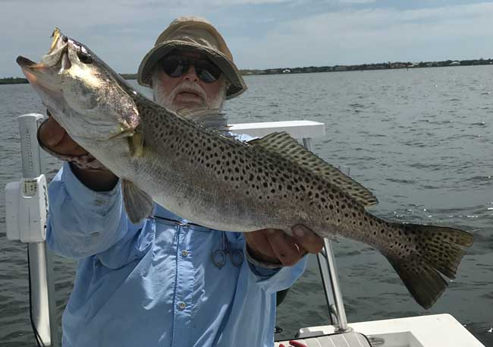
Some days, skill and fortune combine to give great results. Jim Bohrer (top) and Phil Norman (bottom) combined both to catch and release two gator trout in the Indian River Lagoon. These are magic fish.

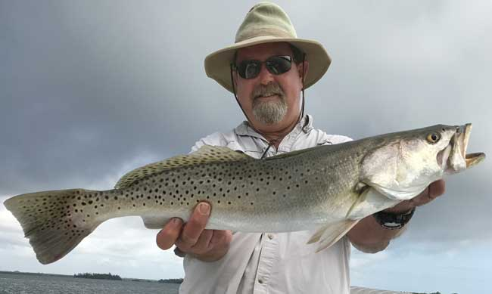

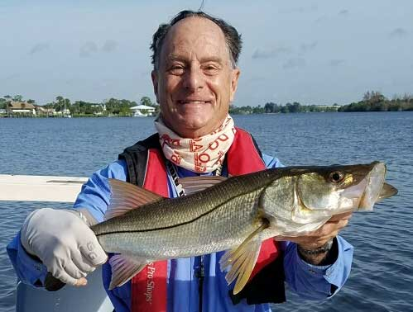
Dusty Smith with a good snook caught in the South Fork of the St. Lucie River

Here is some information that Jim Bohrer found, explaining the economic impact of recreational fishing vs. commercial fishing. Keep this in mind when writing, emailing or phoning your governmental representatives on fishery issues.

Fisheries Economic Picture Comes Into Focus

Recreational fisheries generate far more economic activity with less impact on marine resources. So why are we still treated as an after-thought by NOAA Fisheries?
POSTED ON MAY 18, 2017 BY BRAD GENTNER, PRESIDENT, GENTNER CONSULTING GROUP LLC
NMFS released Fisheries Economics of the United States (FEUS) this week with much fanfare (HTTP://WWW.ST.NMFS.NOAA.GOV/ECONOMICS/PUBLICATIONS/FEUS/FISHERIES_ECONOMICS_2015/INDEX). Thanks to CCA’s and the rest of the industry’s dogged attention to the optics of these types of press releases, NMFS did not try once again to paint the commercial industry as larger than the recreational industry in its announcement. That only makes sense because the commercial industry has a smaller economic footprint no matter how you slice it.
According to FEUS, in 2015, the fisheries economy in the US generated $200 billion in total economic activity. Of that number, $13.9 billion was created by the commercial sector; $38.0 billion from the supply chain all the way to the consumer for those fish caught by US commercial harvesters; $92.3 billion in seafood imports and $63.4 billion from recreational fishing. That’s $63.4 billion recreational vs. $13.9 billion for the commercial harvesting sector, or if you want to be generous, $51.9 billion including the activity all the way through to the restaurants and big box stores like Wal-Mart.
Even in the face of increasingly harsh regulations forcing recreational fishing effort down nation-wide, spending by recreational anglers has stayed strong, even increasing. 2015 was up almost $3 billion dollars over 2014, mainly due to a revised durable good expenditure survey that showed recreational anglers are, on average, spending more per person on durable goods like boats and rods and reels. It is likely that trip expenditure estimates will go up even farther for 2016 as a new trip expenditure survey has recently concluded. The final estimates from that survey are not out yet and therefore weren’t used in this publication. Those trip expenditure estimates should likewise be higher than the last time they were collected in 2011, driving the estimate of our economic importance even higher for 2016.
Meanwhile commercial fishing is shrinking, with revenue dropping more than $300 million from 2014 to 2015 and total economic activity dropping by nearly $10 billion dollars during the same time frame. If the recreational sector produces nearly $12 billion a year more than the entire seafood supply chain from the commercial harvester to the consumer, and nearly $50 billion more than the commercial sector, the inevitable question is, why does NOAA Fisheries spend the bulk of its time, effort and energy on management of the commercial harvesting sector? Why, in mixed-use fisheries that have both commercial and recreational participation, does it fail to recognize the larger footprint of the recreational sector?
This insistence on commercial-centric management in the Lower 48 is propping up relatively tiny, boutique commercial fisheries at the expense of an industry that produces far more economic activity with a much lighter footprint on fish stocks and the environment.
The story gets even more depressing when you net out strictly commercial fisheries in which recreational anglers do not participate – things like shrimp, Pollock and Alaskan king crab. Very conservatively, more than 60 percent of commercial landings come from fisheries an angler wouldn’t even think of participating in. Applying that percentage to the estimates above, the part of the commercial harvesting sector that competes against our fisheries generates less than $5.3 billion in total economic activity. If you include the entire supply chain right to the restaurant plate or the supermarket cart, those fisheries generate less than $20 billion in economic activity. That’s more than three times less than what recreational fishing generates in those same fisheries.
Given how our industry is treated in the management process, that is a shocking revelation, but it certainly isn’t new. The federal government has routinely ignored even its own economic reports that show recreational fishing generates drastically more economic activity with a lighter impact on the environment and on marine resources.
As a nation, we are missing a tremendous economic opportunity when the agency charged with managing the nation’s fisheries operates in such a one-sided and completely illogical manner.
______________________________________________________________________________

State Senate Bill 10 has passed and been signed by the Governor. Both State Representative Joe Negron and our US Representative Congressman Brian Mast are working on clean water initiatives that should help our water quality. None of this action will have immediate results but it is a beginning.

Representative Mast addressed the recent BullSugar.org fundraising event held on May 11th in Jensen Beach. Many of our Stuart Rod and Reel Club members were in attendance.

It would be helpful if you could Email both Joe Negron (FL State Senate president and our local state representative) and Congressman Brian Mast with your message of support for clean water initiatives that help the Treasure Coast and the rest of Florida. You can also mention the economic impact that recreational fishing has on the State of Florida.

Thank you. Your Board of Governors, Stuart Rod and Reel Club.
to
2017 Annual Dues
Fully paid memberships begin the first day of January, and end on the thirty first day of December of each calendar year. An individual membership is one adult 18 years of age or older. Family memberships consist of the member, their spouse or significant other and their children under the age of 18.

Individual membership for a HALF YEAR (June 1 through December) is $45

Family membership for a HALF YEAR is $55
(June 1 thru December)

Send your checks payable to:
Stuart Rod and Reel Club, Inc.
c/o Pete Noll, Treasurer
1888 S. W. Mooring Dr.
Palm City, FL 34990
Membership entitles a single person (or family as applicable) to participate in all outings and to enjoy a meal at every local outing. Members also receive an included meal (with soft drinks) at Shrimper’s and Manatee Island Grill on the appropriate dates. We hold monthly meetings with interesting speakers and share information on where and when to fish in our area.

2017 SRRC Fish
of the Month Contests
The Fish of the Month Contest will run from the day after the monthly membership meeting and end at 12 Noon the day of the following meeting. All fish need to be legal size except for Snook that must be 24 inch minimum. Natural bait (live or dead), artificial lures and flies are allowed. The member catching the most fish will be the monthly winner. The monthly winner will receive a monogrammed club hat.
Date | Species
Jan 13 thru  Feb 09 | Snapper, Bluefish
Feb. 10 thru Mar. 09 | Most Pompano
Mar. 10 thru April 13 | Most Snook
April 14 thru May 21 | Largest Trout
May 12 thru June 18 | Most Snook
June 19 thru July 13 | Most Redfish
July 14 thru Aug 10 | Most Trout
Aug. 11 thru Sept 14 | Most Tarpon Caught and Released
Sept. 15 thru Oct 12 | Largest Snapper
Oct. 13 thru Nov 9 | Largest Redfish
Nov 10 thru Dec 13 | Most Black Drum

The Winner of the Year Overall will be the person catching the most total species during the calendar year. The overall prize is a $50 gift certificate to White’s Tackle in Stuart.

