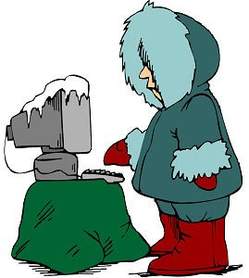
Computer Networking Mr. Schlosser
Winter Assignments Agenda

- Log into Google Classroom
- Complete Daily Quest
- Read over your Agenda
- Work on any or all assignments/tasks that do not require you to have hands-on access to classroom equipment
- Review and preview current TestOut sections
  - Lab Simulations
  - Practice Questions
  - Lesson and Demonstration Videos
- If all assignments are caught up, please go to the certification practice section in TestOut and work through it.
- All seniors can also work on their NOCTI prep assignments.

Below are the links you will need access to:

GMAIL
Google Classroom
TestOut Online Curriculum Jupiter Grades

