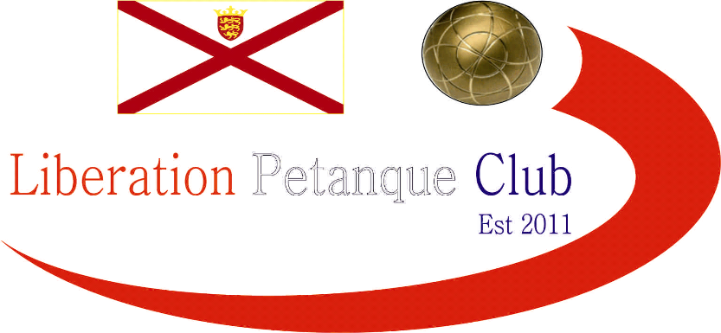

2020

Liberation Petanque Club

Doubles Open

19 Teams took part this year with the Cup’s holders changing partners, meaning new winner/s this year.

Round 1 saw 2017 winner Mark Nicol playing with Matt Pinel. The pair face Janet Gallichan & Margaret Robinson playing in their first competition and they played well against the much fancied team taking six points.

2019 Quarter finalists Ivo Raitchev & Tom Le Sueur had the worst possible start losing 13 – 0 to Derek & Joy Hart, but they were not the only ones as Paul Harris & Nicky MainDonald lost by the same margin to Matt Buesnel & Toby Northern. These were the first two of seven such results throughout the competition a new record.

Ross & Neil won a close match against Gavin & James as did Brian & Paul Le Moine who won against Geoffroy & Laurent in two of the biggest matches of round 1.

Round 2 saw to result of the tournament as relative newcomers Branden De La Haye & Tim Jackson handed out the third 13 – 0 of the tournament to one of the most experienced and top Island pairs Alan Lahiffe & Matt Scholefield.

Mark Nicol & Matt Pinel came from behind to just beat Matt Buesnel & Toby on the last end winning 11 – 10. Brian & Paul made it two from two with a win over Neil & Ross 13 – 11. Geoffroy & Laurent got back to winning ways with a big win over Gavin & James 13 – 1.

Andrew & Callum who had a bye in round 1 won their second round match against Kat & Paul to move to 2 wins. Nicky & Paul recovered from round 1’s zero points to get a win over Daniel & James with Cassie & Jean also getting a big win over Matt & Mo.

Round three saw Matt & Toby give up a 6 – 0 lead against Geoffroy & Laurent who won 12 – 8 in the end. Andrew Limbrick & Stephen Leathem won a close match against Compatriots Alan & Matt 13 – 12. Cassie & Jean lost a close match to Derek & Joy 13 – 11. Gary & Wendy made it two wins taking an 11-7 win over Ivo & Tom.

Round 4 saw the lowest score of the tournament as for the third time Gary & Wendy match was timed out but they won 9 – 7 against Andrew & Stephen. Another match timed out saw Neil & Ross take a 11 – 9 win over Geoffroy & Laurent.

Nicky & Paul came back from 10 – 0 down against Cassie & Jean to win 13 – 11 and Matt & Mark made it 4 from 4 win a 13 – 1 win over Andrew & Callum. Gavin & James made it back to back wins over Matt & Mo and Branden & Tim moved on to three wins with a 13 -7 result over Kat & Paul.

Going into the final round a host of teams were in with a chance of making the top 8. Branden & Tim lost 13 – 0 to Geoffroy & Laurent but despite both teams finishing on 3 wins and the latter the much better points difference it was Branden & Tim who made it through in 8th place.

Brian * Paul played the perfect game against Matt & Toby to finish the highest team with three wins. Alan Lahiffe & Matt Scholefield had a big win over Gavin Scott & James Rondel to make the quarter Finals for the 2nd year running despite round 2’s result. Andrew & Callum beat Andrew & Stephen, but despite this both teams made the top 8 with Andrew & Callum 2nd to Andrew & Stephen 6th.

Gary & Wendy also made the top 8 in 3rd with 4 wins at the expense of opponents Neil & Ross with the 13 – 5 result leaving them missing out by 1 point on points difference. This was to Branden & Tim who despite losing 13 – 0 in the final round to Geoffroy & Laurent made it in 8th place with their opponents finishing 10th.

Derek & Joy defeat to Mark & Mat didn’t prevent them from finishing 5th with Mark & Matt winning all 5 to top the rankings.

FINAL SWISS RANKINGS

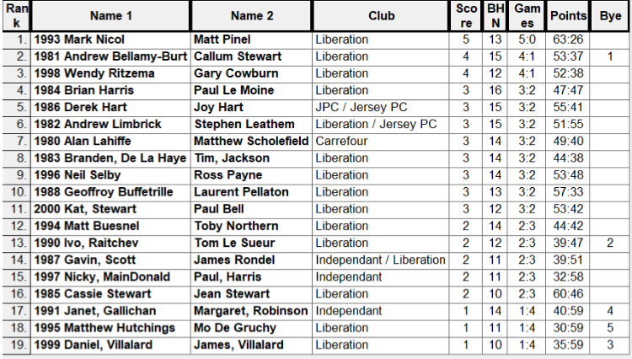

Quarter Finals

Mark Nicol & Matt Pinel v Branden De La Haye & Tim Jackson

Andrew Bellamy-B & Callum Stewart v Alan Lahiffe & Matt Scholefield

Brian Harris & Paul Le Moine v Derek & Joy Hart

Andy Limbrick & Stephen Leathem v Gary Cowburn & Wendy Ritzema

Well Branden & Tim’s fantastic tournament ended with a 13 – 5 defeat to the top ranked pair.

For the second successive year Andrew & Callum played Alan & Matt a different result this year and a big one as Andrew & Callum ran out 13 – 0 winners.

This was not the only 13 – 0 result as Brian & Paul made it two in a row to make the semi-finals.

A match that ran out of time again involved Gary & Wendy but they couldn’t get the six needed on the last end as Andrew & Stephen got revenge for their defeat in round 4.

Semi Finals

Mark Nicol & Matt Pinel v Brian Harris & Paul Le Moine

Andrew Bellamy-B & Callum Stewart v Andy Limbrick & Stephen Leathem

Andrew Bellamy-B & Callum Stewart beat Andrew & Stephen 13 – 5 in round 5 of the swiss system so would have be confident, however to great play by Andrew & Stephen saw them make the final winning 13 – 7.

Brian & Paul competition came to an abrupt end as they lost 13 – 2 to Mark & Matt who were now in top form.

Brian & Paul took third place for a great competition for the experienced pair.

Most people would only have expected one result in the final and it certainly looked like Mark & Matt would make light work of it leading 8 – 2, but then a fantastic 6 followed by another point on the next end saw Andrew & Stephen take the lead 9 – 8 and they had a few chances to pick up more points but maybe the pressure had an impact as Mark & Matt won 5 straight points to lift the title. Both of these have now won this competition three times.

Winners pictured below – Matt Pinel & Mark Nicol

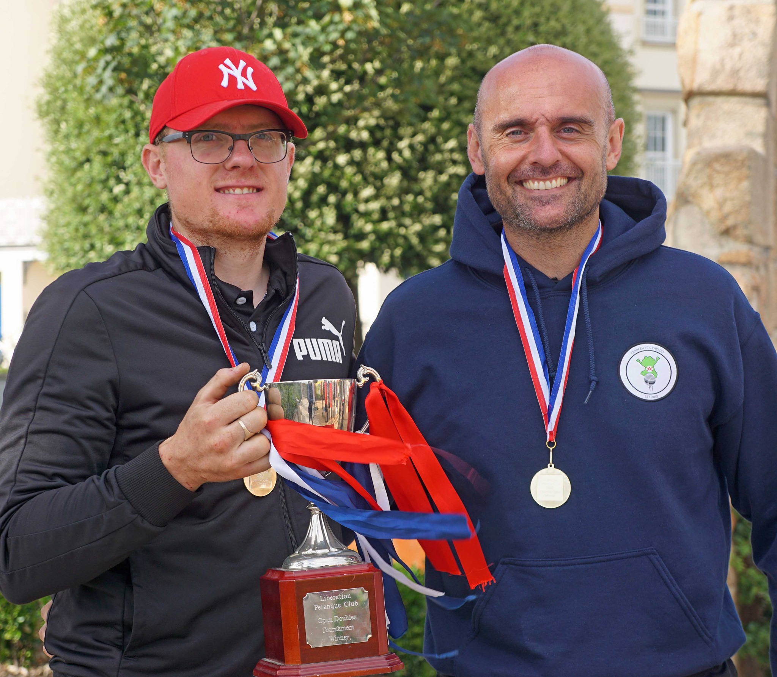

Congratulations to everyone who took part in another successful competition.

Thank you to everyone who helped prepare for this competition and the running of it on the day, which takes a great deal of time and effort.

Kind Regards

Toby Northern

Chairman

Liberation Petanque Club

www.liberationpetanque.co.uk

liberationpc@gmail.com

