Kennedy High School
Advisor: Barry Wilson
Location: 4545 Wenig Rd. NE, Cedar Rapids, IA, 52402
Phone Number: 319-784-7697
bwilson@cr.k12.ia.us
John Tedesco, Grade 11, Crew Chief/ Driver
Collin Flannagan, Grade 9 Assistant Crew Chief
Brian Stubblefield, Grade 9 Documentation Writer
983/A983 (50 car) March Monthly Report
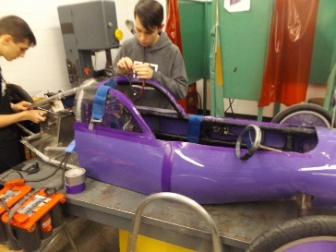
This month, a lot of progress has been made on the 30 car. John Tedesco, and his assistant, Colin Flannagan, have been hard at work getting everything ready to run for the first race on April 6th. This month, they have hooked up the motor, connected the brake lights, set up all the wiring and the cycle analyst, and have been test running everything to ensure peak performance.
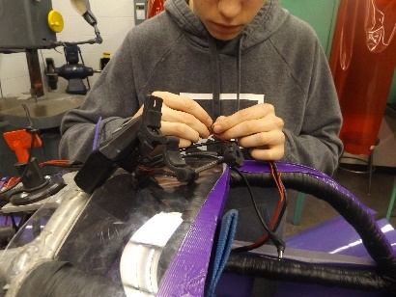
The Batteries team has completed their tests on our battery sets and are working on two things; preparing the trailer for race season and matching up the best possible arrangements for the “B” sets and the setups. The place we used to buy our Optima batteries at has stopped selling them, but we are now buying them from Advanced Auto.
The telemetry team has almost perfected the system, and only has a couple bugs and kinks to work out. After they finish, they will be taking apart our dyno mule, and returning the various elements to storage.
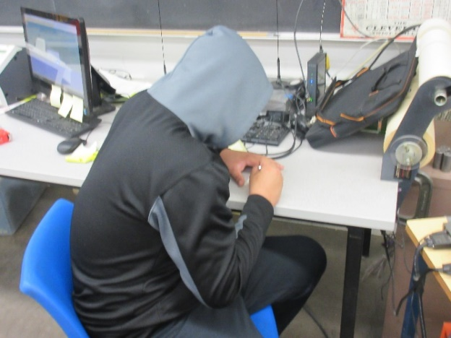
The graphics department has been working constantly to produce the necessary number boards for the first race in Nebraska on April 6th and has also been racing to finish the team shirts.
Our documentation crew has been working beyond overtime to get the books done by the first race but are going to make it with a lot of extra work.

