Public’s Favourite
Bisterne Scarecrow Results Breakdown 2018

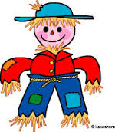

With the 2018 Festival coming to an end, we have counted the votes for the Public's Favourite and the winner is ....
OH LOOK THERE'S A DRAGON

The votes received were
Oh look there's a dragon - 14 votes
Giant Conkers - 12 votes
Tom and Jerry, Unicorn Mainea & Stickman and his family tree - all had 11 votes
The Bells - 8 votes
Bisterne Royals & Beans on Coast - 6 votes
Pokestop, Head over Heels, Half Cut & Peter Rabbit - all had 5 votes
2050AD - 4 votes
Rusty Train & History of Scarecrows - both had 3 votes
Scarycrows - 2 votes
Beastie Boys, Happy as a Pig, Noah's ark, Worzel is in trouble & Poldark & Handsome - all had 1 vote each

Thank you all so much for voting for your favourite and to all who came to see the Scarecrows.

