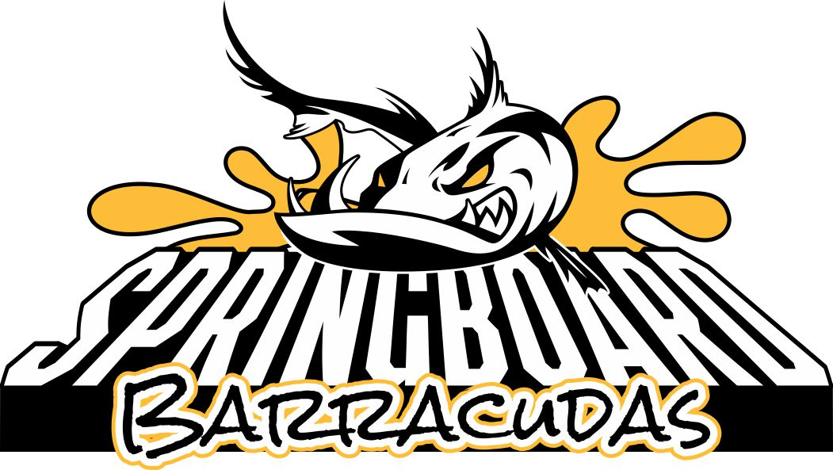

Springboard Barracudas Swim and Dive
2018 Season

Dear Potential Sponsor,

The Springboard Barracudas are asking for your help this summer. Springboard Pool is a private, nonprofit entity and exists exclusively for the benefit of our members and guests. Springboard has been a part of the Springfield-Franconia area for over 50 years. Our swim and dive teams are a part of the Northern Virginia Swim League with over 150 swimmers and divers aged 4 to 18 who practice daily from late May through the end of July and compete against other local swim and dive teams. We host nine home meets throughout the summer which bring families from Springfield as well as other local Northern Virginia communities. This summer we will host Divisional Relay Carnival which will bring participants from six other pools with over 500 competitors and spectators to our pool. This would be a great opportunity to advertise, provide food or host a vendor booth that will be seen by this large audience. Our dive team will host the Divisional Dive meet for the second straight year with over 75 participants from six other pools at the end of the season.

The swim and dive teams have many fees to cover including uniforms, team equipment, awards and coaches pay. Swim and dive team families’ support the teams through registration fees. Parents also spend countless hours volunteering their time and talents to support the team. We are once again inviting area businesses to help support our community, athletes and to showcase your business in our community. All donations, whether monetary in nature such as gift cards or services or in-kind sponsorship will be greatly appreciated. These donations are used to help replace items such as backstroke flags and lane lines. Some donations are used to help raise money for swim and dive through raffle prizes and bingo. All sponsors will be announced at all home meets. We have various sponsor levels that can provide additional business advertisement on our NEW team website hosted by SwimTopia. This site will be used by all swim and dive families throughout the season to access team information. For more information on SwimTopia and sponsorship– see the sponsorship opportunities on the attached Sponsor Opportunities Form.

Please consider supporting our young, dedicated athletes. Our pool is one of the best community pools in Northern Virginia with many families returning year after year and new families joining each year. If you have any questions about our sponsorship program, please contact our sponsorship chairperson, Amber Finnegan, at 801.706.2875 or springboardswimanddive@gmail.com.

Very truly yours,

Carylin Waterval, Swim and Dive Team Committee Chair

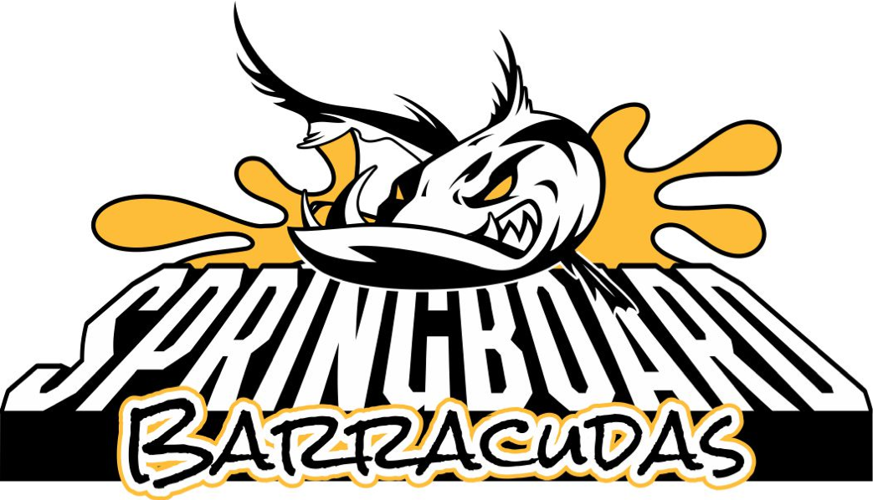
Springboard Recreation Club
P.O. Box 151
Springfield VA 22150

Street Address:
6500 Deepford Street
Springfield, VA 22150

Telephone:
703-719-7359

Web site: www.springboardpool.org

Springboard Barracudas Swim and Dive

SPONSORSHIP OPPORTUNITIES 2018

Bronze Level Sponsorship
- $50 - $100 donation
- In-Kind Sponsor – Donate gift cards, raffle prizes, food or other items for Swim and Dive meets (equivalent value of $50 - $100)

Silver Level Sponsorship
- $150 donation for two years

Silver Level prominently feature your business’ logo with a link directly to your business on our team website, springboardswimanddive.swimtopia.com. Our 100+ team families, as well as our 250+ member families, teams we are competing against and area families seeking more information, will be visiting this site frequently throughout the year for everything from registration to meet information.

Gold Level Sponsorship
- $300 donation for two years

Silver level benefits PLUS 3’ X 6’ Banner displayed on the pool grounds throughout the 2018 and 2019 summer seasons, Sponsors’ names will be announced at all home meets, and posted in our clubhouse throughout the entire summer season. You will also be provided with a team photo to display at your business

Platinum Level Sponsorship
- $1500+ donation for one year

Silver, Gold and Platinum benefits PLUS your logo exclusively on our team t-shirt and your logo featured first (most prominently) on our team website.

We are happy to craft a sponsorship opportunity to fit your needs and your budget. Checks should be made payable to Springboard Pool Swim/Dive Team and may be mailed to the P. O. Box shown above or we will invoice your company. Please inquire at springboardswimanddive@gmail.com for additional information.

