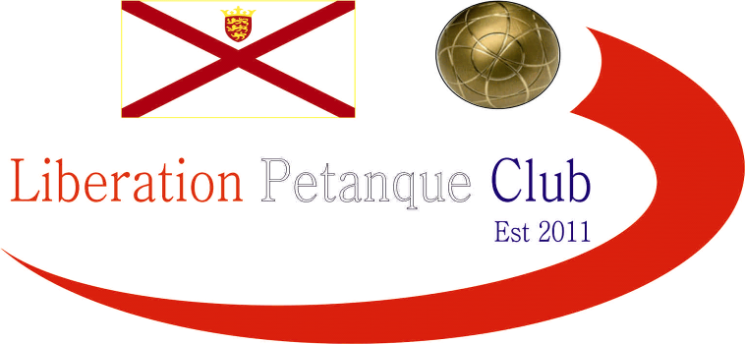

SUMMER - 22 SEASON
2022 Singles Open

The first major competition of the year saw a huge drop in numbers due to the Home Nations play offs held the following day. In fact, it was the lowest entries in ten years. Despite this the quality was still there, with most of the Island top players in attendance.

2017-2019 winner Mark Nicol got his competition off in the best possible way beating Branden De La Haye 13 – 0. Last years Runner up – Andrew Limbrick suffered a heavy defeat to Toby Northern 13 – 3.

Paul Bell beat last years third place finisher Alan Lahiffe and Gavin Scott beat Andrew Bellamy-Burt in some surprise results. Elsewhere all other results went as expected with James Rondel beating David Ibitson, Laurent Pellaton beating Alice Ibitson amongst some other matches.

Round two saw one of the matches of the tournament as Paul Bell handed Gavin Scott a certificate 13 – 0. Laurent also won 13 – 0 over Mo De Gruchy.

Some very close matches in Round two as four 13 – 12 results followed. Neil Selby won a nail biter 13 – 12 against Geoffroy who fired his own boule out at 12 – 12 to give Neil the win. Daniel Villalard lost his second successive match 13 – 12, this time to Brandon. Alan beat David 13 – 12 and Alice beat Lorna Limbrick 13 – 12.

Andrew Bellamy-Burt lost his second successive match, this time to Cassie Stewart-Le Gallais to leave his chances in tatters. Ross Payne made it two out of two with a big 13 – 4 win over Callum Stewart.

In Round three Laurent lead the whole way against Toby before Toby took the win 13 – 12 to make it three from three. Callum beat Geoffroy and Paul Bell also made it three from three with a win over James Rondel.

Ross beat doubles partner Neil and Mark beat Alice as they also moved onto three wins. A big win for Cassie 13 – 3 over Tim moved her into contention and Alan beat Brian 13 – 3.

Round four saw Neil lose his second successive match, this time to Andrew Limbrick as did James losing to doubles partner Gavin.

Geoffroy survived a scare just beating Daniel 13 – 12 and Ross beat Toby 13 – 11 to make it four from four. Mark beat Paul to also make it four wins.

Laurent and Alan made it three from four to give their chances of qualifying a boost.

In the final round several players could qualify. Mark topped the rankings with a 13 – 8 win over Ross with Ross ending in third place. Paul beat Laurent to end on four wins to finish second place, with Laurent just scrapping in eighth place on points difference, albeit an impressive +22.

Toby beat Cassie to finish on four wins and fourth place, with Cassie going out with three wins +10 finishing nineth. Gavin Scott won his fourth match against Alan Lahiffe to finish fifth with Alan still qualifying with three wins in sixth position.

Callum took seventh position with a win over James Rondel. Last years runner up Andrew Limbrick third win over Tom was enough as he lost out on points difference.

Final Rankings

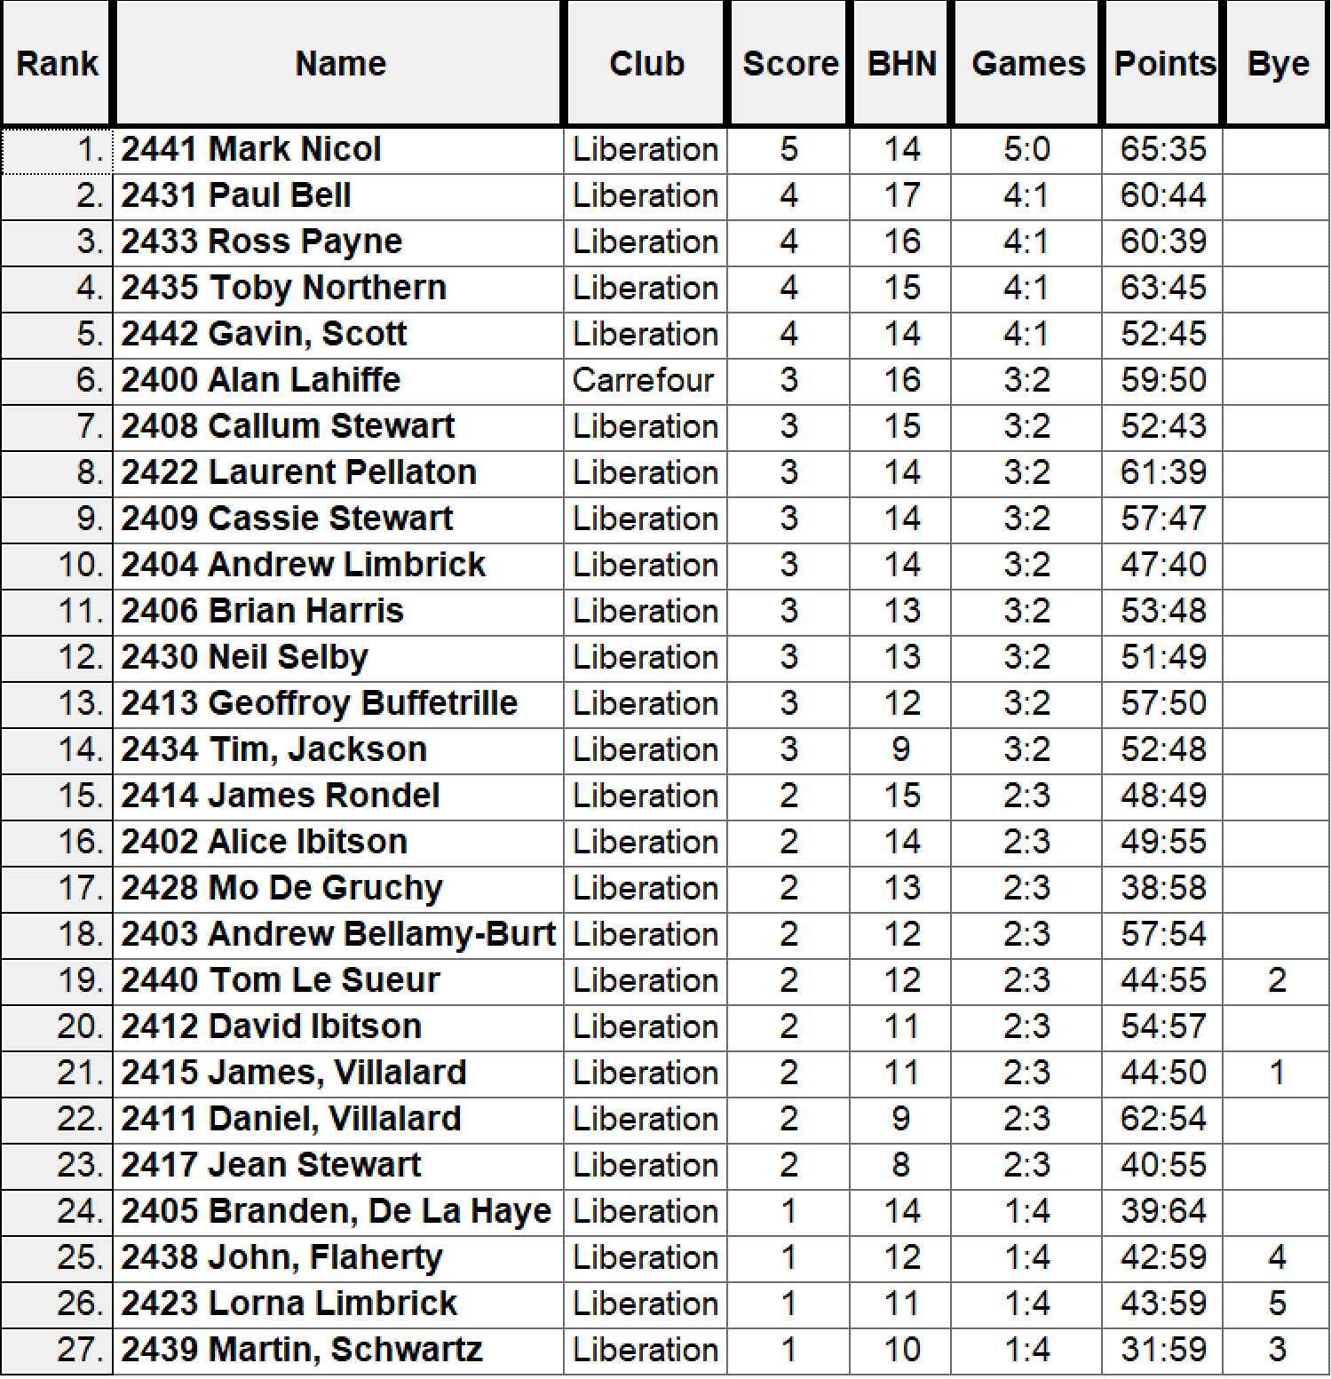

So, the Quarter finals were as follows:

Ranked | Quarter Finals |  |  |  |  | Ranked
1st | Mark Nicol |  | v |  | Laurent Pellaton | 8th
2nd | Paul Bell |  | v |  | Callum Stewart | 7th
3rd | Ross Payne |  | v |  | Alan Lahiffe | 6th
4th | Toby Northern |  | v |  | Gavin Scott | 5th

Mark Nicol was looking good in his quarter final against Laurent leading 9 – 0, but what a comeback from Laurent who only lost won more point winning 13 – 10 as the Swiss curse struck again with the top ranker player losing to eighth position again.

In fact, none of the top four ranked qualifiers made it through to the semi-finals as Gavin beat Toby, Callum beat Paul and Alan beat Ross in a surprise turn out.

Semi-Finals

8th | Laurent Pellaton |  | v |  | Gavin Scott | 5th
7th | Callum Stewart |  | v |  | Alan Lahiffe | 6th

Gavin’s excellent performance in the quarter finals must had taken it out of him as he was out of sorts in his semi-final before gaining some momentum, but it was too late as Laurent made the most of his opportunity winning 13 – 10. Unfortunately Callum didn’t get much of a chance as his form and a few coche moves for Alan helped him win 13 – 6.

In the final Alan was looking good and 7 – 2 up before Laurent came back, and with a few missed fires in consecutiv. nds by Alan, it gave Laurent the chance to win the title, he missed a few chances before sealing a 13 – 11 win for his maiden title.

Gavin took third place over Callum for another great tournament for himself.

Many thanks to James Rondel, Geoffroy Buffetrille, Laurent Pellaton and all those who helped on the day, your support is appreciated.

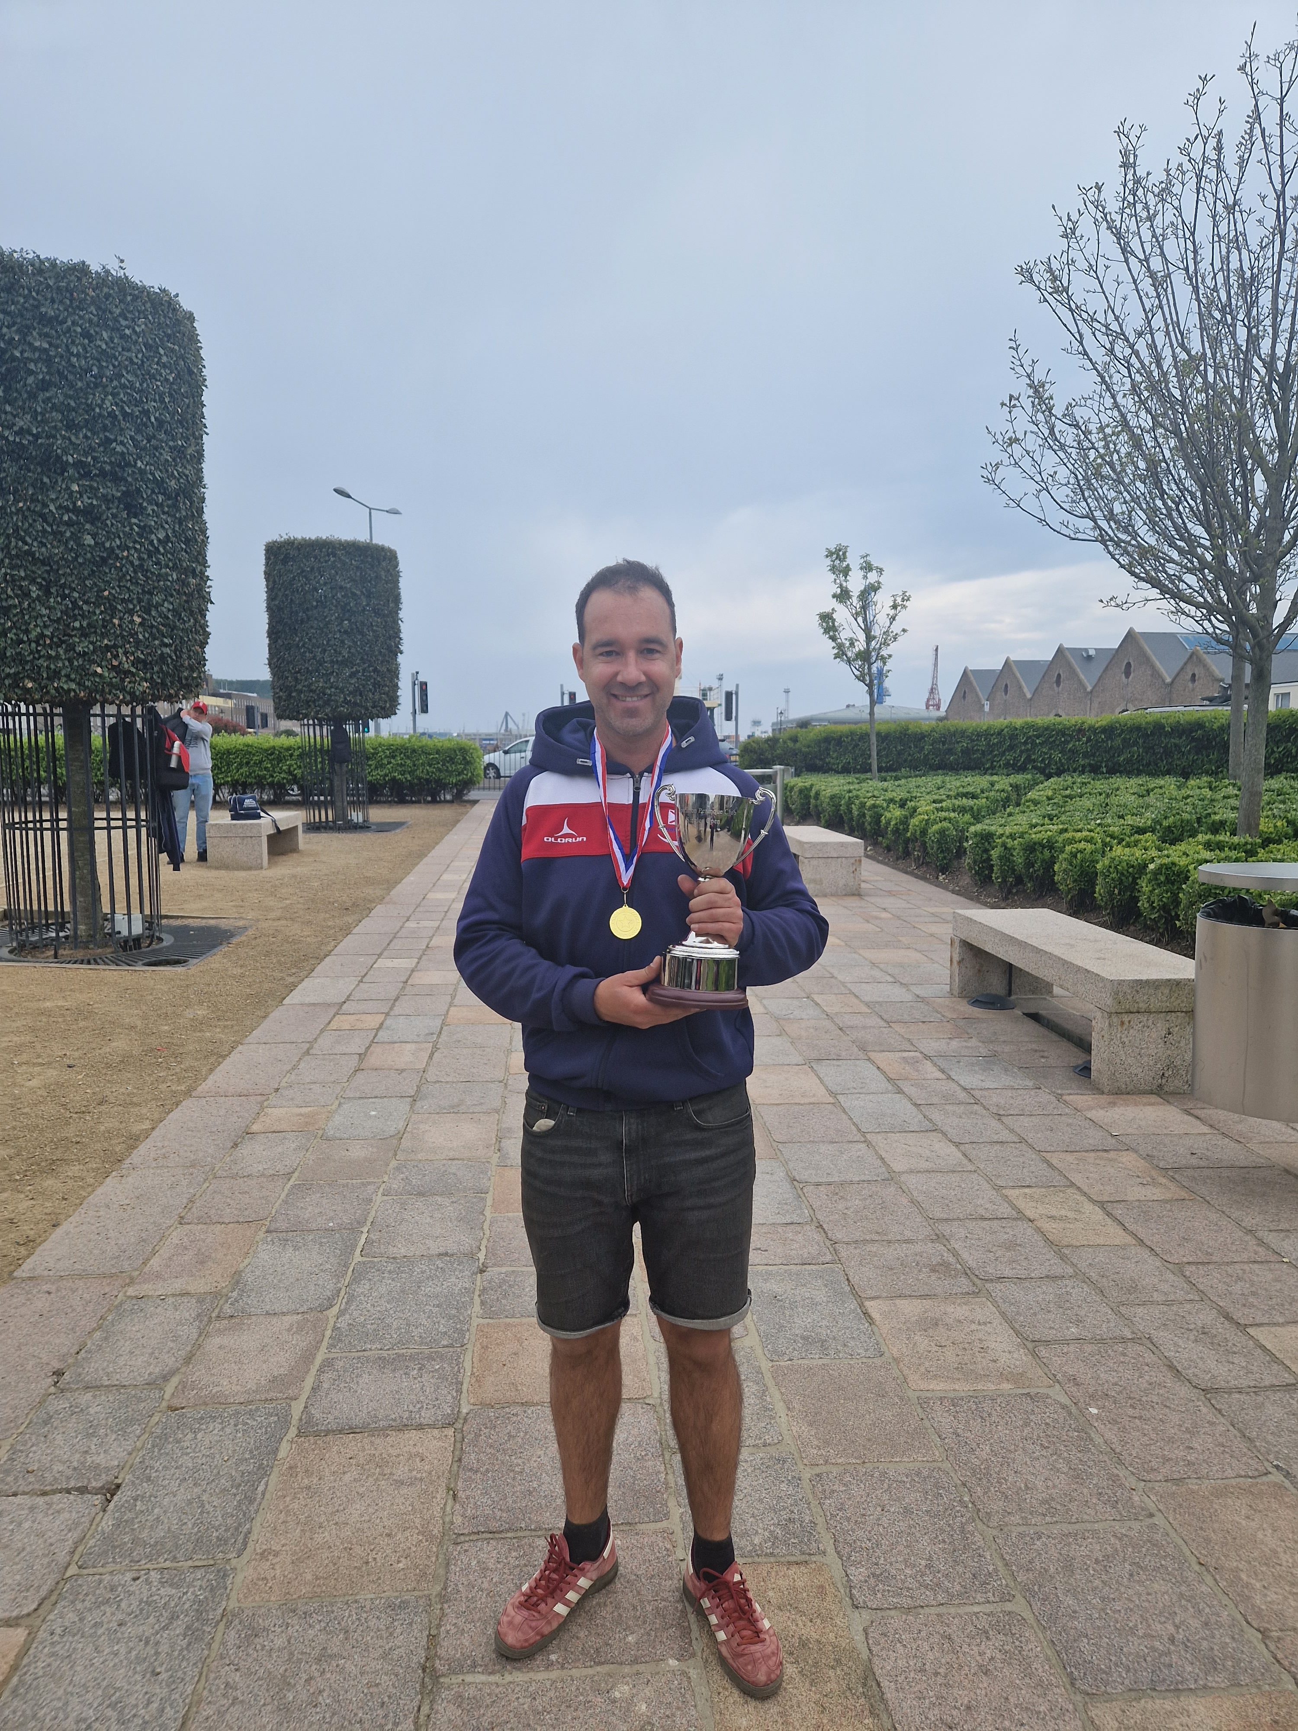

Ranked | Quarter Finals |  |  |  |  | Ranked
1st | Mark Nicol | 10 | v | 13 | Laurent Pellaton | 8th
2nd | Paul Bell | 11 | v | 13 | Callum Stewart | 7th
3rd | Ross Payne | 5 | v | 13 | Alan Lahiffe | 6th
4th | Toby Northern | 4 | v | 13 | Gavin Scott | 5th
 | Semi Finals
8th | Laurent Pellaton | 13 | v | 10 | Gavin Scott | 5th
7th | Callum Stewart | 6 | v | 13 | Alan Lahiffe | 6th
 | 3rd Place Play Off
7th | Callum Stewart | 1 | v | 13 | Gavin Scott | 5th
 | Finals
8th | Laurent Pellaton | 13 | v | 11 | Alan Lahiffe | 6th

Sponsored by



CoinShares | Digital Asset Investment Strategies for Professionals 🚀

Club email address - liberationpc@gmail.com

Club Website - www.liberationpetanque.co.uk

Kind Regards

Toby Northern

Chairman

Liberation Petanque Club

