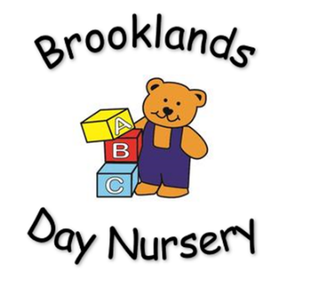
Brooklands Private Day Nursery
Data protection Policy (GDPR)

Brookland’s is a data controller as we collect and use personal data. As such we have a responsibility to ensure your data is protected.
The new General Data Protection Regulation (GDPR) gives you more control over how your personal information is used and makes it quicker and easier for you to check and update the information we, and other organisations we work with, hold about you.
As always, we'll continue to collect, use, store and share your data safely and securely. By keeping your details up to date, we can use this information to provide even better services for you.
To do this we have the following policy
- All personal information is kept safe and secure in the nursery office.
- The nursery manager and deputy manager have access to the information (On occasion the senior members of staff may also need to access your information).
- All staff will not pass on any personal information to other unauthorized persons.
- It may be necessary for us to share your information with other authorized authorities
You have the right to withdraw consent at any time to us passing on information to authorized authorities, doing so would result in us not able to care for and safeguard your child.
We are required to keep your personal information for as long as is necessary for us to operate our business and comply with legal and regulatory obligations.
If you wish to view your personal data held by us at any time please ask.

This policy will be reviewed every 12 months by management.

