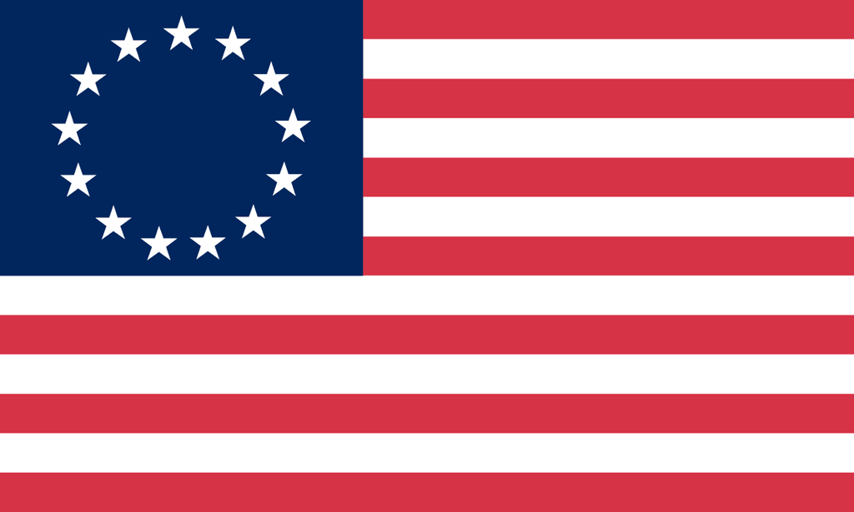U.S. History with Mr. Brown Name _______________________________ Period _____
Ch 6 Vocabulary Activity
Directions: Complete each group of words with the vocabulary term that best fits in that group

1)  Income  Proceeds  Takings  ____________________   | 2)  Refuse  Embargo  Prohibit  _____________________  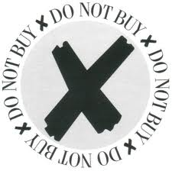
3)  Supporter  Devotee  Stalwart  ____________________   | 4)  Rebel  Jingoist  Nationalist  ____________________  