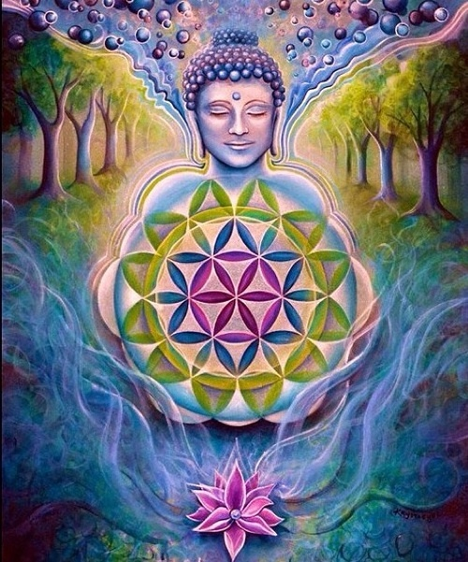**SACRED SOUND SOLSTICE CONCERT**

**DIVINE MOTHER’S INDWELLING GRACE**

**SUNDAY, DECEMBER 22, 2024**

**7pm – 9pm**

**FIRST SPIRITUAL SCIENCE CHURCH**

**3375 S DAHLIA ST, DENVER, CO 80222**

**"Sound will be the medicine of the future"**

**- Edgar Cayce*The future is now!*  
$25 Suggested love offering for FSSC and facilitators.Your presence is welcomed and honored,whatever the love exchange.**

Invoking cosmic transmuting violet flames of compassion, mercy, grace and ease we will be focusing on balancing and dancing with our Ancient Mothers, earth and cosmic, Our blessed earth, Gaia, is now in the photon band of our galaxy WHO NOW CONNECTS TO MANY OTHER GALAXIES! Come and celebrate the Divine through the powerful plasma energies streaming into the planet and creating a massive shift as we invoke the Grace of balance of masculine and feminine.We will be connecting with the Unified Field of Earth and Cosmos pouring onto the planet from the multiverse. Do join us in lifting our light quotient and love vibrations through the pure tones of sacred sound instruments including singing crystal and Tibetan bowls, bells, and gongs, drums, rattles and flute. Aurelia is excited to share her 21st century Titanium gong with “in and out of this world” energies. Do help in enhancing this co-created sacred space and planetary balance by commanding higher dimensional help from the angelic worlds, star beings and ancient wisdom keepers of all traditions! We will collectively connect with groups around the world for this global healing. Expect to clear, cleanse and transform collective outdated thought forms and belief systems by allowing the tones, overtones and your soul and oversoul to utilize the spherical soundings to holographically take you to heightened vibrations to create new potentials in your life Anticipate a Shamanic-type cosmic journey. **Bring pillow, mat and blanket to lie down on for the extended sound journey or enjoy the comfy chairs also provided. Come early for optimal space. RSVP Welcomed! 303.771.5622,** [**AureliaTara@aol.com**](mailto:AureliaTara@aol.com)

FACILITATORS;

**Garrett Duncan,** Navajo Illuminations laughing shaman, author and interdimensional conduit with the Star Nations and indigenous of our worlds, works spontaneously in the moment to bring in star codes and language of light for the group, promoting inter-species communications and peaceful relations for all. Garrett graced all at the fall equinox as Spirit moved through him and brought a beautiful synergistic experience to all attending. www.facebook.com/NAVAJOILLUMINATIONS

**Jonathan Murdock** brings new energies to us! Aurelia knows him primarily through his past beautiful work with Wisdom Healing Qigong. Music and sound have always been sacred for Jonathan and connects him to nature while supporting his inner journey.  A blend of sounds from the Native American flute, gongs, and a wide variety of percussion instruments are what Jonathan uses to create space for deep listening and meditative presence.  Jonathan’s commitment to mindfulness, along with decades of practical experience, guides each drum beat and flute note to create timeless and soul soothing songs.[jonathan.elemento@gmail.com](mailto:jonathan.elemento@gmail.com)

|  |  |  |
| --- | --- | --- |
| **Jack Welker** began his journey with sound in 2004 as he studied and worked with Cosmic Throat Singer Matthew Kocel. He then developed his own style of Toning and Throat Singing and using other sacred sound instruments. Jack does personal & group sound journeys and energy work and can also be reached for handyman services. Contact Jack at [medicinejack@gmail.com](mailto:medicinejack@gmail.com).  **Ann Allen** has been teaching and practicing spirituality her entire life. Her latest holistic endeavors have been with singing bowls, NeuroLink and BioFeedback. In the educational system she taught both gifted and physically challenged children and with an eye for beauty also was an interior designer. She is also the author of the transformational book, *Authenicity At Its Best*. Ann shares classes focused on living authentically. [anyaallen@aol.com](mailto:anyaallen@aol.com) |  |  |
| **Aurelia** has been curiously exploring the metaphysical since a wake-up call in 1970. She and late husband, Al, facilitated solstice and equinox events at FSSC for over a decade and she continues to add to that momentum as long as she is spiritually guided. She is especially connected to frequency medicine such as sound, knowing that sound is a key to clearing outdated consciousness patterns from our fields and the planet. Aurelia is eager for the paradigm shift which many channels acknowledge the earth is NOW receiving. Aurelia can be reached at [aureliatara@aol.com](mailto:aureliatara@aol.com). |  |  |