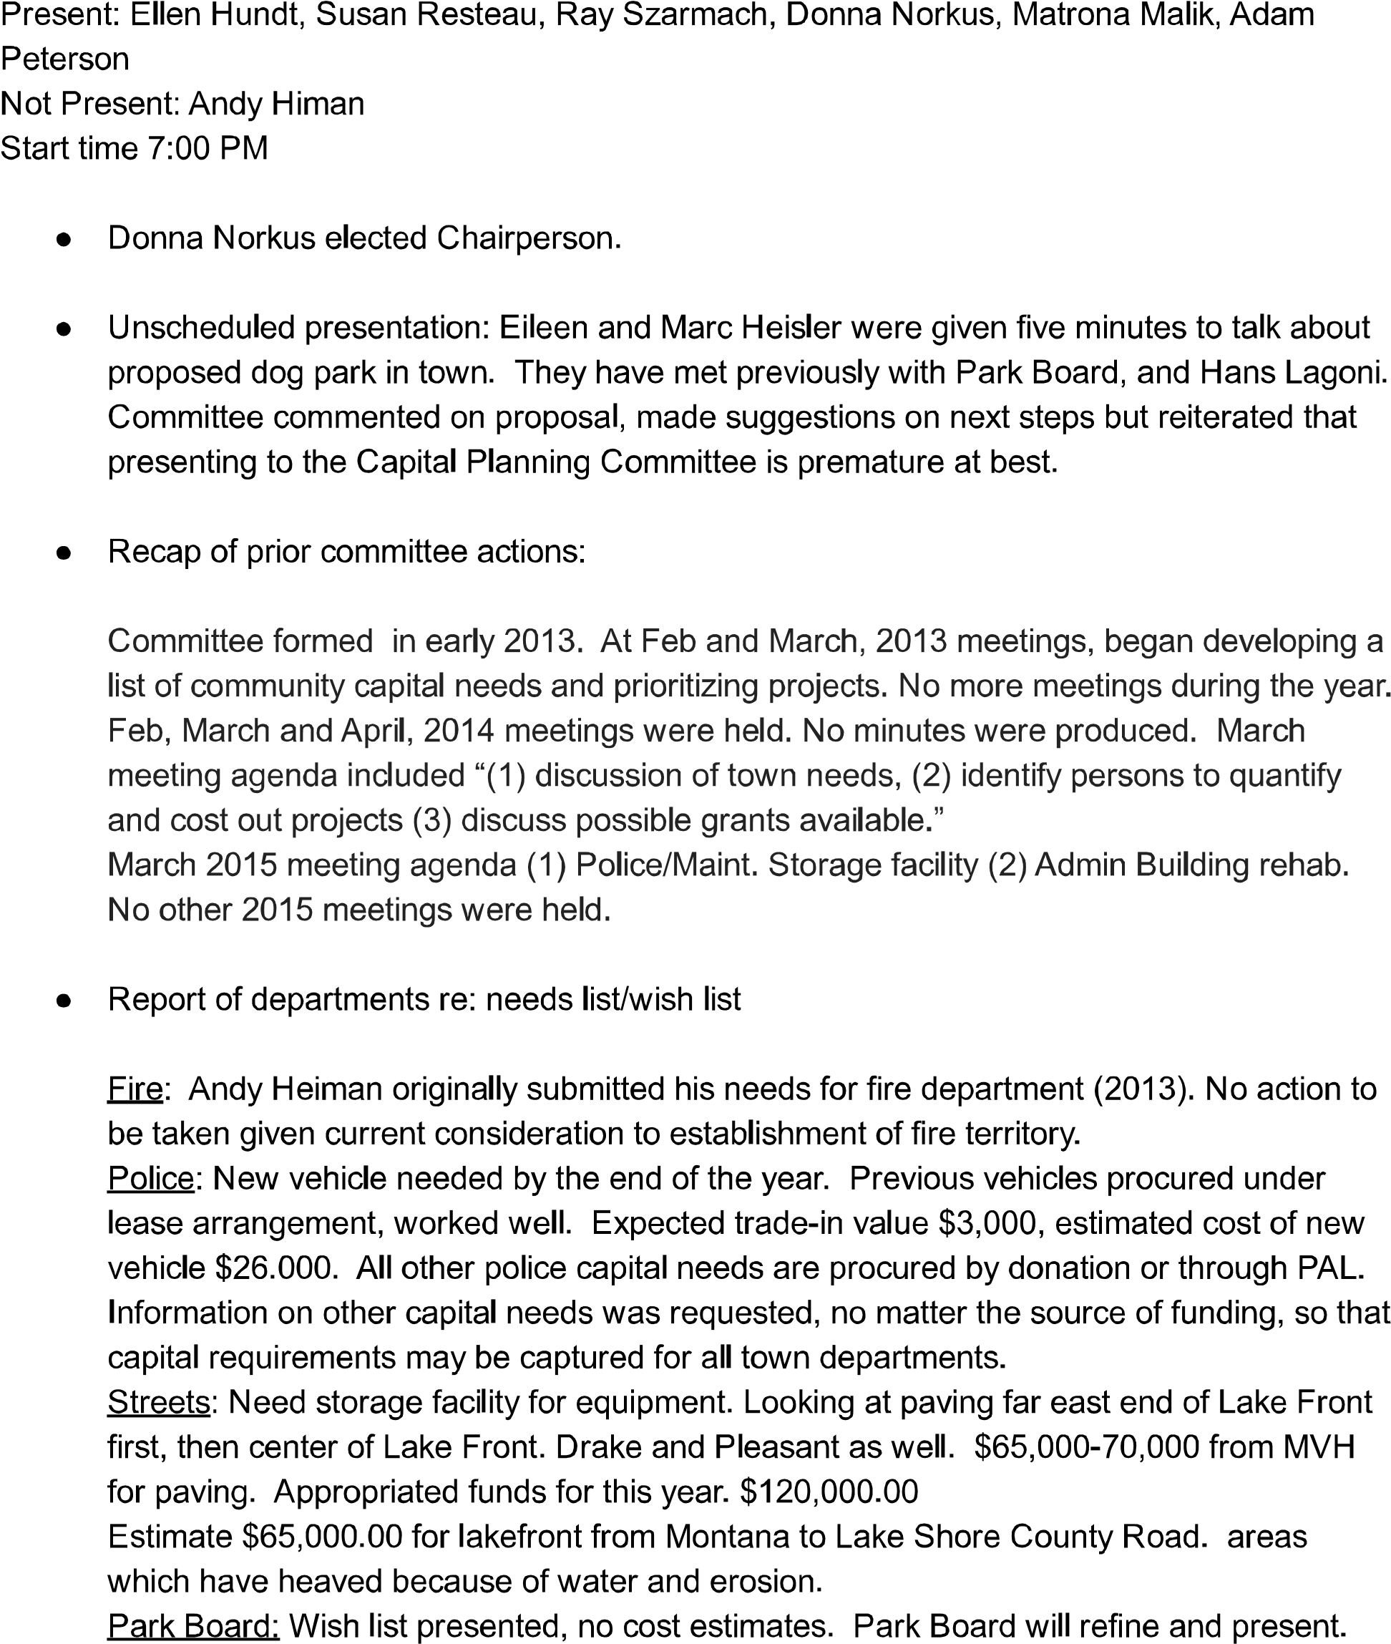
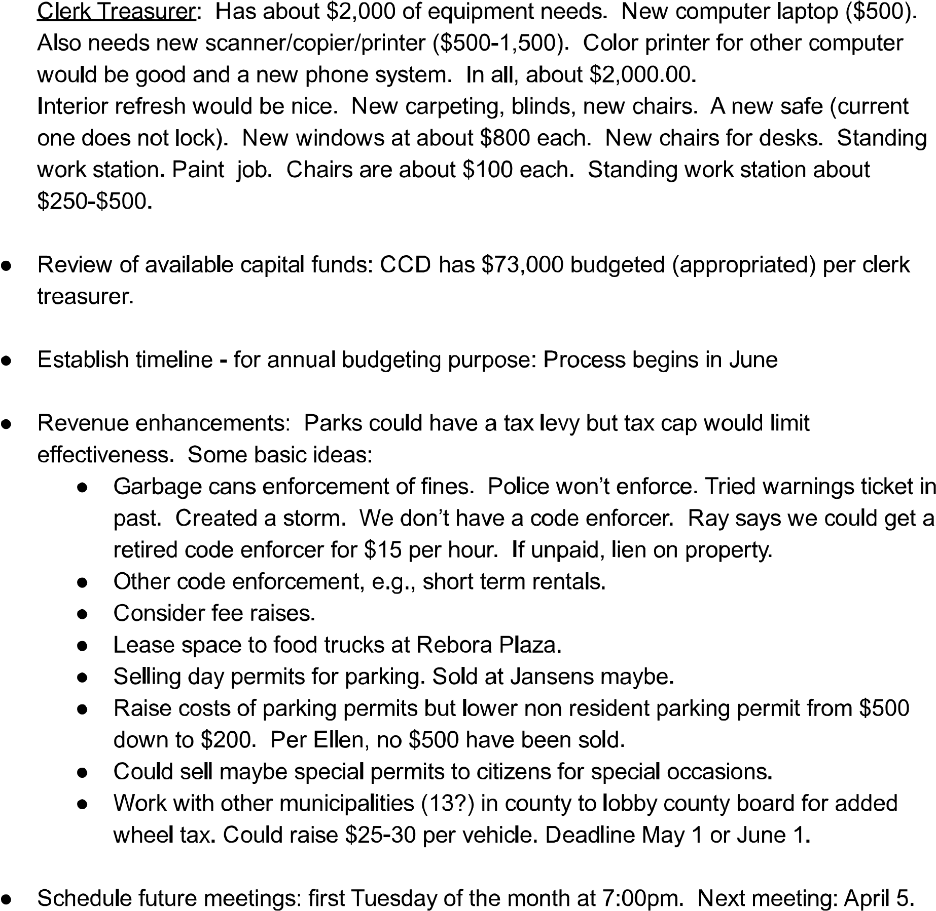

Capital Planning Meeting
5 April 2016 Minutes

Present: Ray Szarmach, Adam Peterson, Donna Norkus, Matrona Malik, Susan Resteau

- Presentation by ABSR representatives on proposed new storage facility and existing building remodel. Mary Marvel presented a brief history of the project; Paul Zucker presented storage building component of proposal. (See attached memo to committee re: Proposed Town Center Project Overview)

- March 15 minutes approved unanimously

- Report on Town Council discussion re: capital planning.

Committee report stated that it would (1) continue gathering information on capital needs and wants of each department, (2) explore possible new sources of capital funds, and (3) develop a fiveyear capital plan.

- Update departments needs list/wish list

Marshal Resteau provided additional information on anticipated police department capital expenditures. Adam Peterson will incorporate into plan along with new list submitted between meetings by ClerkTreasurer.

- Current available capital fund sources
  - Fee levels (garbage, parking/boat permit, etc.). No discussion.
○ Enforcement (garbage can, boat, short term rental, etc.). See resolution below.

- New available capital funding sources
  - Weddings on the beach. See resolution below.
○ Rebora Plaza alternative use. No discussion.
○ Temporary parking permits. See resolution below.
○ Grants. No discussion.
○ Wheel tax. No discussion.

- Resolution

A motion was made by Adam Peterson, seconded by Ray Szarmach to recommend that Town Council immediately consider the following:

- With respect to enforcement of existing ordinances:

Commence enforcement of Beverly Shores Ordinance 51.02(F)(1)^{i} regarding trash containers left at roadside. Enforcement to be accomplished by extending shift of afternoon duty officer by one or two hours during which the officer’s only duty will be Ordinance 51.02(F)(1) enforcement.

Commence enforcement of Ordinance 155.080(B)(5)^{ii} regarding singlefamily dwelling rentals. Enforcement through development of joint effort by Clerk-Treasurer and Beverly Shores Police Department.

Request that the Park Board develop ordinance enforcement plan for boat violations.

- Reducing the cost of annual parking permit for non-resident motor vehicle from $500 to $250.

- Establishing a guest permit parking program whereby residents may purchase a book of day parking passes ($50 for a book of 10) to replace Ordinance 71.06(D)^{iii}.

- Establishing a temporary parking permit program for non-residents at $50 per day. Temporary permits to be issued by police setting forth the specific date and license plate for which the permit is valid.

- Authorizing the Town Clerk to explore offering weddings on the plaza/ beach packages, including officiating and limited parking for a small number of guests.

The resolution passed by unanimous vote.

Meeting adjourned at 8:45.

^{i} (F) (1) No containers (with or without garbage) shall be left along side a street or alley, any other day except the day of garbage collection, unless they are inside a permanently built enclosure. ^{ii} (5) Rental of a single-family dwelling to a single family if, and only if, the following conditions are met:
- The rental period is for a minimum of 30 consecutive days or more and must be evidenced by a written lease which, among other things, must contain the name and date of birth of everyone who will be living in the house pursuant to the lease and detailed and accurate instructions to the tenant regarding the requirements of this chapter and the town=s parking and refuse container rules and restrictions; and
- The rental is to a single family, further limited to 2 persons per bedroom and no more than 8 total persons in any single rental, referred to herein as "tenant;" and
- The rental is for the entire real estate containing the single-family dwelling;
- No person or entity, other than the tenant, uses or occupies the single-family dwelling or any other building or any part of the real estate containing the single-family dwelling during the rental period;
- No sublease or any other rental of any kind of the single-family dwelling or any other building that is part of the real estate containing the single-family dwelling is permitted during the rental period;
- The owner of the single-family dwelling registers each rental in the Clerk-Treasurer's office on a form approved by the town and pays a registration fee of $25. The registration shall be required for each rental. The registration for each rental shall include, at a minimum: the contact information for the owners including the names, addresses and telephone numbers, both home and cell, and emergency contact information; the address of the rental property; the names and permanent addresses of all persons who will occupy the rental property during the rental period and their contact information, including telephone numbers, both rental number and cell, and emergency contact information; the brands, models, and license plate information for all vehicles of the tenant which will be parked at the rental property during the rental period; and the beginning and ending dates of the rental period. A copy of the written lease must also be provided to the Clerk-Treasurer.

^{iii} (D) Guest permits. Upon request of a property owner or resident, the Clerk-Treasurer may issue temporary parking permits for guests. The permit will set forth the specific dates for which the permit is valid. Temporary parking permits for guests will not be issued for renters, busses, campers and/or recreational vehicles.

To: Capital Planning Advisory Committee
From: Mary K. Marvel and Paul Zucker, on behalf of the Town Center Working Group
Subject: Proposed Town Center Project Overview
Date: April 1, 2016

The Town Center Working Group, comprised of representatives from local nonprofit organizations (ABSR, ABSR Community Foundation, the Depot History Museum and Art Gallery, Dunes Woman’s Club, and Police Action League) and from the Town government (the Building Commissioner, Clerk/Treasurer, and Marshal)^{iii} proposes the “Town Center Project”, consisting of the following three separate pieces:

- Refurbish the Town Administration Building
- Rebuild the Community Library
- Construct secure storage for the Town and community groups

Refurbish Town Administration Building^{iii}

The Town Administration Building, serving as the gateway to our community, is in need of a cosmetic overhaul (plaster repair, paint, carpet, new office furniture and equipment).

The costs for the needs identified by the Town Building Commissioner and Clerk/Treasurer are estimated to be $36,000. (The final cost will be determined by the lowest quote from a responsible and responsive bidder. Three quotes will be solicited for plaster repair and painting.)

Rebuild the Community Library

The much-used library in the breezeway of the Community House is in a state of disrepair. The Town Center Working Group proposes demolishing the adjacent decrepit garage and rebuilding the library within the existing library footprint.

The costs for rebuilding the library are estimated to be $12,000. (The final cost will be determined by the lowest quote from a responsible and responsive bidder. Three quotes will be solicited.)

Construct Secure Storage

Representatives from the Town’s Streets Department, Police Department, and Clerk/Treasurer’s office have indicated that they require additional secure storage. ABSR, the Depot, and the Dunes Woman’s Club also have storage needs for equipment that each organization uses for events and programs that serve our community.

To meet these needs, we propose to erect a storage facility to be located on the south side of
Service Avenue in Lot A. This site, across from the driveway to the rear of the Town
Administration Building, was chosen to preserve green space between the Town Administration Building and the Community House.

Costs for construction of the storage unit are estimated to be $70,000. (As with the library, the final cost will be determined by the lowest quote from a responsible and responsive bidder. Three quotes will be solicited.)

Conceptual site plan and storage unit layouts are available upon request.

Costs

It is important to note that the Town is not being asked to contribute funds for refurbishing, rebuilding, or construction. ABSR, the Depot, the Dunes Woman’s Club, and PAL have all agreed to support elements of the project. PAL has allocated $10,000 and ABSR has earmarked $10,000, contingent upon Board approval of the proposal. The Depot and the Dunes Woman’s Club will determine their participation in the near future. The ABSR Community Foundation, pending Board approval of the proposal, will develop a fund-raising program to raise the remainder of the money required for the project.

- The proposed refurbishing of the Town Administration Building will not increase Town utility expenditures.

- The rebuilt Community Library will not require any incremental Town operating costs. Volunteers from the Dunes Woman’s Club maintain the library and pay the NIPSCO charges for the Community House.

- As the Town will occupy over one-half of the storage unit, it is appropriate to assume that it will contribute one-half of the operating costs of the unit.
While precise estimates for an as-yet unconstructed unit are not possible, the following “ballpark” estimates can be made:

  - Assuming the unit is insured for $100,000 (a most generous valuation that likely will be lowered), the insurance agent consulted estimated that the premium would not exceed $500/year. The Town’s share would be $250/year.

  - Discussions with NIPSCO indicate that a 24’ x 56’ unit with the following specifications: one dehumidifier operating six months per year in a 12’ x 16’ space; six exterior lights; 12 interior fluorescent lights; three overhead garage door openers, and 12 service receptacles would be categorized as Rate 621 (General Service-Small) with a minimum monthly charge of $34.00, with each kilowatt hour use billed at $0.117676 for all kilowatt hours used per month. It is difficult to make an a priori prediction of how many kilowatt-hours will be used per month. Community groups will access their spaces infrequently, primarily for events that benefit the entire community. The Clerk/Treasurer only rarely will need to access files stored in the unit. The Police and Streets Departments will access the building more frequently, but it is not anticipated that lights will be on for a protracted period of time. An estimated electrical bill of $40/month, with the Town assuming one-half of the total seems reasonable.

Capital Planning Meeting
7 June 2016 Minutes

Present: Ray Szarmach, Adam Peterson, Donna Norkus, Matrona Malik, Susan Resteau

- April 5 minutes approved unanimously

- Report on Town Council discussion re: capital planning resolution.

Council accepted the resolution and passed new ordinance authorizing guest parking permit program and reducing annual permit cost to non-residents as recommended.

- Review spreadsheet re: available capital funds/capital expenditures

Spreadsheet to be updated by Adam and presented to Town Council at June meeting.

- Discuss matching grant available through recent road funding bill and how to best advantage the town
  - Grant application deadline is July 15.
○ LOIT distribution amount - $15,888.96

- Prepare our recommendation to Council re: 2017 budgeting process
  - Prioritize projects for spending
○ Continue to explore new revenue sources
○ Request Plan Commission consideration of storm water management fee
○ Establish Rainy Day Fund balance
○ Consider car counter on main roads to establish traffic use for future funding requests.

Meeting adjourned at 8:33.

Town of Beverly Shores Capital Planning Committee
September 6, 2016 Meeting
7:00 pm
Administration Building
Minutes

Meeting called to order 7:02
Attendees: Donna Norkus, Adam Peterson, Ellen Hundt, Marshal Resteau, Matrona Malik

- Approved June 7 meeting minutes

- Report on new revenues realized

  - Awarded $35,000 matching road funding grant

  - Water bond refunding anticipated to close early November. Discussion as to whether it is a full refunding or refinance – savings to taxpayer or excess proceeds to town? Question as to whether change in property tax rate assessed on water bond affects tax cap. Details on refunding not yet available.

  - Ellen reports sale of eleven books of temporary parking permits. Printing cost covered 100%.

- Explore potential new revenues

  - Request Plan Commission consider storm water management fee

  - Enforcement of ordinances

    - Letters have been sent to identified rental properties not in compliance
    - Request Plan Commission consider regulations on temporary businesses operating in commercial district, e.g. food trucks, barn sales.

  - Use of town property
    - Consider long term leases and short term agreements with insurance and indemnity requirements.
    - Possible revenue source? Requirements for use of buildings only or also outdoor spaces? --- Community House, Warming Hut, Rebora Plaza, Admin Bldg.

o Historic Landmark Grant – Adam will gather information and prepare initial grant application in consideration of information that funds are available. Committee will hold special meeting to review prior to September 17, 2016 deadline for filing initial application.

- 2017 preliminary budget report – based on anticipated revenues no funds are expected to be available for capital projects except roads.

Next meeting: Thursday, September 15 at 7pm
Adjourned 9:15pm

Town of Beverly Shores Capital Planning Committee
September 15, 2016 Meeting
7:00 pm
Administration Building
DRAFT Minutes

Meeting called to order 7:08
Attendees: Donna Norkus, Adam Peterson, Ellen Hundt, Matrona Malik, 3 citizen guests (Ed
Kleese, David Phelps, Paul Zucker) representing Town Center Working Group and/or ABSR

Coastal (Historic Landmark) Grant
Adam provided two versions of pre-proposal to discuss, one including only renovations to the Administration Building, one expanded to include record storage component. Both versions reflected only Indiana Landmarks and Town of Beverly Shores as project partner.
- Conversations with grant providers led to conclusion that library/community house renovations would not qualify for matching funds.
- Pre-proposal submission only determines whether requestor will be allowed to submit full grant proposal
- Buildings of historic significance, public access are primary determining factors
- Pre-proposal required to be filed by 5pm on September 17, 2016.
Questions were raised by guests as to whether this committee has the authority to file pre-proposal; whether forwarding pre-proposal to town council with indication of intent to file would violate open meeting laws. Donna to follow up with town attorney.
Discussion ensued regarding inclusion of a storage component in the grant pre-proposal to increase size of matching fund request. Guests expressed concern that storage component of grant application would interfere with its fundraising/construction plans. Further concern was raised about the effect of exterior Administration Building renovations on already completed interior renovations.
Adam Peterson moved to submit pre-proposal including renovations of Admininstration Building only. Matrona Malik seconded. Passed unanimously.
Adjourned 8:05pm

Town of Beverly Shores Capital Planning Committee
December 6, 2016 Meeting
7:00 pm
Administration Building
Minutes

Meeting called to order 7:08
Attendees: Adam Peterson, Ellen Hundt, Marshal Resteau, Matrona Malik, Ray Szarmach

- Review of Sept 6 and Sept 15 meeting minutes tabled.

- 2017 budget – expected available capital funds

  - General fund is $70,000 in the hole. Savings on debt service will help o Storm water fees under consideration in Plan Commission

- Coastal Grant proposal (Adam) o Grant proposal due for submission by Friday, December 18. Requesting $35,000. Matching funds will be $8,000-10,000 from Indiana Landmarks with remainder in-kind contributions (town clerk, grant manager time)
  - Funds expected to be distributed late summer

- Other matters o Funds needed for new emergency management radios. Town responsible for purchasing new equipment. Motorola equipment cost estimate $35,000. Alternative $18,000. Multi-year financing available through Motorola
Adjourned 7:44 pm

