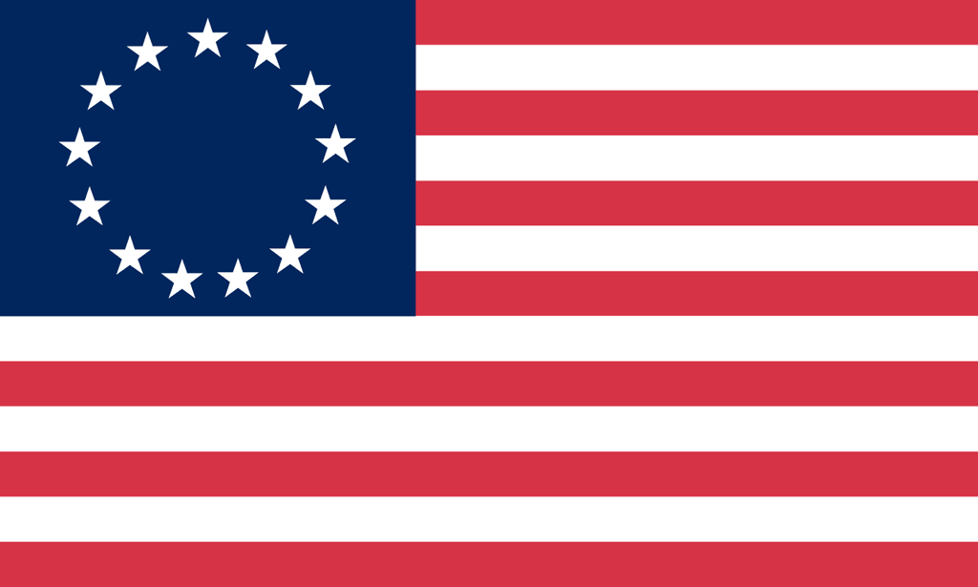U.S. History with Mr. Brown Name _______________________________ Period _____
Early English Colonies Ch 3 Book Preview
Directions: Find the answers to the following questions in Chapter 1 and record your answers in the space provided. Pages 66-

1) In what year was the Jamestown Settlement established?

2) What year did the Pilgrims land at Plymouth?

3) After defeating ___________________________________ in 1588, the English began directing their resources toward establishing colonies in the New World.

4) What year was Jamestown Founded?

5) Why did John Rolfe marry Pocahontas?

6) What event triggered the end of Bacon’s Rebellion?

7) What did the Pilgrim men vow in the Mayflower Compact?

8) What type of governmental idea was expanded by the Fundamental Orders of Connecticut?

9) 20 colonists were found guilty and executed during the Salem Witch Trials. How were those twenty put to death?

10) What were the 4 Middle Colonies AND what year was each founded?

11) Why do the English want the Dutch out of New Netherlands?

12) How did William Penn the Quaker end up founding Pennsylvania in the New World?

13) What influenced the Quakers to develop their belief that all people should live together in peace and harmony?

14) Who established the colony of Maryland AND WHY?

15) Were the Carolina colonies settled for religious or economic reasons?

