RIVER FALLS CLASSIC #3
June 17-18, 2017
14AAA DIVISION

 | American League | Win | Loss | Tie | Total Points
A1 | River Falls
A2 | Mendota Heights
A3 | Foley
A4 | Lakeville North

 | National League | Win | Loss | Tie | Total Points
N1 | Brooklyn Park
N2 | Cottage Grove
N3 | Eden Prairie
N4 | Minneapolis

Pool Play

Saturday | Field | Team | Score | Team | Score
9:00 | Varsity Baseball | River Falls |  | Mendota Heights
11:15 | Varsity Baseball | Foley |  | Lakeville North
1:45 | Varsity Baseball | Mendota Heights |  | Foley
4:00 | Varsity Baseball | River Falls |  | Lakeville North
6:00 | Varsity Baseball | Mendota Heights |  | Lakeville North
Sunday
9:00 | Varsity  Baseball | Foley |  | River Falls

Saturday | Field | Team | Score | Team | Score
9:00 | JV Baseball | Cottage Grove |  | Brooklyn Park
11:15 | JV Baseball | Eden Prairie |  | Minneapolis
1:45 | JV Baseball | Cottage Grove |  | Eden Prairie
4:00 | JV Baseball | Brooklyn Park |  | Minneapolis
6:00 | JV Baseball | Cottage Grove |  | Minneapolis
Sunday
9:00 | JV  Baseball | Brooklyn Park |  | Eden Prairie

Championship Bracket

Sunday | Field | Team | Score | Team | Score
11:15 | Varsity  Baseball (Semi 1) | National #1  ___________ |  | American #2  ___________
1:30 | Varsity Baseball (Champion) | Winner (Semi 1)  ___________ |  | Winner (Semi 2)  ___________

Sunday | Field | Team | Score | Team | Score
11:15 | JV Baseball  (Semi 2) | American #1  ___________ |  | National #2  ___________
1:30 | JV Baseball  (3rd Place) | Loser (Semi 1)  ___________ |  | Loser (Semi 2)  ___________

2017 MBT Qualifier Rules Apply

Pool Play Time Limits (no limit for bracket play):
9U-12U: Time limit: 6 innings/1 hr 45 mins No new inning shall begin after 1 hr 45 mins 4 innings minimum required
13U-15U: Time limit: 7 innings/2 hours No new inning shall begin after 2 hours 5 innings minimum required

POOL PLAY TIE BREAKER METHODS:
1. Won-Loss-Tie Record
2. Head to head
3. Least number of runs allowed against tied teams
4. Run differential against tied teams (maximum plus or minus 10 run)
5. Least number of runs allowed in total pool play
6. Run differential in total pool play (maximum plus or minus 10 run)
7. Coin toss

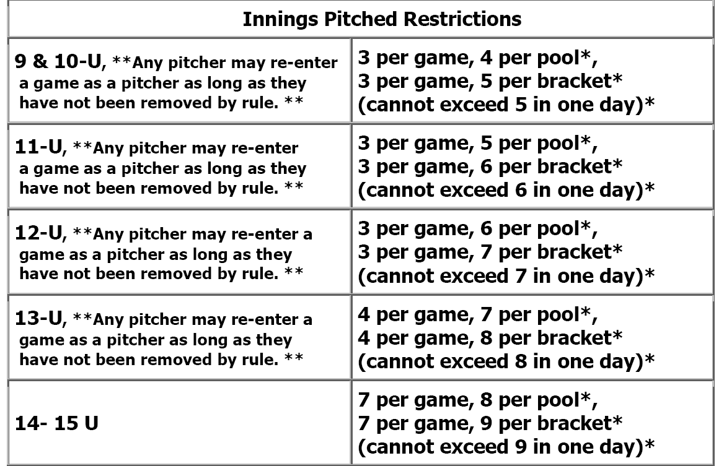

ALL GAMES AT RIVER FALLS HIGH SCHOOL
www.riverfallsyouthbaseball.org

