Does your house need to be painted?

Palm Beach County Residents may qualify to have the exterior of their house painted for free through the non-profit, Paint Your Heart Out Palm Beach County. There are no strings attached, only a few requirements. Proof of home ownership will be required if your home is selected for the program.

**Paint Your Heart Out Palm Beach County Program Guidelines/Information:**

* This is a ONE-TIME donation to Palm Beach County residents whose homes need to be painted, not just a color change.
* Palm Beach County applicants must meet one of the following criteria and fall within HUD Very Low-Income Guidelines:
  + 60 years old and above
  + Living with a disability
  + Single parent with young children
  + Veteran

**HUD Very Low-Income Guidelines:**

|  |  |
| --- | --- |
| **Number of People in Household** | **Maximum Income** |
| 1 | 37,500 |
| 2 | 42,850 |
| 3 | 48,200 |
| 4 | 53,550 |
| 5 | 57,850 |

* If the application is approved, an inspection will occur before painting. Minor scraping/repairs and brush/debris removal close to the house may be arranged. The resident may choose their paint colors – one color for the base and one color for the trim.
* Houses constructed of material other than aluminum siding and unpainted brick will be considered. Mobile, manufactured and modular homes **DO NOT** qualify for this program.

**To apply, complete and return ALL PAGES of this application. For more information, contact**

**561-697-2700, ext. 4701 or ext. 4717.**

**All personal information will be kept confidential.**

|  |  |
| --- | --- |
| **Date of Application:** Click or tap here to enter text. | |
| **Name of Homeowner(s):** Click or tap here to enter text. | |
| **Date(s) of Birth:** Click or tap here to enter text. | **Email Address:** Click or tap here to enter text. |
| **Address:** Click or tap here to enter text. | **City, State, Zip Code:** Click or tap here to enter text. |
| **Home Phone Number:** Click or tap here to enter text. | **Cell/Work Phone Number:** Click or tap here to enter text. |

**Others in the household:** (Use an additional sheet to list all people currently residing in the home.)

|  |  |  |
| --- | --- | --- |
| **Name** | **Date of Birth** | **Age** |
| Click or tap here to enter text. | Click or tap here to enter text. | Click or tap here to enter text. |
| Click or tap here to enter text. | Click or tap here to enter text. | Click or tap here to enter text. |
| Click or tap here to enter text. | Click or tap here to enter text. | Click or tap here to enter text. |
| Click or tap here to enter text. | Click or tap here to enter text. | Click or tap here to enter text. |

**Are you or anyone in your household disabled?** **Yes No**

**If yes, please describe who is disabled and the nature of the disability:** Click or tap here to enter text.

**Household Income**

|  |  |
| --- | --- |
| **Source of Income** | **Amount** |
| Employment | Click or tap here to enter text. |
| Social Security | Click or tap here to enter text. |
| SSI | Click or tap here to enter text. |
| Disability | Click or tap here to enter text. |
| Unemployment | Click or tap here to enter text. |
| Child Support | Click or tap here to enter text. |
| Other (please specify) | Click or tap here to enter text. |
| **Total Monthly Income** | Click or tap here to enter text. |

**My house is:**  **one story  wood frame  stucco  brick siding  Other** (please specify): Click or tap here to enter text.

**Do you currently own and occupy your home?  Yes  No**

**How many people living in your home can help paint?** Click or tap here to enter text.

**How did you hear about Paint Your Heart Out Palm Beach County?** Click or tap here to enter text.

**Are external repairs needed before painting? (homeowner’s responsibility):** Click or tap here to enter text.

I certify that I own and live in the home listed above and gave thorough and complete information to the best of my knowledge. I understand that if I sell my home or the condition of my home changes between the time of approval and the scheduled paint day, my home may be disqualified from the program. False or misleading information about ownership will result in the owner being responsible for all costs incurred for painting your home. (Signature(s) authorizes agents of PAINT YOUR HEART OUT PALM BEACH COUNTY to verify information on the application to be true and correct.)

**Signature(s)** Click or tap here to enter text.________________________ **Date:** Click or tap to enter a date.

**FOR OFFICE USE ONLY**

**Municipality:** Click or tap here to enter text.

**SWA Note #:** Click or tap here to enter text.

**Total Square Feet:** Click or tap here to enter text.

**Date Pressure Cleaned:** Click or tap to enter a date.

**Selected Colors:** Click or tap here to enter text.

**Qualifying Notes:** Click or tap here to enter text.

**Date scheduled/Group:** Click or tap to enter a date.

**Date Completed:** Click or tap here to enter text.

**Approved by:** Click or tap here to enter text.

**Date:** Click or tap to enter a date.

**Pressure Cleaning Agreement**

Each homeowner is responsible for ensuring the house is ready for painting by having it pressure-cleaned before the event. The Paint Your Heart Out Palm Beach County program provides all paint, supplies and volunteers. Please complete and return this form when the house has been pressure-cleaned. For questions or concerns, contact **561-697-2700 ext. 4701, or ext. 4717.**

**Name:** Click or tap here to enter text.

**Address:** Click or tap here to enter text.

**Telephone:** Click or tap here to enter text.

**I agree to have my home pressure cleaned before painting and do not need assistance.**

**I may need assistance with having my home pressure cleaned.**

**\*Please note that assistance is not guaranteed, and it may delay the painting schedule.**

**Signature:** Click or tap here to enter text. **__________________ Date:** Click or tap to enter a date.

**

**Community Services Recycled Paint Donation Application**

**Customer Info:**

**Name:** Click or tap here to enter text.

**Address:** Click or tap here to enter text.

**Phone Number:**

Click or tap here to enter text.

**E-mail address:** Click or tap here to enter text.

|  |  |  |  |
| --- | --- | --- | --- |
| **Color**  (Subject to availability) | **Base** | **Trim** | **Gallons (office use)** |
| Beach Beige |  |  |  |
| Autumn Brown |  |  |  |
| Cloud White |  |  |  |
| Sky Blue |  |  |  |
| Pebble Gray |  |  |  |
| **TOTAL GALLONS (OFFICE USE ONLY)** | Click or tap here to enter text. | Click or tap here to enter text. | Click or tap here to enter text. |

**Please complete and return to:**

**Solid Waste Authority of Palm Beach County**

Customer Information Services

7501 North Jog Road

West Palm Beach, FL 33412

**Phone:** 561-697-2700 ext. 4701 or 4717

**Toll Free:** 1-866-SWA-INFO (792-4636)

**Fax:** 561-640-3400

**\*Select ONLY two (2) colors:**

one (1) Base and one (1) Trim

**Mark an (X) by your color selections.**

**Recycled Paint Color Samples**

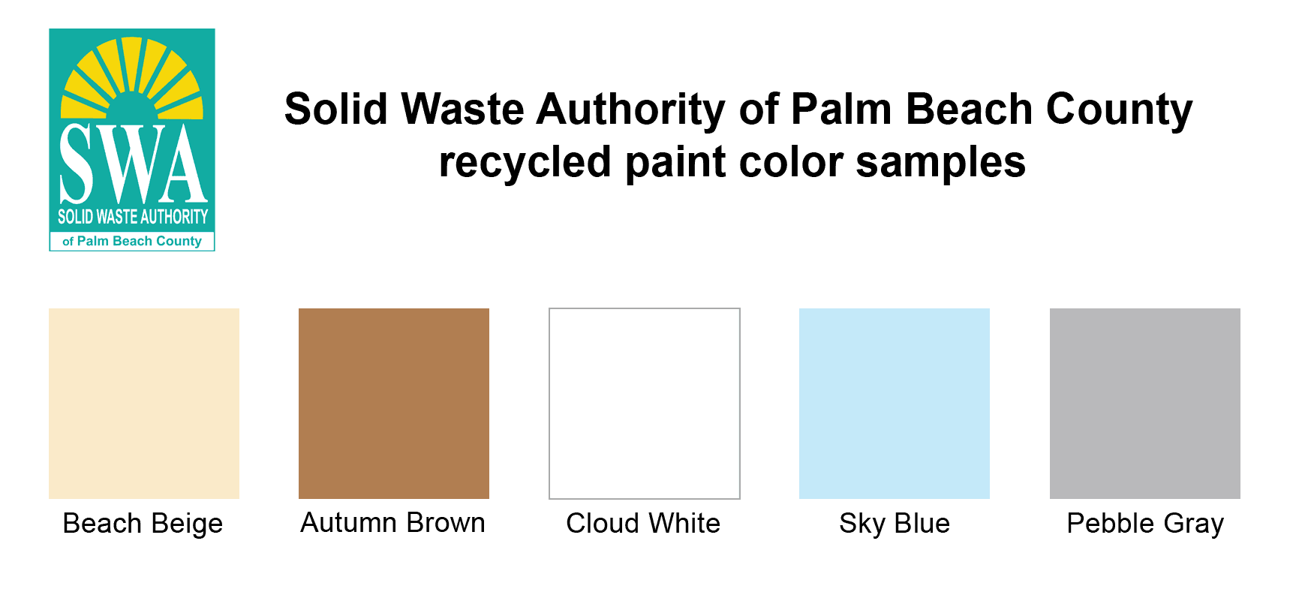

**\*Please note: The Recycled Paint is for EXTERIOR SINGLE-FAMILY HOMES ONLY and is not suitable for use in sprayers. All homes must be pressure washed before receiving a recycled paint donation. For non-profit organizations, a copy of the recipient’s IRS 501(c)(3) or other tax-exempt documentation must be provided at the time of application.**

Recipient agrees to protect, defend, indemnify, and hold harmless the SWA, its employees and representatives, from any and all claims and liabilities including all attorney’s fees and court costs, including appeals, for which the SWA, its employees and representatives, can or may be held liable as a result of injury (including death) to persons or damage to property occurring by reason of any wrongful acts or omissions of the Recipient, its employees or agents, in the performance of Services under this Agreement, of rising out of use of SWA Donated Recycled Paint. **Upon review and approval of the application, you will be notified when to pick up the requested paint order.**

**Signature:** Click or tap here to enter text. **____________________________ Date:**Click or tap to enter a date.

|  |  |  |
| --- | --- | --- |
| **(OFFICE USE ONLY)**  **Square Footage: SWA Note #:**  **Pressure Cleaned: Qualifying Notes:**  **Approved by: Date:** |  | **Attempts to Contact**  **1.**  **2.**  **3.** |
| **Pick up Date: _________________Time __________________ Vehicle Color/Type: __________________________________________________**  **Paint Received By: ____________________________________________________ Date:____________________________________________** | | |

**Acceptance Statement**

I understand that the painting of my home provided by Paint Your Heart Out Palm Beach County is being performed by a non-professional volunteer group. The workmanship will contain no guarantee of trained professional standards. Paint Your Heart Out Palm Beach County volunteers use care and precision to the best of their ability and try to avoid major spillage. In addition, since Paint Your Heart Out Palm Beach County is a non-profit organization, drop cloths are not provided for any of the painting events. By my signature below, I agree to accept this donation under the conditions stated.

**Homeowner:** Click or tap here to enter text.

**Address:** Click or tap here to enter text.

**Signature:** Click or tap here to enter text. **____________________ Date:** Click or tap to enter a date.

**Recycled Paint Color Samples**

