Meeting Pack
Please find in this document the regulations which the club has put in place specifically for meetings. It outlines both what we expect from you and what you can expect from us. We ask that you make sure all attendees of the meetings including speakers and organisers are made aware of the regulations we have put in place and adhere to them when on site. Thank you for helping us to keep both you and the Hough End staff safe.
- All attendees will need to sign into the building for track and trace. (Name, contact number or email and event attending) This will be done by staff on the door so that the club can keep a record of it for 1 month minimum so as to adhere to the track and trace regulations
- All attendees should be urged to contact the club should they be diagnosed with the Coronavirus within 1 week of visiting the club
- Attendees will be asked to sanitise their hands on entry to the club/room
- Unless you are setting up – please be advised that access to the room will only be available 10 minutes prior to the meeting start.
- Chairs and tables are set out in a specific way for social distancing and must not be moved
Anderton Suite
- Maximum 30 people including speakers/organisers
- Classroom style only to avoid any face to face to face work
- 2 metre distancing must be adhered to
- Tea/coffee is table service only. Where tea/coffee has been ordered, disposable cups, individually wrapped biscuits, sugar packets, milk sachets, disposable stirrers and individual water bottles will be placed at each table setting. This will enable fast and safe service of tea/coffee by staff and will enable safer disposal afterwards.
- The room will be fully sanitised straight after meeting
- The room will be fully sanitised before meeting
- Individual wooden tables will be used. Tables with cloths will only be provided if more tables than the requisite number of tables is required
- Participants must bring their own pens/paper/laptop
- Microphones will be sanitised between meetings
- Microphones must be used by speakers to avoid raised voices
- All projector cables will be wiped down between each meeting
- Staff doing table service will wear a face mask or visor and disposable gloves
- Candidates must bring their own drinks where tea/coffee has not been ordered
- Any cups must be put straight in the bin or left at the tables for the servers to dispose of. They must not be brought to the bar

John Berry Suite
- Maximum 10 people
- Classroom style only to avoid face to face working
- Individual wooden tables will be used. Tables with cloths will only be provided if more tables than the requisite number of tables is required
- Any equipment will be sanitised and wiped down between each meeting
- Tea/coffee is table service only. Where tea/coffee has been ordered, disposable cups, individually wrapped biscuits, sugar packets, milk sachets, disposable stirrers and individual water bottles will be placed at each table setting. This will enable fast and safe service of tea/coffee by staff and will enable safer disposal afterwards.
- Staff doing table service will wear a face mask or visor and disposable gloves
- Any cups must be put straight in the bin or left at the tables for the servers to dispose of. They must not be brought to the bar
- Canididates must bring their own drinks where tea/coffee has not been ordered
- Participants must bring their own pens/paper/laptop
- Door must be left open due to ventilation

The Club Regulations - General
- Sanitisers will be available at all entrances
- There is a 1 way system in place to try to avoid bottle neck situations and to avoid people squeezing past in doorways. (please see blue print below)
- Main entrance will be the entrance. The exit will be through the Lounge Bar fire door. This will only change in cases of the use of a wheelchair due to the width of the Lounge Fire door
- Toilets are maximum 1 person and there are new locks on the main toilet doors to use instead of the individual cubicle locks
- Posters are displayed throughout the club to remind people of hand sanitising, the 2 metre rule and that the club has regulations in place regarding Covid-19
- Anyone attending the club will be sent a copy or a list of the regulations relating to them in advance so that they understand what they can expect from us in regards to their safety and also what we expect from them in regards to both their safety and the safety of the Hough End Staff. A copy of the Policy, Risk Assessments and regulations are also available on our website.

Risk Assessments

Meetings

Candidates sat too close/not socially distancing or front facing seating on tables | Everyone | • Maximum numbers will be 30 people for the Anderton Suite and 10 people for the John Berry Suite  • Seating arrangements will be classroom style only so as to avoid front facing. Chairs distanced 2 metres apart
Inhalation of droplets from raised voices ie. From the speaker | Everyone | • Speakers must use the microphones to avoid raising their voices (Anderton Only. This should not be necessary in the John Berry Suite)  • Front row of candidates must be minimum 2 metres back from speaker due to front facing
Cross contamination from equipment (indirect transmission) | Everyone | • All surfaces to be sanitised before and after meetings including tables, wires, microphones, lectern  • Wooden tables to be used where possible (e.g. individual cabarets) so as to be able to sanitise better. Where a table with a cloth has to be used, the cloth must be washed and dried after each use.  • Candidates must bring their own laptop/pen/paper
Cross contamination from tea/coffee pots for beverage service | Everyone | • Tea/coffee is table service only. Where tea/coffee has been ordered, disposable cups, individually wrapped biscuits, sugar packets, milk sachets, disposable stirrers and individual water bottles will be placed at each table setting. This will enable fast and safe service of tea/coffee by staff and will enable safer disposal afterwards.  • Staff will wear gloves and face visors whilst serving and clearing up

The Club/General

Multiple use of door handles potentially causing indirect transmission | Everyone | • Doors to be propped open where possible to avoid hand traffic  • Sanitisers should be available at all entrances
Bottle neck situations at entrances causing difficulty in social distancing | Everyone | • One way system to be put in place—Main Entrance is to be entrance, Lounge fire door is to be exit.  • Signage/floor tape is to be put towards the entrance and around the building to help guide people and to help with distancing
Attendees not knowing the regulations in place when attending the club causing guidance to not be followed | Everyone | • Clear Signage up in the club about the regulations, including hand washing and disposal of rubbish  • Regulations to be sent out to meetings and functions in advance as well as being available on the website  • Regulations and policy to also be mentioned on the members newsletter  • Anyone attending the club that is deemed to not be following the guidelines and regulations put in place even after asking, will be asked to leave the premises

Persons showing symptoms of Covid-19 after attending the club | Everyone | • Club must be shut down for a minimum of 7 days  • It is advised that staff get tested for Covid-19 if showing symptoms  • Anyone attending the club, no matter how long for, must sign in for track and trace (name, contact number, email, reason for visit and time in)
Persons showing symptoms of Covid-19 before attending the club | Everyone | • Anyone showing signs of Covid-19 before they are due to attend the club are urged not to attend
Lack of Ventilation | Everyone | • Doors and windows where appropriate should be left open to allow air to circulate.  • Air con units can be put on where they circulate fresh air, however in the cases of the air con unit using recirculated air, it is advised that these be left off  • In the case of the John Berry Suite, this means that the main door must be left open as it is the only source of ventilation into the room

The Toilets

Lack of social distancing | Everyone | • Toilets are limited to 1 person at a time as demonstrated by signage on the doors  • Urinals in the mens toilets are to be taped off  • This also helps to avoid exposed splashes of body fluids  • Middle sinks are to be taped off
Lack of washing/sanitising facilities | Everyone | • Working sinks with hand soap available in all toilets  • Hand sanitiser available at entrance/exit to toilets  • Signage on proper washing technique on show next to sinks
Indirect transmission through multiple use of the doors leading into the toilets | Eveyone | • Doors to be kept propped open to avoid hand traffic on the doors

One Way System
- Grey areas are staff only areas
- Not to scale

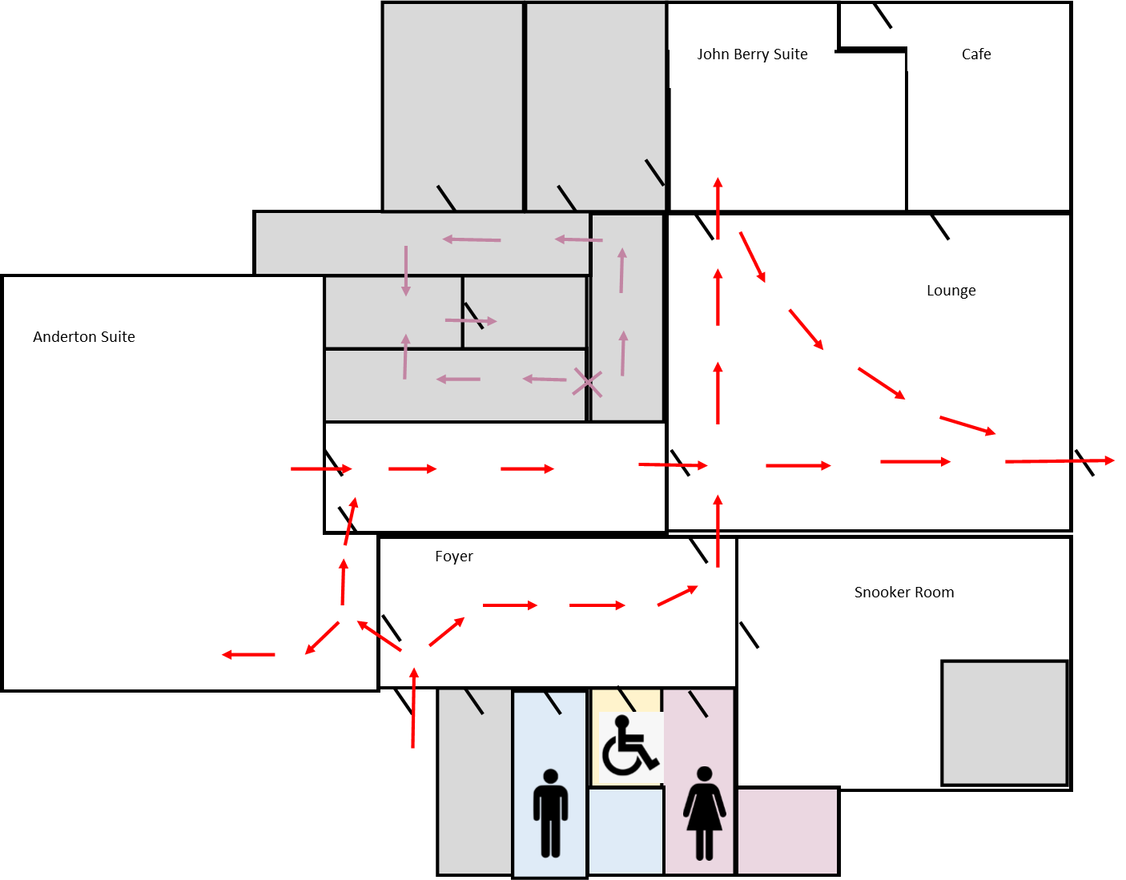
Exit
Entrance

