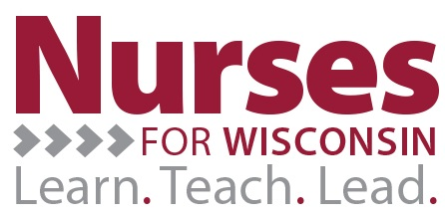
Proof of Payment Form
This Proof of Payment form should be completed and mailed to:
Grant Accountant
Nurses for Wisconsin Project
Schofield 102
105 Garfield Avenue
University of Wisconsin-Eau Claire
Eau Claire WI 54702-4004
within 30 days of all loan payments that were made to any institutions that are not associated with any UW-System Incentive Granting institutions. Accompanying the form should be sufficient statements and/or receipts outlining the payment that was applied to all approved loans associated with the Nurses for Wisconsin Program. If sufficient backup documentation is not included with the submission of the Proof of Payment Form, the Nurses for Wisconsin Program has full authority to request additional information related to the loan payments made, as well as withholding any future payments related to further loan payments. By signing below, you acknowledge that you have attached all necessary backup documentation and agree to the terms and conditions set within the Proof of Payment Form.

__________________________________ _____________________________
Participant Signature Date

__________________________________ _____________________________
Assigned Manager’s Signature Date

__________________________________ _____________________________
Institutional Financial Representative Date

