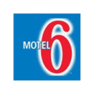
2281 Camp Jordan Pkwy.
East Ridge, TN 37412
Phone (423) 894-1417
Fax (423) 242-1257
Ask for The American Team Championships 2017 Special Rate
Room Type and Price
1 Queen Bed - $44.99
2 Queen Beds - $49.99
2 Full Beds - $59.99 (Each Additional Person $5.00 Maximum 3 people per room)
Free Parking Complimentary High-Speed Internet
Rates do not include tax of 17.25%

