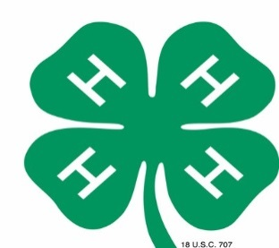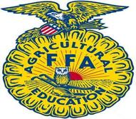
4H &FFA AGRICULTURE EXHIBITS
“OUR YEAR IN REVIEW”

Each group entry should be based on your “Year in Review” as a group.
Field trips, educational aspects, fundraisers, etc. that you as a group participated in and/or learned about.
Tell us about your year… We want to know ALL about it

Rules:
- Entries may be submitted by 4H & FFA groups ONLY.
- Entries will be judged and awarded Ribbons and Cash Prizes.
- Placing/Awards will be awarded as follows:
1st Place – Blue Ribbon & $100.00 Cash Reward
2nd Place – Red Ribbon & $50.00 Cash Reward
3rd Place – White Ribbon & $25.00 Cash Reward
- The decision of the judges will be final
- A 4’x6’ space with electricity WILL be available
- Registration forms must be turned into Penny Buckles or Michelle Jankowski by March 31, 2017. You can email to flaglerctyfair@bellsouth.net or mcjankows@aol.com
- All exhibits will be on display at the fairgrounds during the upcoming Flagler County Fair & Youth Show
- Entrants shall assume all liability for table decorations placed on exhibits. The Flagler County Fair and its staff are not responsible for any damage or loss.

Judging Criteria: TOTAL POINTS = 100 POINTS
Educational Value
- Is the central theme of exhibit worthwhile, distinctive, significant and appropriate…20
- Does the story told around the central theme have unity, that is does each article, object, specimen and label contribute to the amplification of the central theme…25
- Is the booth free from error of thought – grammar, spelling, object use, label use, assumptions intended, figure of speech, etc…20
Power to Attract Attention & Hold Interest
- Exhibit presents an original, unusual or striking method of display…20
- Is the general appearance of the booth attractive, including background, good arrangement of objects, scale and balance, appearance of labels…15

Important Dates & Deadlines:
- April 2nd 2017 (12pm-4pm) & April 3rd 2017 (9am-7pm) – Groups will be allowed to set their exhibits up
- April 4th 2017 - Judging
- April 10th 2017 – Take down exhibits (between 1pm-6pm)

Contacts for this Competition:
Penny Buckles – Fair Manager (386) 931-6597
Michelle Jankowski – Home & Family Division Fair Superintendent (386) 931-0911
Email: flaglerctyfair@bellsouth.net or mcjankows@aol.com Website: www.flaglercountyfair.com

2016-2017 Flagler County Fair & Youth Show, Inc.

4H AND FFA AGRICULTURE EXHIBIT REGISTRATION FORM
“Our Year In Review”

Exhibitor’s Name/Group Name _____________________________________________

Mailing Address _________________________________________________________

City & Zip Code ________________________________Telephone # ______________

Email Address:_________________________________________________________

Check One: 4-H______ FFA______

What will be showcased in your exhibit?_____________________________________
_______________________________________________________________________

4H or FFA Leader Signature________________________________________________

