THIS IS AN OPTIONAL – BONUS – ASSIGNMENT
PRINT AND COMPLETE IN INK.

Name:_______________________________________ Class Period:____ Due Date:___/____/____
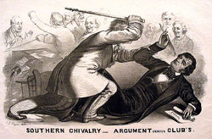
Guided Reading & Analysis: The Union in Peril, 1848-1861

Chapter 13- Sectionalism Propelling the Nation into Civil War pp 247-261

Reading Assignment:
Ch. 13 AMSCO other source covering Period 5.

Purpose:
This guide is not only a place to record notes as you read, but also to provide a place and structure for reflections and analysis using your noggin (thinking skills) with new knowledge gained from the reading. Mastery of the course and AP exam await all who choose to process the information as they read/receive. This is an optional assignment. So… young Jedi… what is your choice? Do? Or do not? There is no try. (image from released College Board exam)

Directions:
- Pre-Read: Read the prompts/questions within this guide before you read the chapter.
- Skim: Flip through the chapter and note titles and subtitles. Look at images and read captions. Get a feel for the content you are about to read.
- Read/Analyze: Read the chapter. If you have your own copy of AMSCO, Highlight key events and people as you read. Remember, the goal is not
to “fish” for a specific answer(s) to reading guide questions, but to consider questions in order to critically understand what you read!
- Write Write (do not type) your notes and analysis in the spaces provided. Complete it in INK!

Key Concepts FOR PERIOD 5:
Key Concept 5.1: The United States became more connected with the world, pursued an expansionist foreign policy in the Western Hemisphere, and emerged as the destination for many migrants from other countries.
Key Concept 5.2: Intensified by expansion and deepening regional divisions, debates over slavery and other economic, cultural, and political issues led the nation into civil war.
Key Concept 5.3: The Union victory in the Civil War and the contested reconstruction of the South settled the issues of slavery and secession, but left unresolved many questions about the power of the federal government and citizenship rights.

Section 1 Guided Reading, pp 247-260

- Intro: The Union in Peril, 1848-1861 page 247

Key Concepts &  Main Ideas | Notes
Intensified by expansion and deepening regional divisions, debates over slavery and other economic, cultural, and political issues led the nation into civil war. | Read the Abraham Lincoln quote and first paragraph of the chapter on page 247.  List and explain the four main reasons historians agree on that propelled the nation into civil war.  1)  2)  3)  4)  Which cause do you view as the most significant?

- Conflict Over Status of Territories pp 247-248
REMEMBER…As you read the chapter, jot down your notes in the middle column. Consider your notes to be elaborations on the Objectives and Main Ideas presented in the left column and in the subtitles of the text. INCLUDE IN YOUR NOTES ALL SIGNIFICANT VOCABULARY AND PEOPLE. After read and take notes, thoughtfully, analyze what you read by answering the questions in the right column. Remember this step is essential to your processing of information. Completing this guide thoughtfully will increase your retention as well as your comprehension!

Key Concepts & Main Ideas | Notes | Analysis
The institution of slavery and its attendant ideological debates, along with regional economic and demographic changes, territorial expansion in the 1840s and 1850s, and cultural differences between the North and the South, all intensified sectionalism. | Conflict Over Status of Territories…  Free-Soil Movement…  Southern Position…  Popular Sovereignty…  Election of 1848… | The Mexican-American War ended in 1848. What was the impact of the Mexican Cession on American politics?  How was the impact of the Mexican Cession in 1848 similar to the impact of the Louisiana Purchase in 1803? Make sure your answer includes specific evidence connecting the broad context of both events.

- The Compromise of 1850, pp 248-249 (this is a major event in the framework… make sure you thoroughly understand it!)

Key Concepts & Main Ideas | Notes | Analysis
Repeated attempts  at political compromise failed to calm tensions over slavery and often made sectional tensions worse, breaking down the trust between sectional leaders and culminating in the bitter election of 1860, followed by the secession of southern states.  National leaders made a variety of proposals to resolve the issue of slavery in the territories, including the Compromise of 1850… | The Compromise of 1850… | What was the most contentious aspect of this compromise? Explain and defend your answer.

Before the Compromise of 1850

This compromise took several months to hammer out. One of the most famous speeches regarded this crisis.

“Peaceable secession! Peaceable secession! The concurrent agreement of all the members of this great republic to separate! A voluntary separation, with alimony on one side and on the other. Why, what would be the result? Where is the line to be drawn? What States are to seceded? What is to remain American? What am I to be? An American no longer? Am I to become a sectional man, a local man, a separatist, with no country in common with the gentlemen who sit around me here, or who fill the other house of Congress? Heaven forbid! Where is the flag of the republic to remain? Where is the eagle still to tower? Or is he to cower, and shrink, and fall to the ground? Why, Sir, our ancestors, our fathers and our grandfathers, those of them that are yet living amongst us with prolonged lives, would rebuke and reproach us; and our children and our grandchildren would cry out shame upon us, if we of this generation should dishonor these ensigns of the power of the government and the harmony of that Union which is every day felt among us with so much joy and gratitude.”
Seventh of March Speech, Daniel Webster, 1850

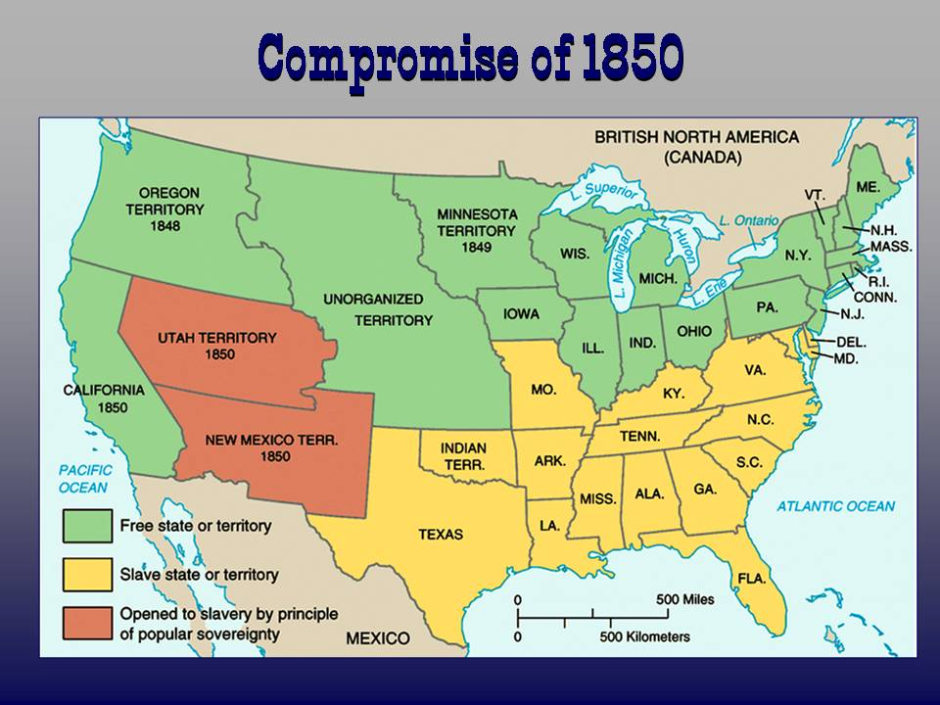
After the Compromise
- Agitation Over Slavery, pp 249-251

Key Concepts  & Main Ideas | Notes | Analysis
The institution of slavery and its attendant ideological debates, along with regional economic and demographic changes, territorial expansion in the 1840s and 1850s, and cultural differences between the North and the South, all intensified sectionalism.  The North’s expanding economy and its increasing reliance on a free-labor manufacturing economy contrasted with the South’s dependence on an economic system characterized by slave-based agriculture and slow population growth.  National leaders made a variety of proposals to resolve the issue of slavery in the territories, including the Compromise of 1850 and the Kansas–Nebraska Act.  Abolitionists, although a minority in the North, mounted a highly visible campaign against slavery, adopting strategies of resistance ranging from fierce arguments against the institution and assistance in helping slaves escape to willingness to use violence to achieve their goals.  States’ rights, nullification, and racist stereotyping provided the foundation for the Southern defense of slavery as a positive good. | Agitation Over Slavery…  Fugitive Slave Law…  Enforcement and Opposition…  Underground Railroad…  Books on Slavery – Pro and Con  Uncle Tom’s Cabin…  Did you know… what an “Uncle Tom” is? Uncle Tom, the title character, was initially seen as a noble, long-suffering Christian slave. In more recent years, however, his name has become an epithet directed towards African-Americans who are accused of ‘selling out’ to whites. Stowe intended Tom to be a "noble hero and praiseworthy person.” Throughout the book, far from allowing himself to be exploited, Tom stands up for his beliefs and is grudgingly admired even by his enemies.  Impending Crisis of the South…  Comparing the Free and Slave States in the 1850s (Chart)…  Southern Reaction…  Effect of Law and Literature… | Explain how abolitionists impacted state institutions and American culture.  Explain how the arts impacted movements for social and political change in the Antebellum Era.  Horace Greely(an abolitionist who also started the New York Tribune; a very influential newspaper) distributed Impending Crisis of the South across the South in an effort to increase southern white support for abolition. Why would an abolitionist embrace this book?

- National Parties in Crisis and Extremists and Violence, pp 252-255
KANSAS – NEBRASKA!!! KNOW IT WELL!!!

Key Concepts & Main Ideas | Notes | Analysis
Intensified by expansion and deepening regional divisions, debates over slavery and other economic, cultural, and political issues led the nation into civil war.  National leaders made a variety of proposals to resolve the issue of slavery in the territories, including the Compromise of 1850 and the Kansas–Nebraska Act.  The second party system ended when the issues of slavery and anti-immigrant nativism weakened loyalties to the two major parties and fostered the emergence of sectional parties, most notably the Republican Party in the North and the Midwest. | National Parties in Crisis…  The Election of 1852…  The Kansas-Nebraska Act (1854)…  Extremists and Violence…  “Bleeding Kansas”…  Canning of Senator Sumner…  New Parties…  Know-Nothing Party… | Compare and contrast the Kansas Nebraska Act of 1854 to the Missouri Compromise of 1820. Identify a minimum of 2 similarities and 2 differences.  Similarities:  1.  2.  Differences:  1.  2.  Which one was more successful? Explain your reasoning.  If the canning of Sumner occurred in modern times, how might the outcome be different? What is the difference in Antebellum America and modern America that paints such a different picture?
National Parties in Crisis and Extremists and Violence Continued…
Key Concepts & Main Ideas | Notes | Analysis
The second party system ended when the issues of slavery and anti-immigrant nativism weakened loyalties to the two major parties and fostered the emergence of sectional parties, most notably the Republican Party in the North and the Midwest. | Birth of the Republican Party…  The Election 1856… | Compare the impact of nativism to the impact of slavery on the American political system from 1848-1860.

- Constitutional Issues, pp 255-257… KNOW DRED SCOTT!

Key Concepts & Main Ideas | Notes | Analysis
National leaders made a variety of proposals to resolve the issue of slavery in the territories, including the Compromise of 1850, the Kansas–Nebraska Act, and the Dred Scott decision, but these ultimately failed to reduce sectional conflict. | Constitutional Issues…  Lecompton Constitution…  Dred Scott v. Sandford (1857)…  Lincoln-Douglas Debates… | Support or refute the assertion that the Dred Scott case was the worst Supreme Court ruling in American history. Defend your answer.  Which event was a more significant turning point, The Marshall Court’s 1803 Marbury v. Madison ruling or the Taney Court’s 1857 Dred Scott v. Sandford ruling? Defend your view.

- The Road to Secession, pp 257-260

Key Concepts & Main Ideas | Notes | Analysis
The institution of slavery and its attendant ideological debates, along with regional economic and demographic changes, territorial expansion in the 1840s and 1850s, and cultural differences between the North and the South, all intensified sectionalism.  Abolitionists, although a minority in the North, mounted a highly visible campaign against slavery, adopting strategies of resistance ranging from fierce arguments against the institution and assistance in helping slaves escape to willingness to use violence to achieve their goals.  The second party system ended when the issues of slavery and anti-immigrant nativism weakened loyalties to the two major parties and fostered the emergence of sectional parties, most notably the Republican Party in the North and the Midwest. | The Road to Secession…  John Brown’s Raid at Harper’s Ferry…  The Election of 1860…  Breakup of the Democratic Party…  Republican Nomination of Lincoln…  A Fourth Political party…  Election Results…  Secession of the Deep South… | Support or refute the assertion that John Brown was a martyr.  Compare the issues and results of the 1860 presidential election to those of the 1852 election.  In what ways were the rationales of secession following the election of Abraham Lincoln in 1860 similar to the rationales of the South Carolina Exposition and Protest and Ordinance of Nullification during the Jackson Era?

The Road to Secession continued
Key Concepts & Main Ideas | Notes | Analysis
Repeated attempts at political compromise failed to calm tensions over slavery and often made sectional tensions worse, breaking down the trust between sectional leaders and culminating in the bitter election of 1860, followed by the secession of southern states  Lincoln’s election on a free soil platform in the election of 1860 led various Southern leaders to conclude that their states must secede from the Union, precipitating civil war. | Crittenden Compromise… | Compare and Contrast the Crittenden Compromise and the Wilmot Proviso. Explain the significance of this comparison.

- Historical Perspectives: What Caused the Civil War? pp 260-261

Civil War was caused by slavery… | Civil War was caused by conflicting interpretations of the Constitution… | Civil War was caused by opposing economic systems… | Civil War was caused by a failure of compromise…

Which viewpoint do you agree with most? Explain your choice.

How it all broke down… literally… a brief review…
Coming Apart over… | Northern extremists (radical Republicans, some moderate Republicans, and radical abolitionists) | Moderates (Northern “Peace” Democrats, pro-Union Southerners, Some moderate Republicans) | Southern extremists and sympathizers (including Northern copperheads)
Slavery is… | A wicked sin that must be abolished at once, before Christ’s return! | Maybe good, maybe bad, but definitely not worth getting killed over… | An inalienable right, sanctioned in the Bible and supported in the Constitution and an integral part of the Southern economy…
Possible remedies include… | Remedy? We said abolish it! And no, we won’t pay for a buyout! | The government could spend billions to buy out slave owners… maybe return slaves to Africa… or maybe just let the states solve the issue in their own time… | Meddling Yankees could mind their own (bleep) business.
Future expansion… | Cannot include any new slave states, period. | Should adhere to the original 36⁰ 30’ border laid out in 1820 | Should include slave states even if they are above 36⁰ 30’ if voters choose to have it.
Tariffs on imports… | Are critical to encourage industry by protecting against British dumping of surplus goods which will ruin the Northern economy. | Should probably be repealed or lowered to avoid provoking foreign counter-tariffs and southern rebellion | Are a Yankee industrialist plot to provoke foreign tariffs on cotton exports and ruin the Southern economy.
States’ rights… | Don’t include the right to secede (and we wont’ allow slavery to spread). | Allow slavery in new states if the people vote for it, but not secession. | Allow slavery in new states and allow secession.
Secession is… | Treason! | Tragedy! | A Second American Revolution!
Source: The Mental Floss History of the United States by Erik Sass

Which viewpoint do you agree with most? Does that make you a radical or a moderate?

Bonus for your Bonus:
Log into Skyward and take the brief quiz over “Compromises, Cop-Outs, and Confusion… Your Congress At Work.”

Reading Guide written by Rebecca Richardson, Allen High School
Sources include but are not limited to: 2015 edition of AMSCO’s United States History Preparing for the Advanced Placement Examination,
College Board Advanced Placement United States History Framework, and other sources as cited in document and collected/adapted over 20 years of teaching and collaborating..

