REGULAR MEETING
SEPTEMBR 23, 2015

A Regular Meeting of the Town Board of the Town of Hampton, County of Washington and the State of New York was held at the Town Hall, 2629 State Route 22A, Hampton, New York on the 23rd day of September, 2015.

PRESENT: David K. O’Brien------------Supervisor
Tamme Taran---------------Councilwoman
David Jensen-----------------Councilman
Donald Sady-----------------Councilman
Andrea Sweeney------------Councilwoman
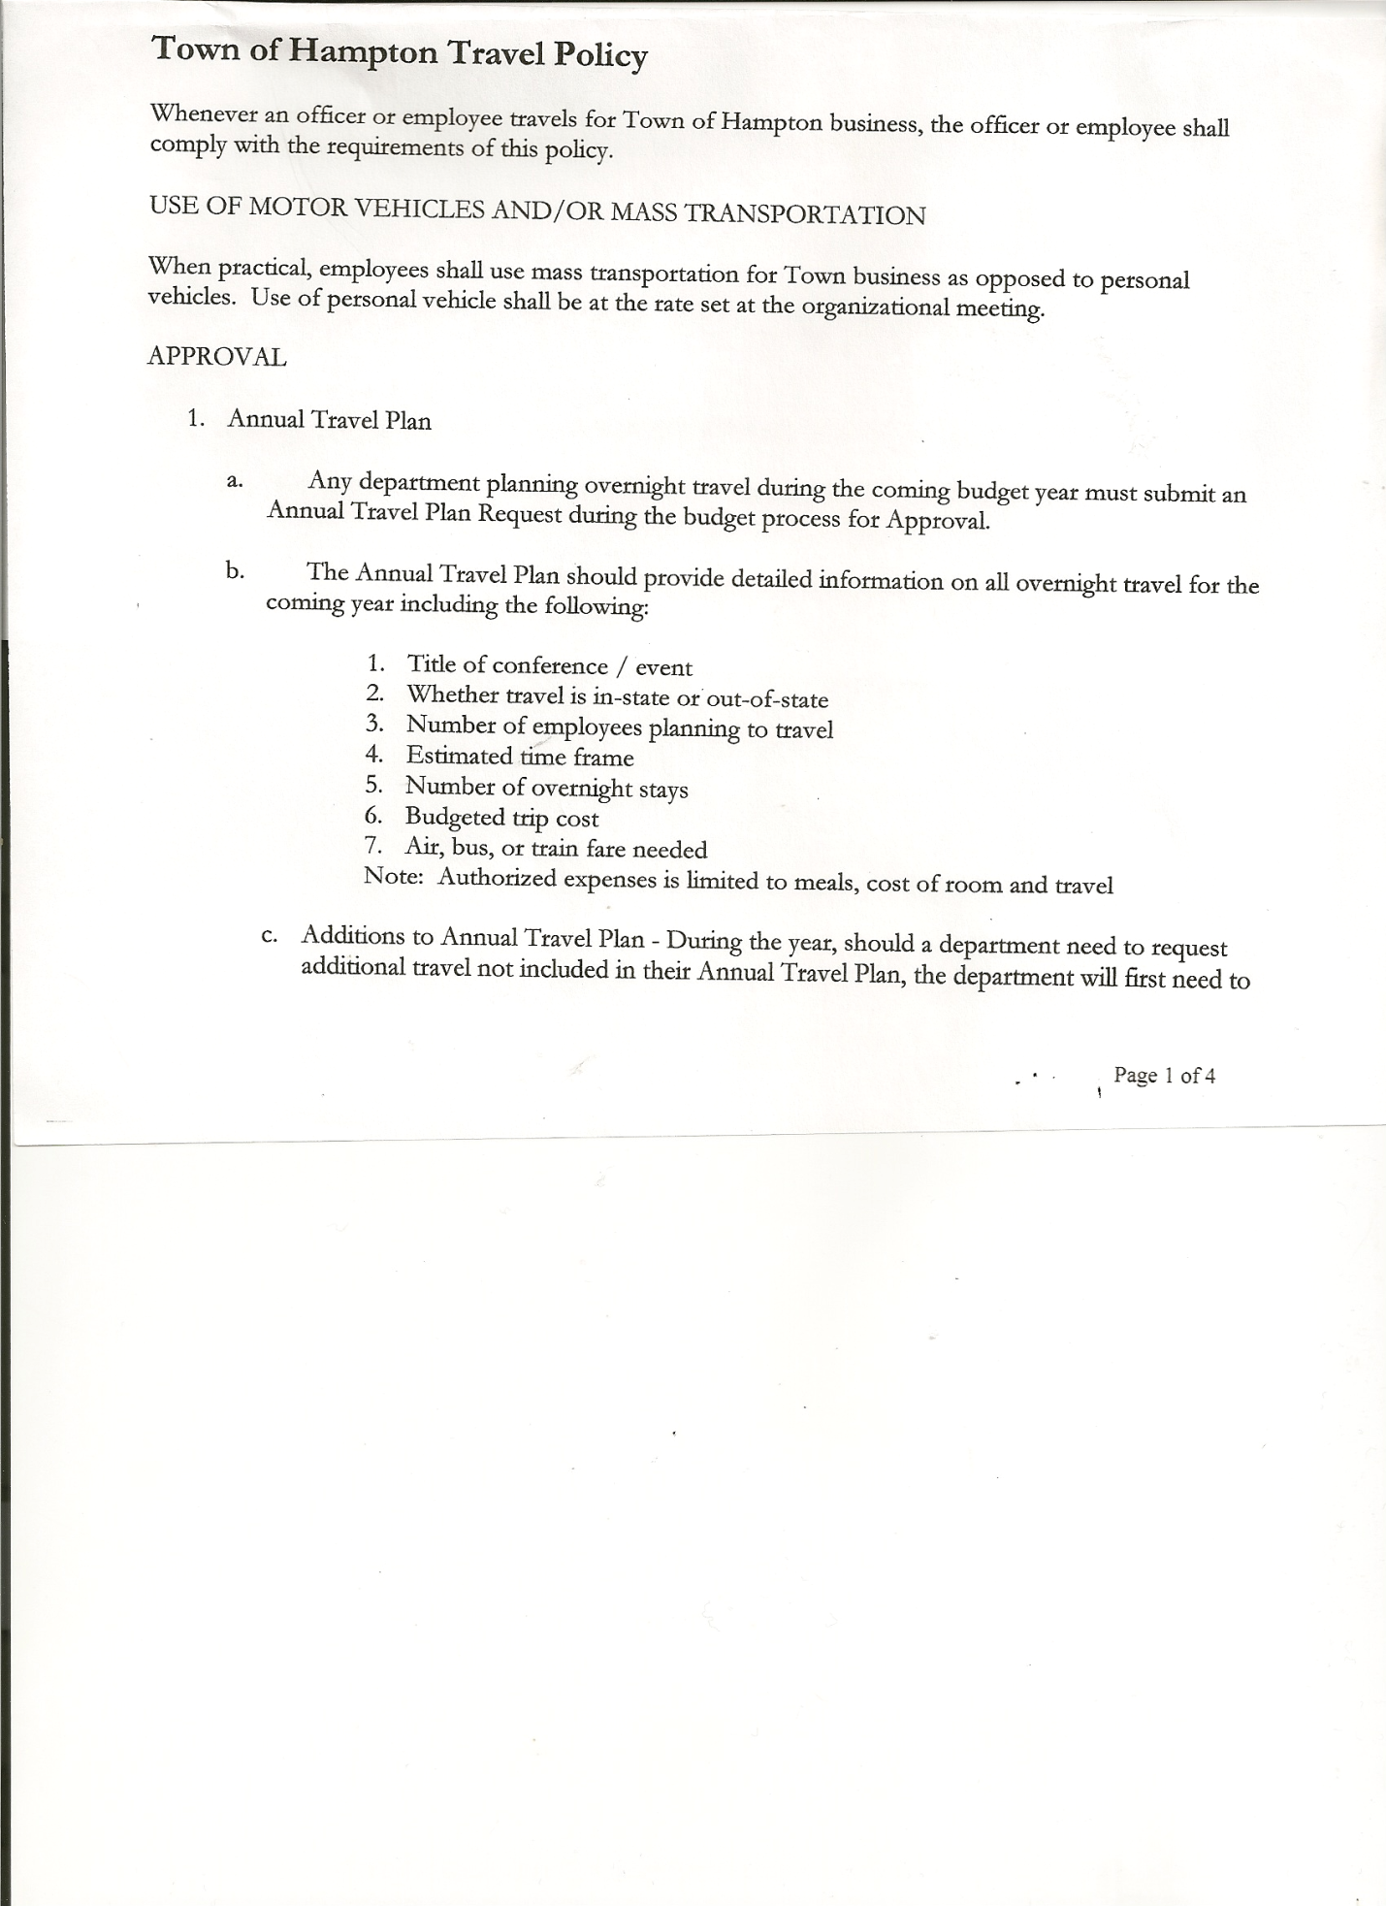
Rebecca Jones---------------Town Clerk
Camilla Shaw----------------Tax Collector/Deputy Town Clerk
Herbert Sady, Jr.-------------Highway Superintendent - absent

Planning Board Member(s): Bonnie Hawley, Chair

Also present: Artie Pratt, Doran Pratt, Sr., Matthew Pratt, Leonard Reed and Kim Perry, Bookkeeper came at 8:35pm

The meeting was called to order by Supervisor O’Brien at 7:30pm followed by the Pledge of Allegiance. Locations of Fire Exits were given.

Supervisor O’Brien asked for a moment of silence in memory of Norma Foote, resident of Douglas Way.

RESOLUTION NO. 54-2015
APPROVAL OF THE MINUTES
On a motion of Councilwoman Taran, seconded by Councilman Sady, the following resolution was ADOPTED: Ayes 5 O’Brien,Taran, Jensen, Sady, Sweeney
Nays 0
RESOLVED that the Regular Town Board Minutes for August 19th, 2015 are approved.

Camilla Shaw, Tax Collector submitted her report to the Town Board , she also had board members sign and date bank reconciliation statement dated August 31st, 2015.

Larry Carman, Dog Control Officer submitted his report, which was read by Supervisor O’Brien, copy of report is attached for 8/18/15-9/12/15.

Planning Board Report….Bonnie Hawley, Chair gave the report:
- Recommending Ed Connolly, Hills Pond Road as a Planning Board Member
- Still looking for another board member and alternate
- Discussed and introduced the proposed Mobile Home Parks Law

TOWN BOARD MEETING
SEPTEMBER 23, 2015 PAGE 2

RESOLUTION NO. 55-2015
MOTION BY: Councilman Donald Sady
SECONDED BY: Councilman David Jensen

TITLE: RESOLUTION INTRODUCING PROPOSED LOCAL LAW REGULATING MOBILE HOME PARKS IN THE TOWN OF HAMPTON

WHEREAS, to Section 64 of the Town Law of the State of New York and the Municipal Home Rule Law, the Town Board (the “Board”) of the Town of Hampton (the “Town”) has the
authority to adopt a local laws protecting the health, safety and welfare of the residents of the Town of Hampton; and

WHEREAS, the Board has been reviewing and discussing the possibility of adopting a local law regulating mobile home parks in the Town of Hampton and a local law has been drafted and prepared regarding the regulation of mobile home parks in the Town of Hampton; and

WHEREAS, the Board believes that it is in the best interests of the residents of the Town of Hampton to proceed with the review and holding of a public hearing with regard to the proposed local law;

WHEREAS, the Town Board wishes to hold a public hearing with regard to the proposed local law.

NOW, THEREFORE BE IT:

RESOLVED, that the Town Board hereby schedules a public hearing on the proposed local law regulating mobile home parks to be held at the Town Board’s meeting on October 21st, 2015 at 7:00 p.m.; and be it further

RESOLVED, that the Town Clerk publish notice of the public hearing in the official newspaper of the Town; and be it further

RESOLVED, that this resolution shall take effect immediately.

DATED: September 23, 2015 Supervisor O’Brien AYE
Councilwoman Taran AYE
Councilman Jensen AYE
Councilman Sady AYE
Councilman Sweeney AYE

TOWN BOARD MEETING
SEPTEMBER 23, 2015 PAGE 3

RESOLUTION NO. 56-2015
PUBLIC HEARING ON PROPOSED LOCAL LAW 1OF 2015
On a motion of Councilwoman Taran, seconded by Councilman Sady, the following resolution was ADOPTED: Ayes 5 O’Brien,Taran, Jensen, Sady, Sweeney
Nays 0
RESOLVED, to set a Public Hearing on proposed Local Law 1 of 2015 Regulating Mobile Home Parks in the Town of Hampton, for October 21st, 2015 at 7:00pm.

RESOLUTION NO. 57-2015
APPOINT PLANNING BOARD MEMBER
On a motion of Councilman Sady, seconded by Councilwoman Taran, the following resolution was ADOPTED: Ayes 5 O’Brien,Taran, Jensen, Sady, Sweeney
Nays 0
RESOLVED, to appoint Edward Connolly to the Planning Board.

Herbert Sady, Jr., Highway Superintendent submitted his report, which was read by Supervisor O’Brien (a copy is attached).

RESOLUTION NO. 58-2015
MOWING CONTRACT
On a motion of Councilwoman Taran, seconded by Councilman Sady, the following resolution was ADOPTED: Ayes 5 O’Brien,Taran, Jensen, Sady, Sweeney
Nays 0
RESOLVED, that Herbert Sady, Jr., Highway Superintendent, be authorized to sign the Washington County Mowing Contract for 2015.

County Updates/Communications
Letter from NYS Department of Public Service regarding the State of Telecommunications in New York State.
Letter from Meyer & Fuller with renewal rates for 2016
Letter from Washington County Real Property Tax Services regarding reappointing Board of Assessment Review member Leonard Reed.

RESOLUTION NO. 59-2015
BOARD OF ASSESSMENT REVIEW
On a motion of Councilman Sady, seconded by Councilwoman Sweeney, the following resolution was ADOPTED: Ayes 5 O’Brien,Taran, Jensen, Sady, Sweeney
Nays 0
RESOLVED, to reappoint Leonard Reed to the Board of Assessment Review for the term 10/1/15 to 9/30/20.

NEW BUSINESS
2016 Sales Tax Distribution Worksheet, Hampton should receive $20,086.55 for 2016.
Washington County-Workers’ Compensation Assessment…$1335.00 for 2016 compared to $2045 for 2015, down $710.00.
Health Insurance renewal rates

TOWN BOARD MEETING
SEPTEMBER 23, 2015 PAGE 4

RESOLUTION NO. 60-2015
APPROVAL OF SUPERVISOR’S MONTHLY REPORT
On a motion of Councilman Sady, seconded by Councilwoman Sweeney, the following resolution was ADOPTED : Ayes 4 O’Brien, Taran, Jensen, Sady, Sweeney
Nays 0
RESOLVED that the Supervisor’s Monthly report be accepted as submitted for AUGUST 2015
7/31/15 8/31/15
ACCOUNT BALANCE RECEIPTS DISBURSEMENTS BALANCE
General Fund $ 72818.86 $ 925.18 $ 6371.80 $ 67372.24
Highway Fund $ 59272.70 $ 2.46 $ 11301.91 $ 47973.25
Equipment Reserve $ 100187.71 $ 4.25 $ 0.00 $100191.96
Fire #1 $ 17014.79 $ .82 $ 0.00 $ 17015.61
Fire #2 $ 2377.00 $ 0.00 $ 0.00 $ 2377.00
Totals $ 251671.06 $ 932.71 $ 17673.71 $234930.06

All Board Members present signed Supervisor’s Report.

The Town Clerk’s report for August 2015 was submitted to the Board. The Town Clerk had Board Members review and sign bank reconciliation statements for the Town Clerk Account and Special Town Clerk Account dated August 31st, 2015.

RESOLUTION NO. 61-2015
HEALTH INSURANCE RENEWAL
On a motion of Councilwoman Taran, seconded by Councilman Sady, the following resolution was ADOPTED : Ayes 4 O’Brien, Taran, Jensen, Sady, Sweeney
Nays 0
RESOLVED, to have CDPHP Plan EPO-203-Gold as health insurance plan for 2016 for employees.

RESOLUTION NO. 62-2015

AUDIT OF CLAIMS
On a motion of Councilwoman Taran, seconded by Councilman Sady the following resolution was ADOPTED Ayes 5 O’Brien, Taran, Jensen, Sady, Sweeney
Nays 0
RESOLVED that the bills have been reviewed by the Town Board and are authorized for payment in the following amounts.
General Fund No. 116 through No. 125 $ 1021.62
Highway Fund No. 88 through No. 93 $ 1694.49
Total both funds $ 2716.11

The Tentative Budget for 2016 was presented to the Town Board.

TOWN BOARD MEETING
SEPTEMBER 23, 2015 PAGE 5

RESOLUTION NO. 63-2015
BUDGET WORKSHOP
On a motion of Councilman Sady, seconded by Councilwoman Taran the following resolution was ADOPTED Ayes 5 O’Brien, Taran, Jensen, Sady, Sweeney
Nays 0
RESOLVED, to set a Special Budget Workshop Meeting to be held on Monday, October 5, 2015 at 7:00pm

RESOLUTION NO. 64-2015
PUBLIC HEARING ON PRELIMINARY BUDGET FOR 2016
On a motion of Councilman Sady, seconded by Councilman Jensen the following resolution was ADOPTED Ayes 5 O’Brien, Taran, Jensen, Sady, Sweeney
Nays 0
RESOLVED, to set the Public Hearing on the Preliminary Budget for 2016 for October 21, 2015 at 7:15pm

On a motion of Councilman Sady, seconded by Councilwoman Sweeney, the meeting adjourned at 8:56pm. All in favor Aye.

Respectfully submitted,

Rebecca S. Jones, RMC
Town Clerk

