CONTINUATION OF ANNUAL TOWN MEETING
September 13, 2016
Aurora, MN

IN ATTENDANCE: (13) Jon Skelton, Craig Anttila, Mike Patchin, Jodi Knaus, Emma Shuck, Greg Hinsz, Lorna Kallio, Bob Kallio, Betty Stende, Matt Reid, Roger Belange, Judith Belange, Steve Giorgi;

- The 2016 Continuation of the Annual Town Meeting of the Town of White was called to order by Jon Skelton on Tuesday, September 13, 2016, at 6:00 P.M., at the Loon Lake Community Center.
- Pledge of Allegiance
- Jon Skelton called for Nominations for Moderator
IT WAS MOVED BY KNAUS, SUPPORTED BY ANTTILA TO NOMINATE JON SKELTON AS MODERATOR. NO OTHER NOMINATIONS. MOTION CARRIED
IT WAS MOVED BY KNAUS, SUPPORTED BY KALLIO THAT NOMINATIONS BE CLOSED. MOTION CARRIED

Jon Skelton took the chair as moderator.

4.) IT WAS MOVED BY ANTTILA, SUPPORTED BY ROGER BELANGE TO APPROVE & ADOPT THE AGENDA AS PRESENTED. MOTION CARRIED

5.) Moderator Skelton introduced Matt Reid from S.E.H. who presented on the Comprehensive Planning process for the Town of White. He distributed a handout outlining the process initiated by the East Range Joint Powers Board. The final Comprehensive Plan is necessary in order to receive grant funding through the IRRRB. A consultant has been hired to lead the process. The East Range will be viewed as a whole for economic development and opportunities and it is important to pull together collaboratively. This is being funded by the ERJPB/IRRRB and each entity will also pay a portion. The next open house will be October 12th. Community members are encouraged to attend and participate in the process. Information is available on the S.E.H. website including survey results.

6.) Moderator Skelton introduced Steve Giorgi, Director of RAMS who handed out brochures of the organization and gave a brief overview of the services to the communities that are members. The Township pays annual dues of $400.00 to the RAMS organization. RAMS has 46 entities in their membership and over 72,000 members.

7.) IT WAS MOVED BY HINSZ, SUPPORTED BY ANTTILA TO SUSPEND READING & APPROVE THE SEPTEMBER 2016 CONTINUATION OF THE ANNUAL MEETING MINTUES AS WRITTEN. MOTION CARRIED

8.) Moderator Skelton read the PowerPoint Presentation outlining the Clerk’s Report including Strategic Plan Outcomes and the 2016-17 Budget Discussion (included at end of minutes).

IT WAS MOVED BY HINSZ, SUPPORTED BY ANTTILA TO APPROVE $1,000.00 ANNUALLY TO THE EMPLOYEE RECOGNITION PROGRAM PER RESOLUTION 2015-005 ESTABLISHING THE EMPLOYEE RECOGNITION POLICY.
IT WAS MOVED BY ANTTILA, SUPPORTED BY HINSZ TO ACCEPT THE CLERK’S REPORT. MOTION CARRIED

9.) Levy Discussion was held.
IT WAS MOVED BY HINSZ, SUPPORTED BY ANTTILA TO APPROVE AN INCREASE IN THE LEVY BY 2% TO BE RECEIVED IN 2017. MOTION CARRIED

10.) Other Business

Skelton thanked the Public Work’s crew for doing such a fantastic job in emergency response from last week’s storm in Scenic Acres.

11.) IT WAS MOVED BY HINSZ, SUPPORTED BY ANTTILA TO KEEP THE 2016 CONTINUATION OF THE ANNUAL MEETING OPEN UNTIL THE TOWN ANNUAL MEETING ON TUESDAY, MARCH 14, 2017 AT 6:00 P.M. AT THE LOON LAKE COMMUNITY CENTER. MOTION CARRIED AT 7:14 P.M.

POWERPOINT PRESENTATION SLIDES ARE ATTACHED.

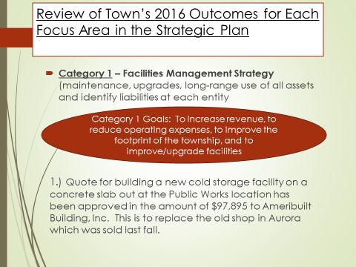

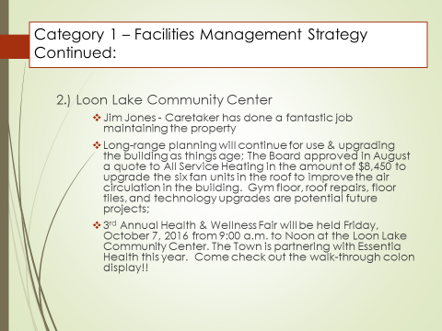

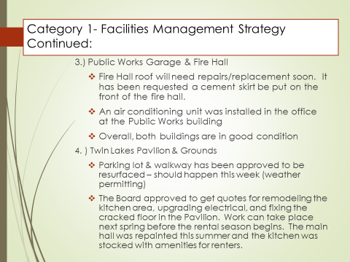

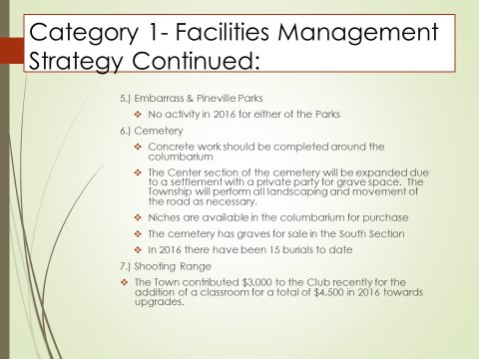

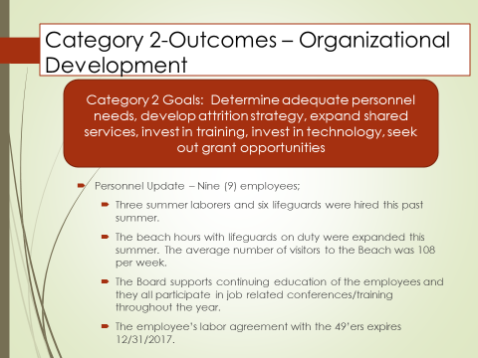

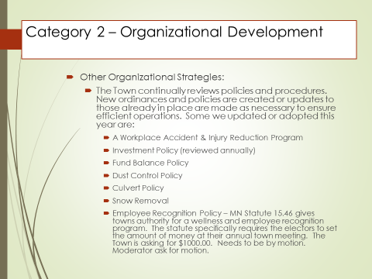

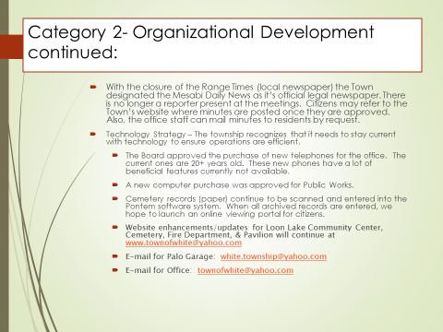

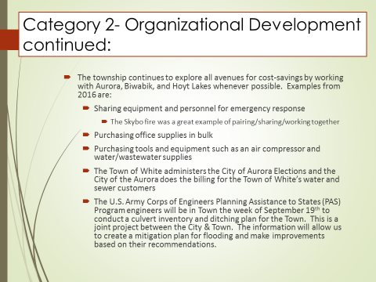

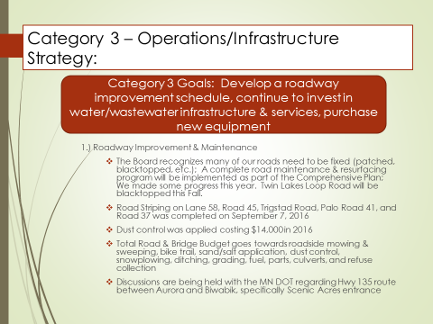

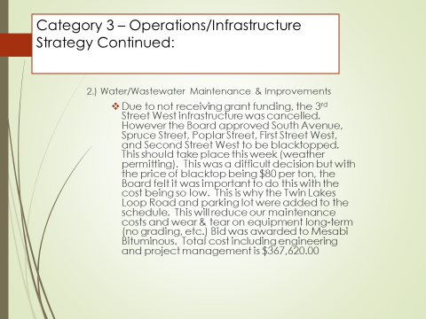

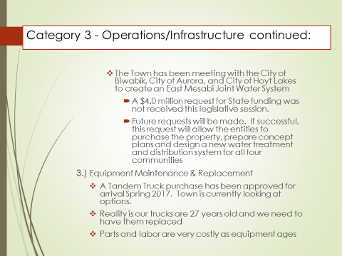

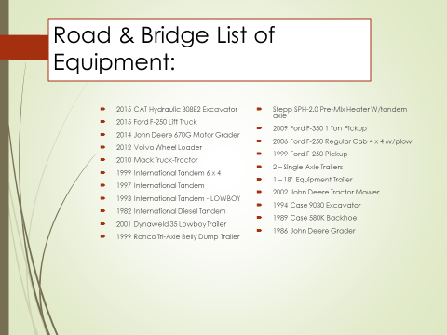

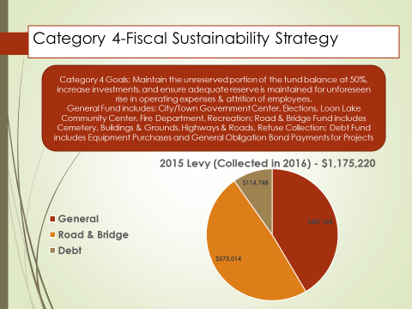

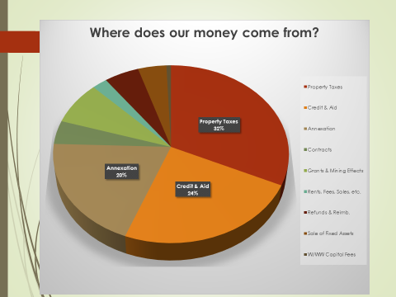

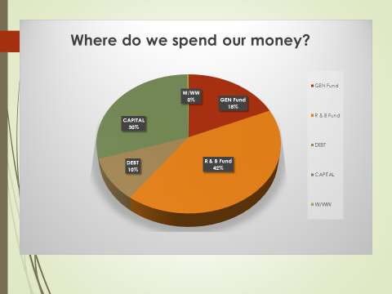

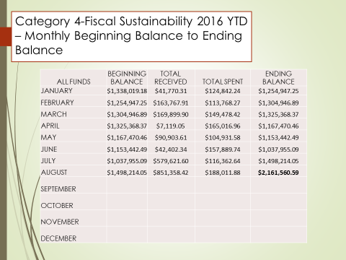

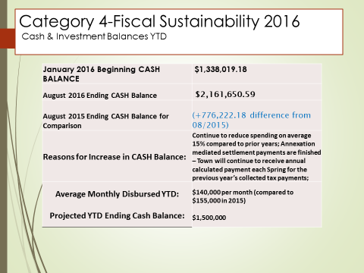

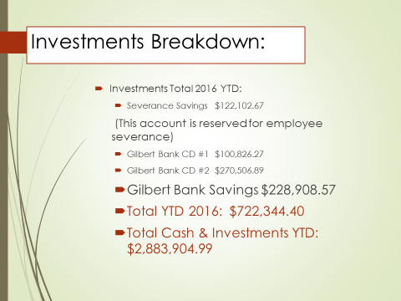

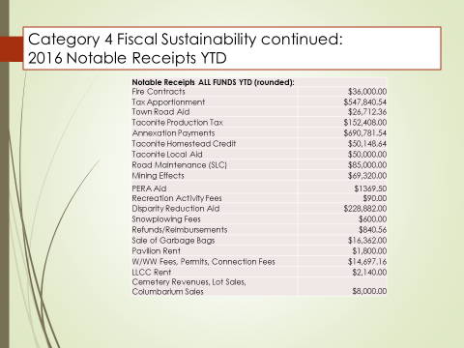

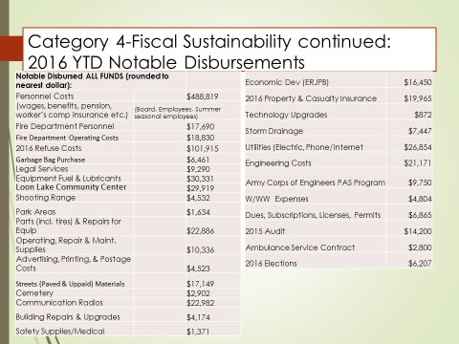

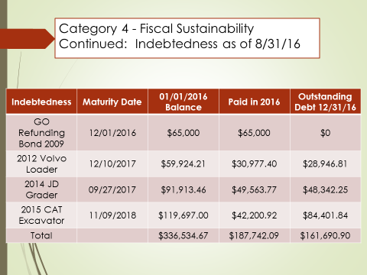

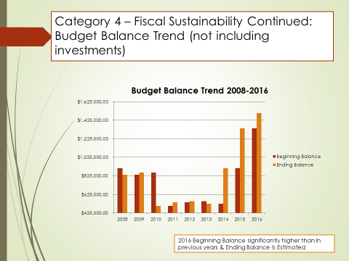

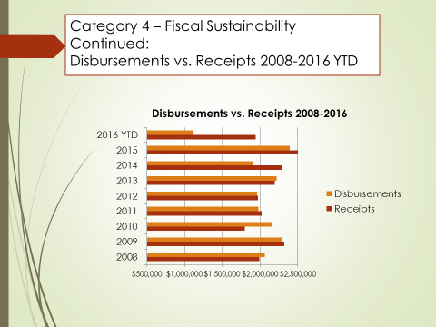

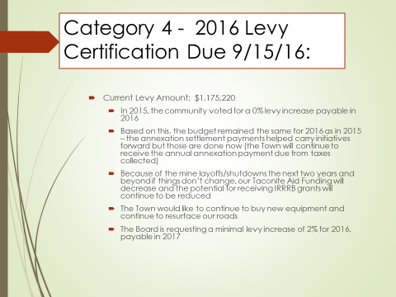

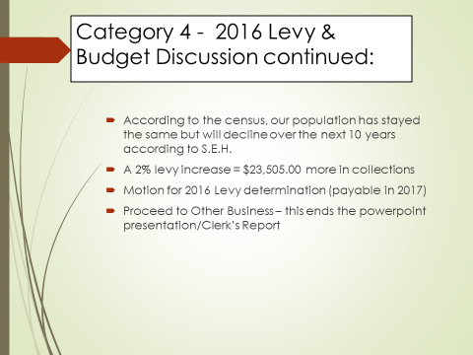

_____________________________________ _________________________________________
Jodi Knaus, Clerk Jon Skelton, Moderator

