RSAI Regional Meeting Minutes
RSAI NE District 3-year term expires Sept. 2021
Nick Trenkamp
RSAI SE District 3-year term expires Sept. 2020
RSAI SW District 3-year term expires Sept. 2019
RSAI NW District 3-year term expires Sept. 2020
One At-large position expires Sept 2019 (Dennis McClain, Clay Central Everly CSD)

Northeast Region

North Fayette Valley CSD
600 N Pine Street, West Union
June 23, 2019 – 2pm

Attendees:
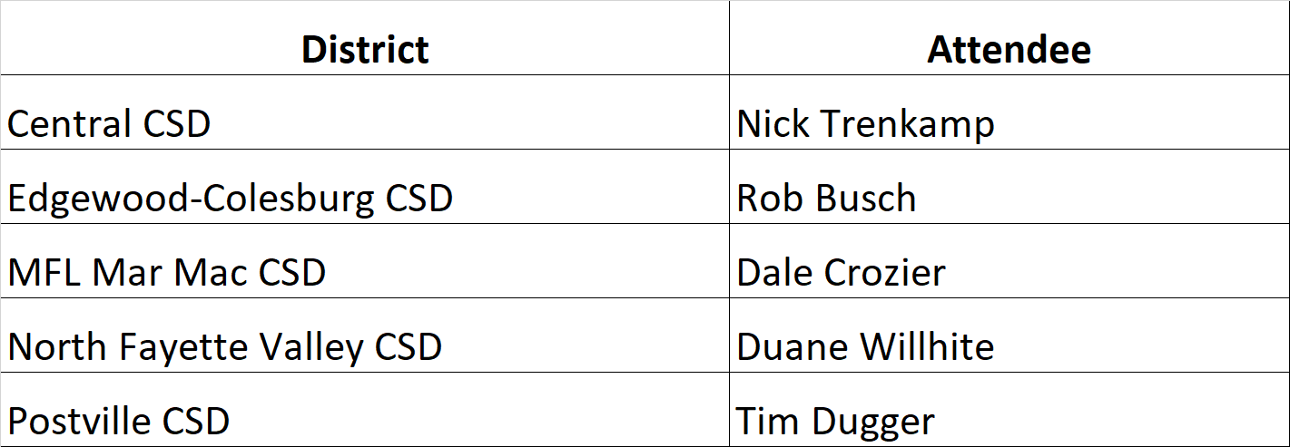
Nick Trenkamp, Central CSD, convened the meeting at 2:03 pm
- Approval of Agenda:
Rob Busch, Edgewood-Colesburg CSD, moved approval of the agenda. Tim Dugger, Postville CSD, seconded. The vote was unanimously approved.
- Election of RSAI District Representative to the Leadership Group. Terms are specified in bylaws. Ongoing office is a 3-year term. No election this year.
- Election of RSAI District Liaison representing District NE to the RSAI Legislative Group (Annual Election) Thanks to Darin Strike, Supt., West Fork for serving in 2018-19! Rep. attends Legislative Group meeting in Des Moines at ISFIS, Aug. 9, 2019, and supports legislative advocacy during the 2020 Session.
  - Nominations:
Barb Schwamman, Sup from Osage and Riceville was nominated by Duane Willhite.
Tim Dugger seconded the nomination.
No other nominations were made.
  - Election: The nomination was unanimously approved.
- Consideration of Proposed Amendments to RSAI Bylaws if any (Requires 2/3 majority) None were proposed.

- Review of the 2019 Legislative Session and Data Supporting Key Issues Critical to RSAI member districts: Margaret Buckton, ISFIS, reviewed the legislative action of the 2019 Session on RSAI priorities from pages 4-5 of the RSAI Legislative Digest and answered questions about RSAI Priorities and other legislative action.
- Establish RSAI District legislative priorities for the upcoming Iowa Legislative Session to forward to the RSAI Legislative Group. By consensus, the attendees discussed and recommended the following for the 2020 RSAI Legislative Priorities:
Remove the State Penny extension from the list
Remove the Sharing Incentives priority from the list. (However keep the sharing incentives information available for members to keep talking to legislators about the value and benefits of sharing so next time renewal is topical, everyone will be informed.)
Remove Transportation Equity from the list
Formula Equity should stay on the priority list. RSAI should advocate for an accelerated pace (more than $5 per student per year) Discussed outreach to districts above the average who can contact legislators about the property tax relief that happens when the state picks up more of that district cost per pupil.
Teacher Shortage and Quality Instruction: despite some small wins in this area, the group spent the most time talking about this issue. RSAI should support continued advancements in offer and teach opportunities (such as not needing to reapply for a waiver every year if you use online options or concurrent enrollment options). Consider additional ways to share teachers, grow your own programs and loan forgiveness options. Create a special education generalist credential that can serve K-12. Rural districts will continue to struggle since young teachers and other employees seek amenities that aren’t readily available in rural areas. Other positions such as bus drivers are also difficult to fill.
State Supplemental Assistance: The group agreed that funding has not been adequate but didn’t expect more than 2%, as the new normal. Continued emphasis on other investment must be considered. Politics – the “bramble bush of contradiction” that legislators say they support local control but would rather invest funds in specific categoricals and line-items rather than in SSA, which local districts control. Also discussed attempting to roll some of the categoricals into the state cost per pupil but after considering the original distribution formulas, decided this was not in the best interest of rural schools.
Student Mental Health: keep it on the list. A big issue and the new structure alone is not sufficient. Students need access to services. Supported the ability to connect students to mental health service virtually.
School Safety: take the reference to the state penny and technology and facilities off the list, but keep the item about staff and training costs on there.
Funding Equity for At-Risk Students: The group discussed the relationship between poverty and mental health. There was conversation about more students eligible for free and reduced price lunch, but some trepidation as to whether additional resources would make a difference given low-income parent resistance to any help from schools. Also mentioned that parents today do not want their kids to ever have to struggle, which creates some tough conversations with parents and likely contributes to more home school or open enrollment out of school districts. There was some discussion about addressing the inequity of the DoP cap (2.5 – 5.0 % based on old history no longer relevant). The group encouraged RSAI to engage with the athletic associations about considering factors of at-risk such as poverty in establishing the athletic conferences.
Quality Preschool: little conversation about this one, aside from the transportation costs in rural districts that make half day PK unaffordable.
New Ideas: Some discussion about rural economic development and making sure that investments in economic development deliver results. The three needs in rural communities are 1) high paying jobs 2) affordable housing and 3) day care/child care. Lack of economic development in rural areas is a problem for the survival of rural schools. Some concern in the group that, although the premise is correct, should rural economic development be a priority of rural school leaders? Is it outside of our jurisdiction or mission?
- Other business: the group discussed membership growth and outreach to other districts in the region that would benefit from RSAI membership. The group also discussed the growth in membership and the possibility of creating additional regions, which Buckton mentioned had been suggested by the member replying to an invitation to a regional meeting. The travel distance was simply too long. Adding regions would take a by-laws change, which could come up at the legislative group or leadership group meetings, or at the annual meeting in October. Trenkamp thanked Willhite and NFV for hosting the meeting.
- Adjourn: Tim Dugger, Postville CSD, motioned for adjournment, Rob Busch, Edgewood-Colesburg CSD, seconded. The vote was unanimously approved to adjourn at 3:48 pm.
Save the date: 2019 RSAI Annual Meeting
Oct. 16, 2019 4:30-7:30PM (includes working dinner)
FFA Enrichment Center (DMACC Campus)
1055 SW Prairie Trail Parkway, Ankeny, Iowa 50023
Conduct annual business, set Legislative Priorities, and plan for successful advocacy

