How is sponsorship money used?
- Advertising
- Shuttle buses
- Paying contracted services, such as: traffic control, trash collection, gate workers, children’s area tent workers, demonstrators, restroom attendants, entertainment and emergency medical staff.
Sponsorship Levels
Olde Time Sponsorships $1000
Log Cabin Sponsorship $1000
Shopping Bag Sponsorship $500
Prairie Sponsorship $750
Frontier Sponsorship $500
Pioneer Sponsorship $250
Homestead Sponsorship $100
Whenever possible school groups and local community groups are used for contracted services. Currently, the FFA, Soccer and Football teams, Tennis Boosters, Scout and Cheerleading groups and PTO organizations are used to make the festival happen.
The Levels
Olde Time Sponsor
-10 parking passes
-Festival announcement of Sponsors
-Marketing Package
-“A” Frame Sign in front of business
-Unlimited use of Logo
-Business name used at Festival

Prairie Sponsor
-7 parking passes
-Festival announcement of Sponsors
-Marketing Package
-Business name used at Festival

Frontier Sponsor
-5 parking passes
-Marketing Package
-Business name used at Festival

Pioneer Sponsor
-2 parking passes
-name listed on website and in brochure
-name at information booth

Homestead Sponsor
-Name on website and in brochure

Shopping Bag Sponsor

Budget for shopping bags - $3000

5000 shopping bags printed with Business logo

Log Cabin Sponsorship
Budget for Log Cabin - $4500
This pays for 15 demonstrators
- Demonstrators are expected to demonstrate their time period craft throughout the 2 day festival
- Demonstrators are paid to demonstrate because they are not allowed to sell their items during the festival.
- Each demonstrator is paid $300 for the weekend.
Types of crafts include: Candle Dipping, Wheat Weaving, Spinning, Weaving, Scherenschnitte, Dulcimer Making, Bobbin Lace, Hooked Rugs, Quilting, Wood Carving, Sheep Shearing, Chair Caning, Shoe Cobbler, Penny Rug and Sheep Shearing.

The Apple Festival of Kendallville has been a community festival for 32 years. The festival was started as a way to bring people to Kendallville and offer them an educational and entertaining experience centered around the fall harvest season. The goals of the festival have stayed the same since the beginning and continue to be the driving force behind decisions made for the festival. The festival brings thousands of people into the city of Kendallville each year many of whom spend lots of money at the festival and businesses in the area.
The Apple Festival of Kendallville is a board run festival. The committee is always looking for individuals who believe in the festival and want to be part of the organizing group behind it. The festival is broken into many areas; foods, crafts, demonstrations, entertainment, antiques and primitives. The food area of the festival is 75% not-for-profit groups. Most of which raise their yearly fundraising dollars during the Apple Festival. Those dollars are then put back into the community in a variety of projects. Some of those projects include:
Scholarships, Food Pantry, Mission trips, adopt a family, parks, etc. 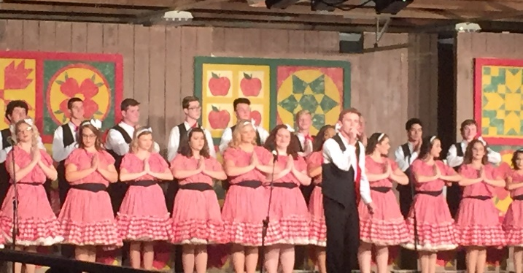

Marketing package
The marketing package includes:
- a website listing
  - Olde Time sponsor gets logo with reciprocating link
  - All others get name listing
- Brochure listing
  - 30,000 printed
  - Distributed to area businesses, campgrounds, area festivals, and mailed by request
- Facebook acknowledgement
  - Business name listed in month before festival
- Print Advertising
  - Local newspapers
  - regional magazines
  - state publications
- Business name used at festival
  - At the information booth
  - Outside entrance on Fair Street
  - At Stages
  - On FFA barn
  - Various other locations where applicable
Website:
Over 2000 hits a month
www.kendallvilleapplefestival.org

Facebook:
Over 6000 fans
http://www.facebook.com/applefestival
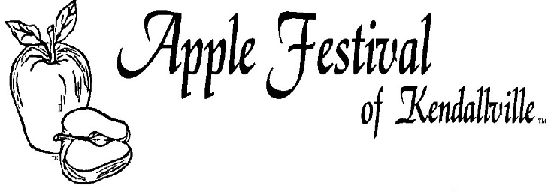

Sponsorship Opportunities
And
Festival Information
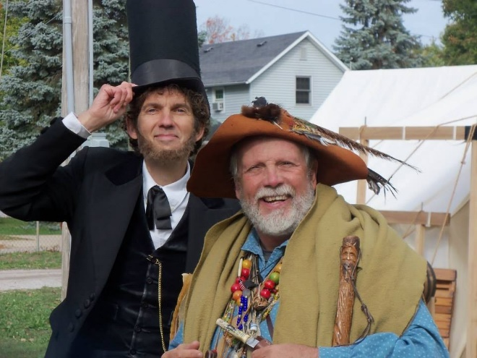
2019

