October
2017
TRUE LIES
The Stuart Rod & Reel Club Newsletter
The Stuart Rod and Reel Club is dedicated to improving local fishing through by increasing angler knowledge, encouraging conservation and maximizing the fun involved in light tackle fishing in the Stuart Florida area. We hold monthly meetings on the second Thursday of each month, year-round. Please join us or contact any board member for more information on how you can become a member of the Stuart Rod and Reel Club.
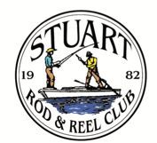

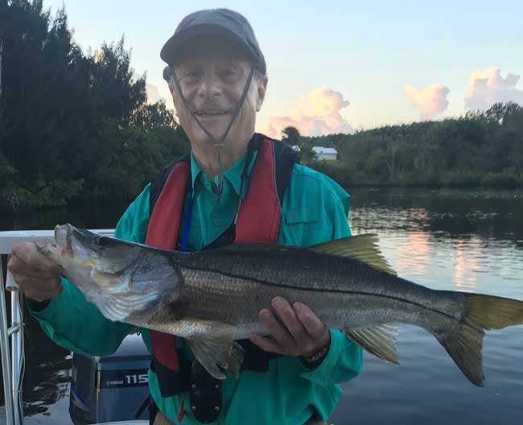
Dusty Smith caught this early morning snook while fishing with Jerry Hoge after the storm. Jerry and Dusty combined for 7 snook that morning, with this being the biggest fish. Dusty’s largest (photo above) was 30 inches caught with a lure, so he wins the September outing and an embroidered shirt.

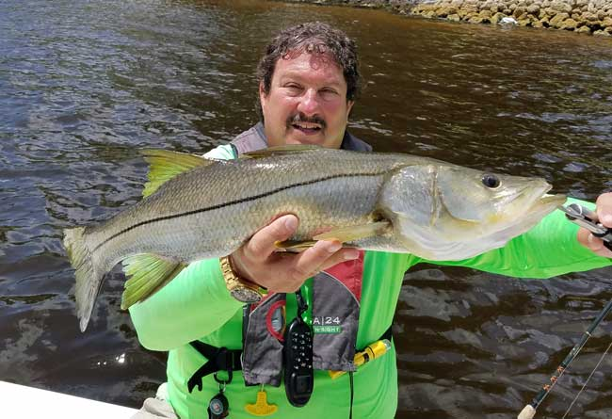
Keith Palant with a bright phase snook. This is a gorgeous fish, silvery from the ocean.

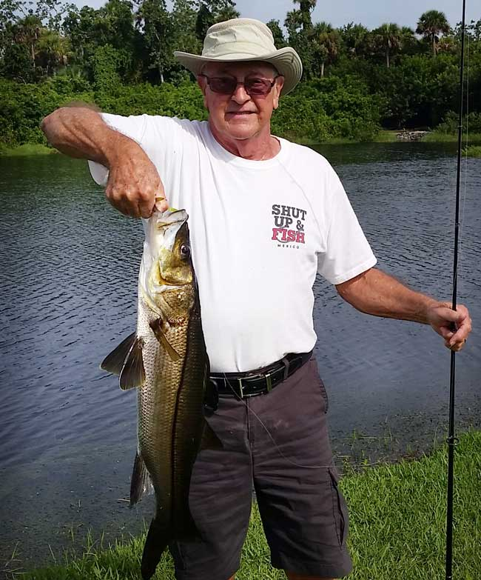
Mike Chilton caught this fine 29 ½ inch snook right before the snook season reopened. He put it back in the water to live and fight another day.
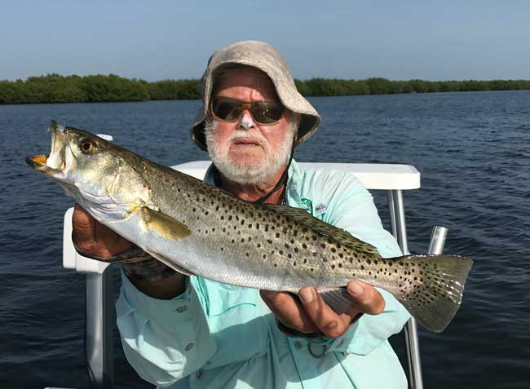

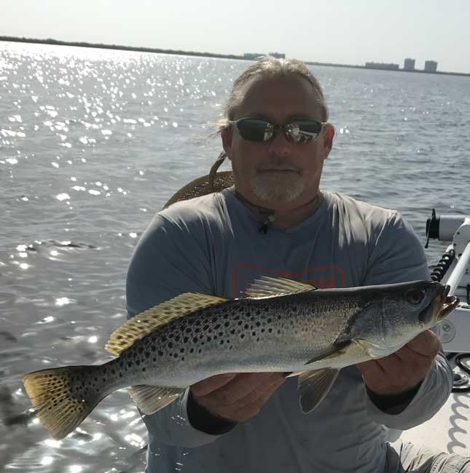
Jim Bohrer and Jay Honan found a good trout bite near Round Island one day before the hurricane. Jim reports that he was able to find good patches of sea grasses and this is where trout love to live and eat. Jay and Jim caught and released a number of trout on one lucky day.
Sea Grasses are tremendously important to the life of all sea trout. Many areas in Florida have healthy sea grass coverage. However, because of lake discharges and other factors, our sea grass population has declined in both acreage and quality. Please do your part in preserving sea grasses and in encouraging our elected representatives to do the same.
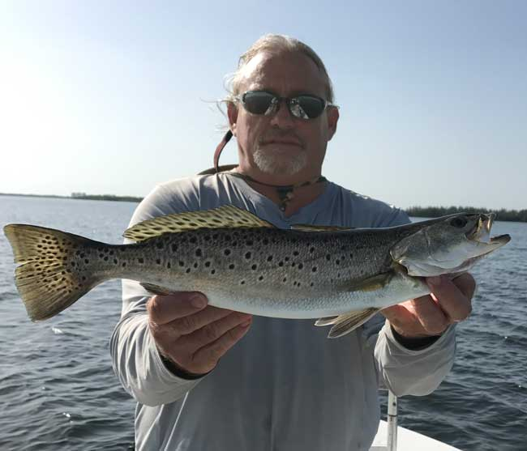

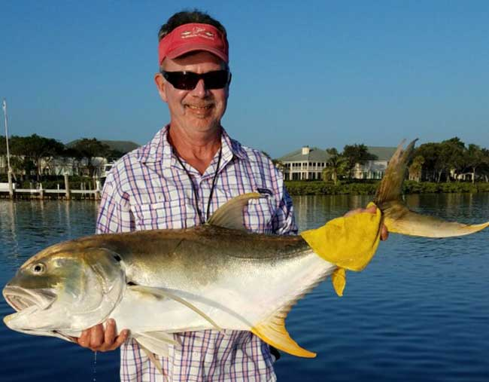
Phillip Quick with a super strong Jack Crevalle. This is a fish from the St. Lucie River, looking for the mullet run. No fish in this size class runs longer or fights harder in the Treasure Coast.
 |  |  | Club Officers
President | Jim Bohrer |  | halieutics@gmail.com | 301-648-2052
Vice President | Jim Bowdish |  | jlsb@crarybuchanan.com | 772-475-5068
Treasurer | Pete Noll |  | mpnoll@aol.com | 772-223-2136
Secretary and Newsletter Editor | Fred Bartlett |  | fredbart@aol.com | 913-909-9326
 |  |  | Board of Governors
Director |  | Roy Buckley | rlbuckley007@aol.com | 772-871-7008
House Committee |  | Jerry Hoge | jhoge@hogeengineering.com | 772-485-7267
Angling Committee |  | Frank Miller | frmiami2@gmail.com | 305-469-4654
Membership Comm. |  | Eric Rosenberg | erosen1031@aol.com | 772-210-5563
Meeting Speakers |  | Jim Bohrer | halieutics@gmail.com | 301-648-2052
Raffle Chairman and Conservation Coordinator |  | Jim Harter | pjharter@comcast.net | 772-223-0648
Director |  | Frank Pryzbylski | 1pratt@comcast.net | 772-486-3531
Events Coordinator |  | Bob Ruggeri | bob.ruggeri@yahoo.com | 772-285-4264
E-mail all newsletter copy and photos to Jim Bohrer at halieutics@gmail.com or to Fred Bartlett at fredbart@aol.com. Closing date for photos and copy is the 25th of the month preceding publication.

Angling Director’s Report by Frank Miller

STUART ROD AND REEL CLUB OFFICIAL SLATE OF CANDIDATES FOR THE 2018 BOARD OF GOVERNORS:
This is the official notice of the slate of governors/directors for the calendar year 2018: It is published in the October newsletter to comply with the bylaws. The election will be held at the November general membership meeting.
President | Jim Bohrer
Vice President | Jim Bowdish
Treasurer | Pete Noll
Secretary | Fred Bartlett
Director |  | Roy Buckley
Director |  | Jerry Hoge
Director |  | Frank Miller

Please attend the November meeting where the vote will be held. Your Board is always looking for people to help. Thank you for your consideration.
Date | Outing/Event | Details | Host/Food Service | Rules
October  13, 14, 15 | Pine Island | Total Length in Inches: 1 Trout, 1 Redfish, 1 Snook (24” minimum on snook) | Pine Island Away  No Local Luncheon | Longest total length
November  10,11,12 | Local Redfish | Longest Overall Redfish | Sandsprit Park 1:00 PM, Nov 11th. | Longest total length
December 9 | Christmas Party | No Outing | Dolphin Bar & Fish House Jensen Beach | No Outing.

All Stuart Rod and Reel Club Outings are based purely on the Honor System. All scheduled Club Outings will be “Daylight Outings”. You can fish any of the dates listed above. Event will begin at the first safe light in the morning with lines out of the water by 1PM. Scores must be turned into the Angling Director or other board member by email, phone or verbally by 2 PM local time on the day after the event.  Natural Bait (alive or dead) is allowed except for March, May and July. Bait restriction is in effect for September.  Guests and spouses are invited to attend the food services on Saturday at Sandsprit Park. For food at restaurants, guest and spouses will be charged for their meal and beverage costs. | Family members under the age of 18 must be accompanied by a parent or legal guardian to participate in an outing. While guests are always welcome to join members during our outings, you must be a paid member of the Stuart Rod and Reel Club to be eligible to win an outing. Outing scores shall be published in the Club’s Newsletter following the Outing. Outings cancelled due to weather shall be rescheduled for the following weekend. Outing result disputes shall be settled by the Angling Director.  OUTING SCHEDULES AND RULES MAY CHANGE DURING THE YEAR.  FISHING BOUNDARIES  Boundaries will extend from the south shore of the Jupiter Inlet to the North Vero Beach Bridge.

2017 TOURNAMENT OUTING SCHEDULE
Support our Advertising Sponsors
We are very fortunate to have many local businesses that advertise on our web site and provide additional sponsorship support to the Club. These businesses provide a wide range of products and services for the entire community. Whether you are looking for lodging, restaurants, fishing supplies, boat repair and restoration, guide services, legal services, or roof repair our sponsors deserve your consideration. You can learn more about these businesses by visiting our website at www.stuartrodandreel.com. Click on the advertiser’s tab and you will find a brief description of our sponsors with contact information and links to their websites. Make our advertising sponsors your priority when shopping. Please let them know that you learned about them through the Stuart Rod and Reel Club and that you appreciate their support.

Bait & Tackle  - Crowder Rods  - D.O.A. Lures  - Fish Heads of Stuart  - Snook Nook  - Treasure Coast Rod and Reel  - White's Tackle  - T & A Jigs, Inc. | Area Lodging  - Marriott - Hutchison Island Resort
Area Dining  - Big Apple Pizza  - Crawdaddy’s  - Dixie Grill  - Manatee Island Bar & Grill  - Manero’s Restaurant  - Polka European Deli  - Rancho Chico  - Shrimper’s | Guide & Charter Services  - Cajun Fishing Adventures Louisiana  - Catch 22 Charters Florida  - The Fish Intimidator Louisiana
Marine Products & Services  - C&H Trailer  - Manatee Marina  - Marine Customs Unlimited  - Marine Parts Outlet  - Master Repair  - Metco Marine Electronics  - Outboards Only  - Sailfish Marina  - Stuart Propeller  - Treasure Coast Battery & Alternator | General Business  - Capps Roofing  - Inn of the Dog  - Plaza 95 Marathon, Dairy Queen and Highway Café  Professional  - Crary Buchanan Attorneys

MEMBER’S INFORMATION
MONTHLY MEMBERSHIP MEETINGS WITH SPEAKERS: The monthly membership meeting is the second Thursday of the month. Our home port is The Quality Inn/Flanigan’s Bar & Grill located at 950 SE Federal Hwy. (US 1) Stuart, FL. We have the privilege of listening to many fishing industry and conservation leaders in the Southeastern Florida region. These experts include tackle manufacturers, tournament winning Captains and guides, television and print journalists, and academic researchers. We have a guest speaker from this pool at each monthly meeting. Speakers will address topics of interests such as how to fish for the upcoming outing’s targeted species and our diverse estuary system. This is a great way to gain additional local knowledge of this fishery. Dinner begins at 6PM with Meeting at 7 PM.

MONTHLY OUTINGS: The Club sponsors a fishing outing each month. All outings are based on an Honor System. You don’t have to keep your catch or take a picture of it either. Outings are scheduled for the weekend following the general membership meeting. Outings are usually three day events where anglers select to fish Friday, Saturday or Sunday. Most outings are scheduled from first safe light till 1PM. The targeted fish and scoring change from month to month with interesting twists such as more points for one species than another. The intent is to have fun! The winner of each monthly outing receives a Club logo embroidered fishing shirt. As part of the outing we have several lunches at restaurants along with club and family cook-outs. Additionally, the Board is encouraging members to partake of the lunch regardless of the day fished. These are no-cost events. With two away outings and the remainder based at Sandsprit Park, there is opportunity to participate without travelling around the state. Frank Miller as the Angling Committee Chairman will also consider your ideas about other outings in other parts of the state. This year’s outing schedule was developed to increase participation, emphasizing the fun of fishing. You are able to view the schedule in every edition of True Lies.

NEWSLETTER: We publish a newsletter, True Lies, each month. It is circulated by e-mail. We are constantly looking for your fishing reports, pictures, recipes, and any other Club related information for inclusion. Submitting information is easy. You can send an e-mail to Jim Bohrer (halieutics@gmail.com).

WEB SITE: The Club’s web site (www.stuartrodandreel.com) is a wealth of information. You can find the latest weather and tides, fishing tips and information on our advertisers/sponsors.

RAFFLE: An activity at our membership meetings that generates a great amount of interest is the “Raffle”. Tickets are $1 each or 6 for $5. Raffle prizes vary monthly but usually include a fishing rod, reel or combination. Other prizes have been tackle bags, boxes, pliers, lures and boating accessories. Your purchase of raffle tickets gives you a good chance of winning and helps support the activities of your club.

MEMBER DISCOUNTS: Your Club membership can help you to save some money. White’s Tackle offers a 10% store discount on all purchases. Be sure to mention that you are a current member of the Stuart Rod and Reel Club and that you appreciate the support that they give the club.

The Stuart Rod and Reel Club will join with the St. Lucie Angler’s Club for a fun filled charity tournament on October 22. Check in begins at 8:30 AM with the fishing to begin at 9:00 AM. For an entry fee of $25.00, you will receive a logo Tee shirt and a pink Barbie® fishing rod. This rod must be used in the tournament. The Port St. Lucie Botanical Garden has a nice pond stocked with crappie, bass and tilapia. You can bring your own lures or they will have a supply of worms and small hooks.
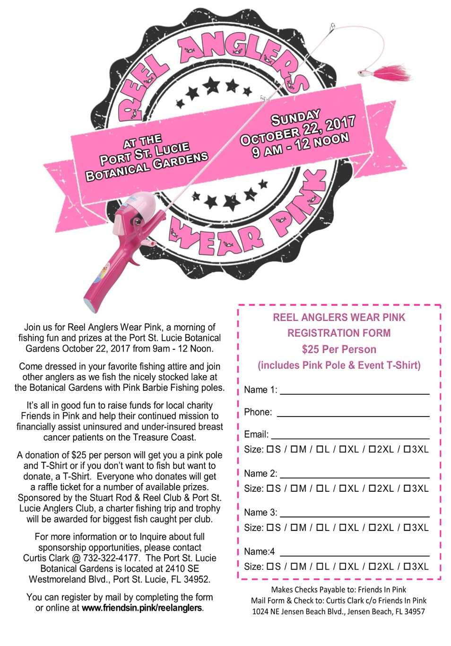

The awards ceremony will take place at about 11:00 with numerous prizes. Each club will have a winner who will receive an off-shore fishing charter with a licensed captain. Please join us for this fun event. There are also numerous sponsorship opportunities available for individuals and businesses. Please contact Mr. Curtis Clark at the voice phone number listed above for more information.

Shelly Bowdish found a very interesting website that provides a wealth of information on Stuart area fishing: http://www.tides4fishing.com/us/florida-east-coast/stuart#_tides
This valuable site provides local area tides, solunar activity and other data that will help you plan a successful and safe trip on the water. In addition, you can enter other geographic areas that may be in your travels. This does not appear to be accessible as an app in the Apple store for iPhones.

WILDERNESS FISHING CANADA-2018 SEASON with Hank Friedman, Club Member.
Hank Friedman is looking for people to go on a Canadian fishing trip in Summer 2018.
If interested and for more details call Hank at 561 746 6019 or Email him at pilothank1@hotmail.com. Please contact him as soon as possible as these lodges fill up fast.
Here are some links for you to look at. Cut and paste them into your browser for more information. The Canadian dollar is at a favorable rate and you will find a welcoming adventure in Canada.
www.fishingadventurer.com/videos/jurassic-pike-james-bay-que
https://www.youtube.com/watch?v=wiJDbu6rGYc
www.lakelubbers.com

to
GUEST SPEAKER FOR SEPTEMBER
Our speaker for the October General Membership Meeting will be Terry Gibson. Mr. Gibson has been very active in the local “clean waters” movement. Terry lives in Jensen Beach and has been fishing in the southeast since the 1970’s. He has served as an editor for Saltwater Fly Fishing Magazine and Florida Sportsman among others. He is a recreational fishing consultant for the Pew Charitable Trust’s Environmental Group. Please join us for his presentation.
2017 Annual Dues
Fully paid memberships begin the first day of January, and end on the thirty first day of December of each calendar year. An individual membership is one adult 18 years of age or older. Family memberships consist of the member, their spouse or significant other and their children under the age of 18.

Individual membership for a HALF YEAR (June 1 through December) is $45

Family membership for a HALF YEAR is $55
(June 1 thru December)

Send your checks payable to:
Stuart Rod and Reel Club, Inc.
c/o Pete Noll, Treasurer
1888 S. W. Mooring Dr.
Palm City, FL 34990
Membership entitles a single person (or family as applicable) to participate in all outings and to enjoy a meal at every local outing. Members also receive an included meal (with soft drinks) at Shrimper’s and Manatee Island Grill on the appropriate dates. We hold monthly meetings with interesting speakers and share information on where and when to fish in our area.

2017 SRRC Fish
of the Month Contests
The Fish of the Month Contest will run from the day after the monthly membership meeting and end at 12 Noon the day of the following meeting. All fish need to be legal size except for Snook that must be 24-inch minimum. Natural bait (live or dead), artificial lures and flies are allowed. The member catching the most fish will be the monthly winner. The monthly winner will receive a monogrammed club hat.
Date | Species
Jan 13 thru  Feb 09 | Snapper, Bluefish
Feb. 10 thru Mar. 09 | Most Pompano
Mar. 10 thru April 13 | Most Snook
April 14 thru May 21 | Largest Trout
May 12 thru June 18 | Most Snook
June 19 thru July 13 | Most Redfish
July 14 thru Aug 10 | Most Trout
Aug. 11 thru Sept 14 | Most Tarpon Caught and Released
Sept. 15 thru Oct 12 | Largest Snapper
Oct. 13 thru Nov 9 | Largest Redfish
Nov 10 thru Dec 13 | Most Black Drum

The Winner of the Year Overall will be the person catching the most total species during the calendar year. The overall prize is a $50 gift certificate to White’s Tackle in Stuart.

