Broughton-Bretton Motor Club
Clothing Range Brochure
Please place your order on the official order form and send to the details provided on the order form. Both the Brochure and Order Form can be found on the clubs website.
All names are to be stitched in yellow, when a name is requested to be added to the item
All Prices below are plus VAT at 20%
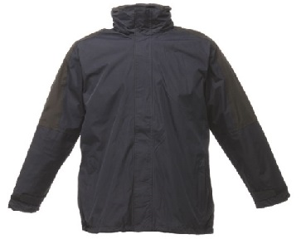 | 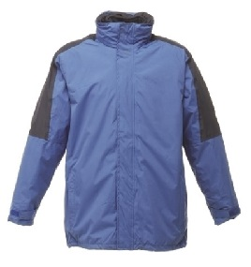
GENTS 3 IN 1 JACKET - NAVY  With BBMC Logo £40.30 / With BBMC Logo & Name £42.10 | GENTS 3 IN 1 JACKET – ROYAL BLUE  With BBMC Logo £40.30 / With BBMC Logo & Name £42.10
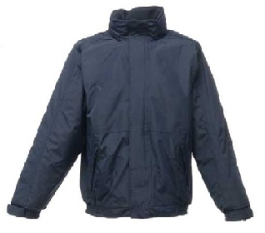 | 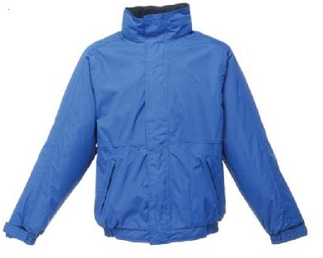
DOVER JACKET – NAVY  With BBMC Logo £22.10 / With BBMC Logo & Name £23.95 | DOVER JACKET – ROYAL BLUE  With BBMC Logo £22.10 / With BBMC Logo & Name £23.95
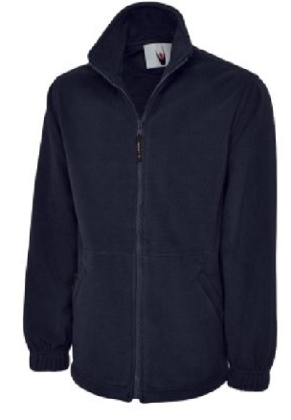 | 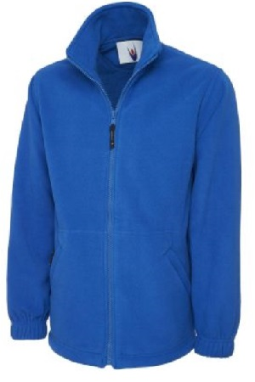
GENTS FLEECE - NAVY  With BBMC Logo £13.75 / With BBMC Logo & Name £15.55 | GENTS FLEECE – ROYAL BLUE  With BBMC Logo £13.75 / With BBMC Logo & Name £15.55
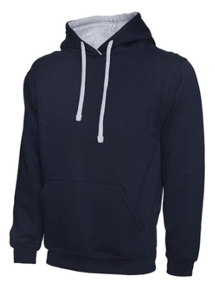 | 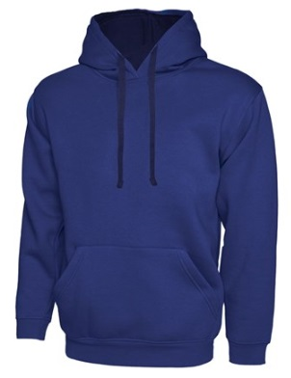
HOODY – NAVY / GREY  With BBMC Logo £12.75 / With BBMC Logo & Name £14.55 | HOODY – ROYAL BLUE / NAVY  With BBMC Logo £12.75 / With BBMC Logo & Name £14.55
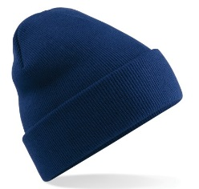 | 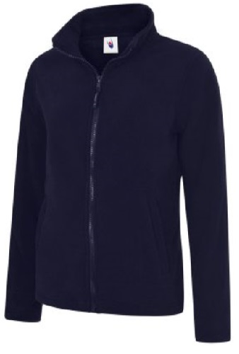
SOFT KNIT SKI HAT – OXFORD NAVY  With BBMC Logo £4 | LADIES FLEECE – NAVY  With BBMC Logo £11.50 / With BBMC Logo & Name £13.50
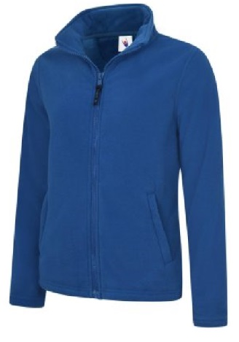 | 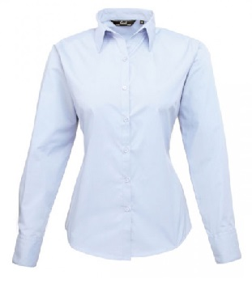
LADIES FLEECE – ROYAL BLUE  With BBMC Logo £11.50 / With BBMC Logo & Name £13.50 | LADIES LONG SLEEVE SHIRT – LIGHT BLUE  With BBMC Logo £12.25 / With BBMC Logo & Name £14.05
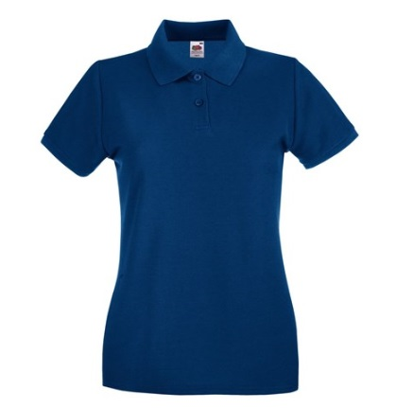 | 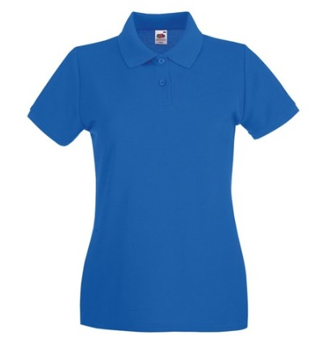
LADIES POLO SHIRT – NAVY  With BBMC Logo £8.50 / With BBMC Logo & Name £10.30 | LADIES POLO SHIRT – ROYAL BLUE  With BBMC Logo £8.50 / With BBMC Logo & Name £10.30
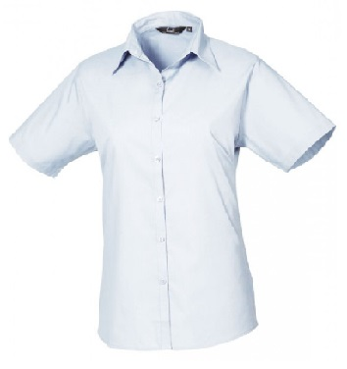 | 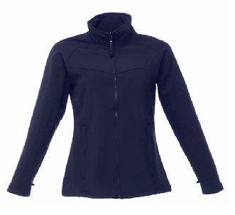
LADIES SHORT SLEEVE SHIRT – LIGHT BLUE  With BBMC Logo £11 / With BBMC Logo & Name £12.80 | LADIES SOFT SHELL JACKET – NAVY  With BBMC Logo £23.80 / With BBMC Logo & Name £25.60
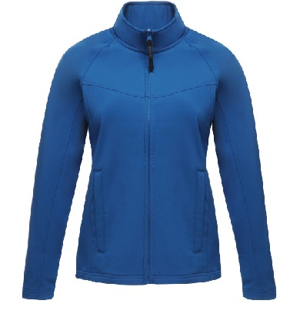 | 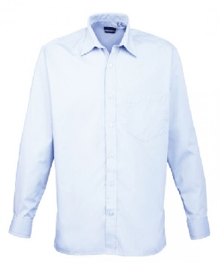
LADIES SOFT SHELL JACKET – OXFORD BLUE  With BBMC Logo £23.80 / With BBMC Logo & Name £25.60 | GENTS LONG SLEEVE SHIRT – LIGHT BLUE  With BBMC Logo £12.25 / With BBMC Logo & Name £14.05
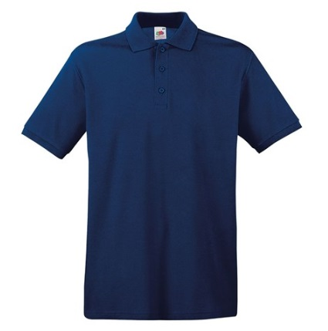 | 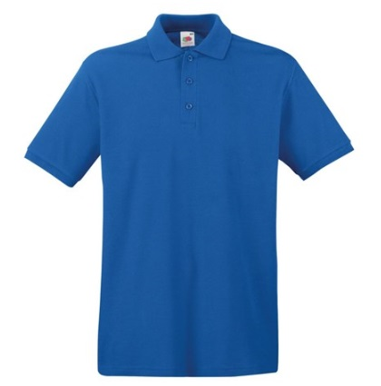
GENTS POLOSHIRT – NAVY  With BBMC Logo £8.25 / With BBMC Logo & Name £9.95 | GENTS POLO SHIRT – ROYAL BLUE  With BBMC Logo £8.25 / With BBMC Logo & Name £9.95
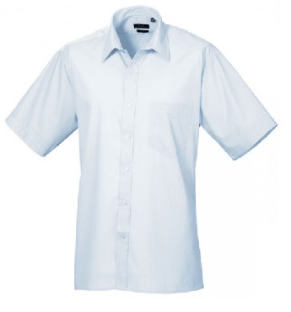 | 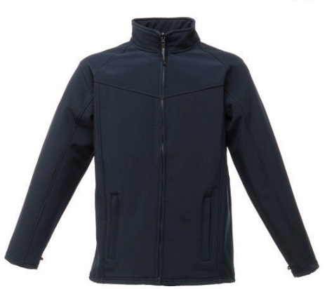
GETNS SHORT SLEEVE SHIRT – LIGHT BLUE  With BBMC Logo £11 / With BBMC Logo & Name £12.80 | GENTS SOFT SHELL JACKET – NAVY  With BBMC Logo £24.50 / With BBMC Logo & Name £26.30
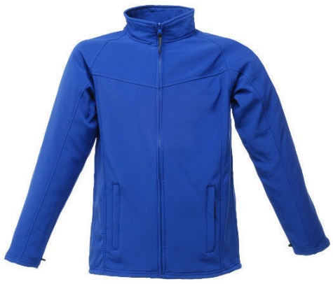 | 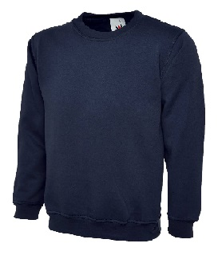
GENTS SOFT SHELL JACKET – royal blue  With BBMC Logo £24.50 / With BBMC Logo & Name £26.30 | SWEATSHIRT – NAVY  With BBMC Logo £9.65 / With BBMC Logo & Name £11.50
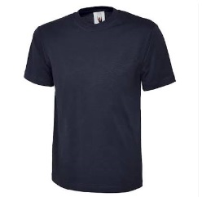 | 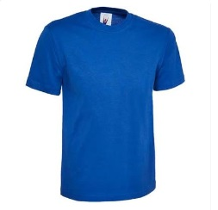
T-SHIRT – NAVY  With BBMC Logo £5.15 / With BBMC Logo & Name £6.95 | T-SHIRT – ROYAL BLUE  With BBMC Logo £5.15 / With BBMC Logo & Name £6.95

Item | Price with club logo + VAT | Price with club logo & name + VAT
3 in 1 Jacket | £48.36 | £50.52
Dover Jacket | £26.52 | £28.74
Gents Soft Shell Jacket | £29.40 | £31.56
Ladies Soft Shell Jacket | £28.56 | £30.72
Hoody | £15.30 | £17.46
Gents Fleece | £16.50 | £18.66
Ladies Fleece | £13.80 | £16.20
Gents Polo Shirt | £9.90 | £11.94
Ladies Polo Shirt | £10.20 | £12.36
Gents Long Sleeve Shirt | £14.70 | £16.86
Ladies Long Sleeve Shirt | £14.70 | £16.86
Gents Short Sleeve Shirt | £13.20 | £15.36
Ladies Short Sleeve Shirt | £13.20 | £15.36
T Shirt | £6.18 | £8.34
Ski Hat | £4.80 | n/a
Price List including VAT

Club Logo:
