ANNUAL TOWN MEETING
March 13, 2018
Aurora, MN

IN ATTENDANCE: (57) Craig Anttila, Jon Skelton, Ed Kippley, Jodi Knaus, Emma Shuck, Michael Couri, Ken Kiefat, Donna Kiefat, Gerry Kangas, John Kangas, Beth Wilkes, Alta Sprink, LeRoy Sprink, George Brown, Janice Brown, Jeannine Saari, Sam Wilkes, Mike Palm, Doris Helgerson, Roger Belange, Jeanette Johnson, Robert Allison, Donna Allison, Joe Hochevar, Corinne Thompson, Arlette Mikulich, Dale Erickson, Jeremy Deedrick, Rebekah Deedrick, Betty Stende, Faye Radtke, Betty Harsila, Dean Gibson, Gloria Curfman, Tammy Mineheine, Deidre Schackman, Jim Schackman, Ila Fodness, Ron Johnson, Adam Heikkila, James Larson, Loretta Larson, Mary Matteson, Mark Fredin, Donna Fredin, Denise Ramfjord, David Ramfjord, Mike Skinner, Joanne Barstad, Don Barstad, Bill Maki, Aaron Undeland, Michael Starken, Kay Freeman, Greg Hinsz, Kari Pecacheck, Chad Skelton

- The 2018 Annual Town Meeting of the Town of White was called to order by Jon Skelton on Tuesday, March 13, 2018, at 8:30 P.M., at the Loon Lake Community Center.
- Pledge of Allegiance
- Jon Skelton called for Nominations for Moderator
John Skelton was nominated by John Kangaas. No other nominations.
IT WAS MOVED BY SKELTON, SUPPORTED BY KIPPLEY THAT NOMINATIONS BE CLOSED. MOTION CARRIED

Jon Skelton took the chair as moderator.

4.) IT WAS MOVED BY MAKI, SUPPORTED BY CHAD SKELTON TO ADJOURN THE 2017 ANNUAL TOWN MEETING. MOTION CARRIED
IT WAS MOVED BY SKELTON, SUPPORTED BY KIPPLEY TO OPEN & CONDUCT THE 2018 ANNUAL TOWN MEETING. MOTION CARRIED

Approve and Adopt Agenda as presented

IT WAS MOVED BY PALM, SUPPORTED BY DON BARSTAD TO APPROVE AND ADOPT THE AGENDA AS PRESENTED. MOTION CARRIED

- Skelton read preliminary results of the Special Election 273 YES votes and 143 NO votes with Board of Canvass meeting on Thursday, March 15, 2018. Michael Couri was introduced and gave a synopsis of the history of the elections. The City of Aurora was incorporated in 1903 as a village and three years later the citizens of the Village petitioned to combine as one entity for political purposes for voting with the Township. Aurora residents could then vote in Township elections and run for Township office. Township residents could not vote in Aurora elections or run for Aurora Offices. Special legislation M.S. 365.44 allowed this but there was a clause preventing separation for decades. In the 70’s, further special legislation was then passed allowing the Township to separate from the City but both entities could vote in this election. In 1978 a Special Election was held and the vote did not pass. In 1985, M.S. 365.44 was amended with language changes allowing a petition by the residents of a Township and City residents could not vote. Residents of the Township filed a petition in 2017 with the election being held today, March 13, 2018. The separation will occur after the canvassing of the election results. From this point forward, Aurora residents cannot attend annual meetings and cannot vote in Township elections or run for Township office. The Township is now separated for all purposes from the City of Aurora. This legally means the two entities are separated for political purposes only. It does not require White Township to sever all ties and relationships with Aurora or Aurora to sever all ties and relationships with White Township. The shared City Hall/Town Hall back from 1909 with the Township owning 20% remains and does not change. This building can still remain as the Town Hall. It will not impact sewer and water services with water provided by the City. It will not impact either the Town’s or City’s membership in the East Range Joint Powers Board, the tax rate, public work’s operations, or financials. All of this remains unchanged unless the Township Board authorizes changes. Matteson asked if Aurora residents are Township residents. Couri answered yes, for voting purposes because we were not politically separated. Skelton wanted to state as a Board they needed to remain neutral regarding the election. He is proud of the projects they have accomplished and the projects they have planned for the future. These projects rely on relationships with the City of Biwabik, City of Aurora, and the City of Hoyt Lakes. This Board is really committed to continue working on these projects and with our neighboring communities. These relationships are driving forces to get these projects accomplished. Some residents may not agree with the water and sewer projects, but these projects bring new people into our community, creates more revenue and brings new kids into our schools. It’s all about economic development. We partner heavily with St. Louis County and will be discussing road projects for next year. We as a Board want to keep our community strong and continue to fight for these things, joint projects and working together. Past Boards and relationships with the communities around us have all helped and brought us to today.

- Matteson asked her name to be corrected in the 2017 minutes.
IT WAS MOVED BY STENDE, SUPPORTED BY SAARI TO WAIVE READING OF AND APPROVE THE 2017 CONTINUATION OF THE ANNUAL MEETING MINUTES. MOTION CARRIED

- IT WAS MOVED BY KIEFAT, SUPPORTED BY STENDE TO SET THE 2019 ANNUAL TOWN MEETING FOR TUESDAY, MARCH 12, 2019 AT THE LOON LAKE COMMUNITY CENTER AT 6:00 P.M. MOTION CARRIED

8.) PowerPoint Presentation – Clerk & Treasurer’s Report including Strategic Plan Outcomes (included at end of minutes)

Skelton presented the PowerPoint.

Kangas questioned will the City administer and pay for their own elections now? Knaus replied these conversations have not been held but the City has always reimbursed the Township for all costs for their elections. The presentation continued.

IT WAS MOVED BY WILKES, SUPPORTED BY CHAD SKELTON PRELIMINARY APPROVING THE TOWNSHIP TO BORROW UP TO $1,400,000.00 FOR ROAD WORK TO BE COMPLETED ON STEPETZ ROAD, PALO ROAD 41, LANE 49, AND ROAD 51 IN 2018 AND 2019. MOTION CARRIED

Saari asked who to call regarding Highway 99/37 & 16 visibility and Kippley informed her to call Eric Fallstrom with St. Louis County. Kangas inquired why the Employee Recognition Policy was not on the agenda for approval. Knaus replied it would be on the Continuation of Annual Meeting agenda or it can be added at the end of the agenda. Matteson inquired why the Township paid for half of the cost for the blacktop trailer. Skelton replied we have more roads and use it more and partnering with the City of Aurora and City of Hoyt Lakes saved us a lot of money. Harsila inquired how the roads are selected for dust control. Skelton indicated roads are selected based on usage and the budget. It was requested to be applied on Hult Road by the powerlines which is a County Road and Kippley stated we will inform the County. Skelton invited anyone coming to the Board meetings and ask questions before the whole Board. Stende inquired if the annexation funds are included in the Category 4 Beginning Balance to Ending Balance chart and Knaus replied yes, because they are deposited. Kiefat’s inquired about grant funding as they are the only house not connected to water and sewer on 3rd street. It is important to them and they want to be connected. Kippley informed them we have applied for grant funding through IRRRB again this year. Matteson asked why the annexation payments are not included in the graph on page 19. Knaus explained because this graph explains our day to day operations. Matteson asked about the total settlement payments for annexation. Knaus replied $1.6 million in the Board of Audit packet. Stende inquired if all debt was included in the graph on page 20 including vehicle payments. Knaus replied yes. Matteson inquired if interest rates were monitored and questioned why we don’t purchase six months CD’s with a higher interest rate. Knaus replied we went with the highest interest rates offered and we will look into shorter CD’s. Kangas would like to see the costs for water and wastewater services separated out so they can see what we are spending as we move forward with this venture. Kangas would like to see where we have saved money. Kippley explained a big savings has been getting our fuel through St. Louis County.

IT WAS MOVED BY MATTESON, SUPPORTED BY PALM TO DELAY THE 2018 LEVY DISCUSSION UNTIL THE CONTINUATION OF THE ANNUAL MEETING. MOTION CARRIED
IT WAS MOVED BY MATTESON, SUPPORTED BY RADTKE TO ACCEPT THE CLERK’S REPORT. MOTION CARRIED

9.) Other Business

IT WAS MOVED BY KANGAS, SUPPORTED BY WILKES APPROVING THE TOWNSHIP TO SPEND $1,000.00 ON THE EMPLOYEE RECOGNITION. MOTION CARRIED

10.) IT WAS MOVED BY STENDE, SUPPORTED BY SAARI TO KEEP THE MEETING OPEN AND TO SCHEDULE THE CONTINUATION OF ANNUAL MEETING FOR TUESDAY, SEPTEMBER 11, 2018 AT 6:00 P.M. AT THE LOON LAKE COMMUNITY CENTER. MOTION CARRIED AT 9:45 P.M.

POWERPOINT PRESENTATION SLIDES ARE ATTACHED.

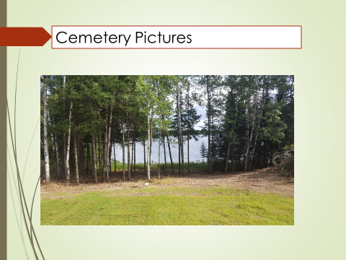

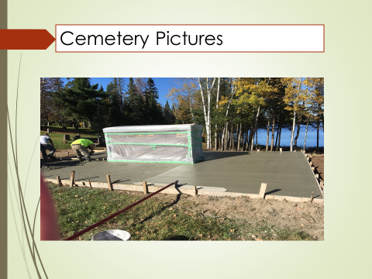

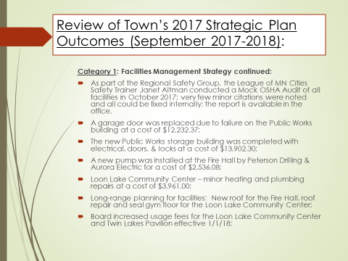

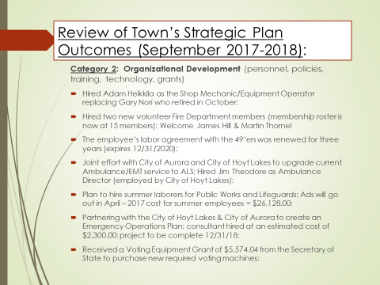

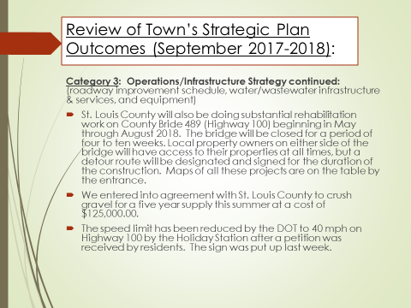

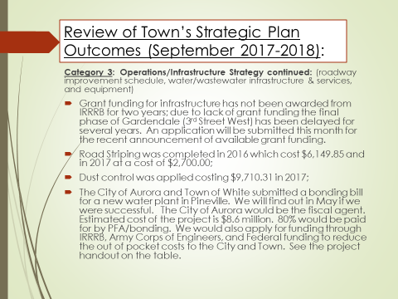

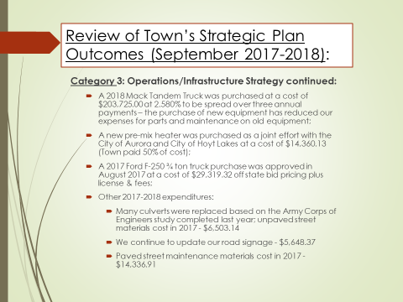

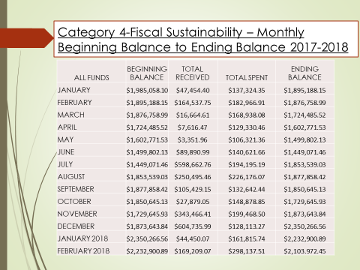

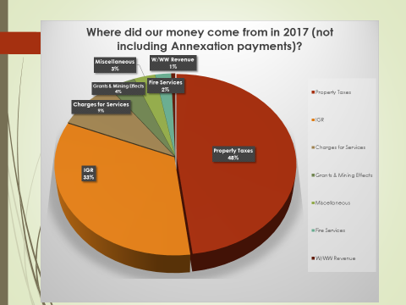

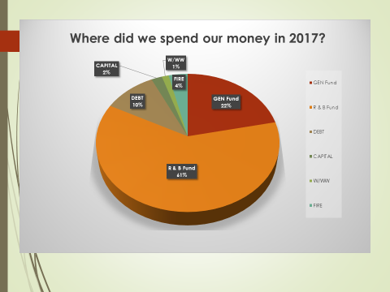

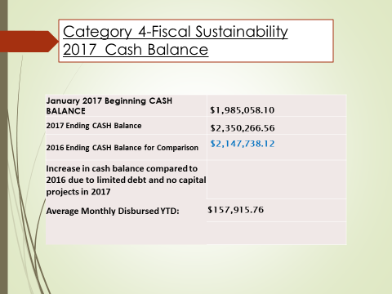

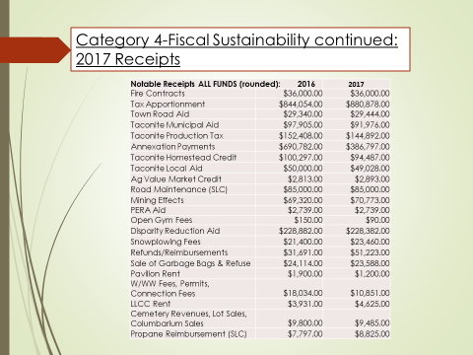

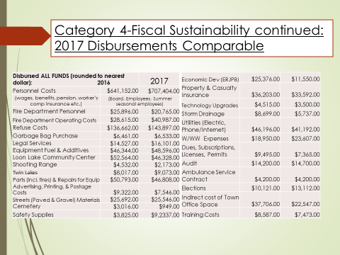

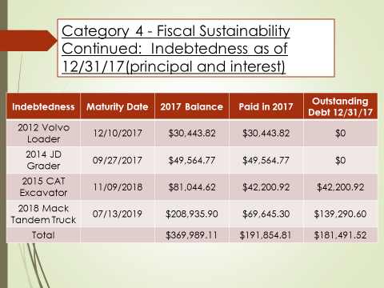

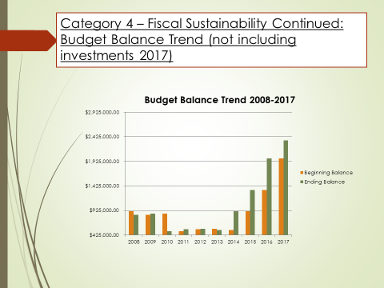

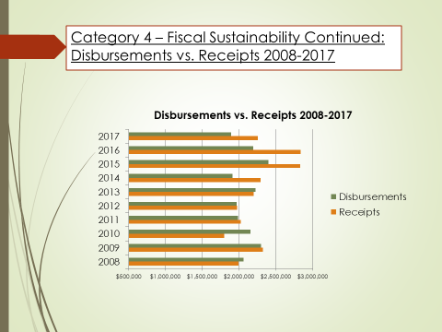

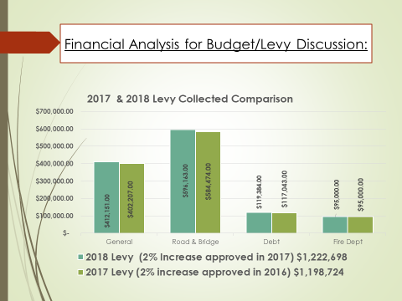

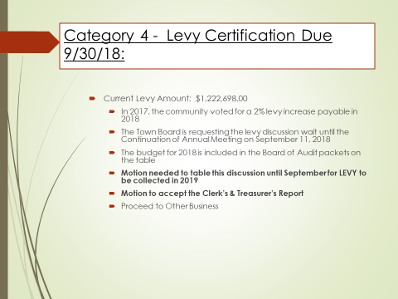

_____________________________________ _________________________________________
Jodi Knaus, Clerk Jon Skelton, Moderator

