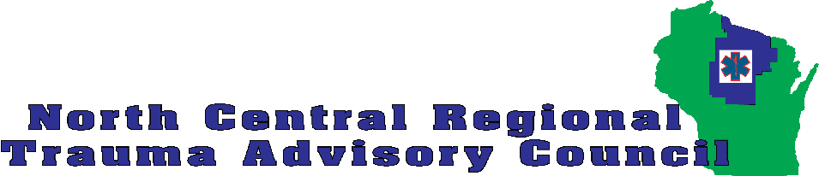

Request for Honorarium for Instruction of
Bleeding Control Basics Course

The NCRTAC supports ongoing teaching of the Bleeding Control Basics (B-Con, aka Stop the Bleed) courses in our region by supporting instructors with teaching materials/ equipment and instructor honoraria when appropriate.

Instructors may apply for an honorarium of $100 for each B-Con course taught if all of the following conditions are met:
- The instructor is not being paid by any other organization or employer to conduct the course.
- The instructor is registered with BleedingControl.org as a B-Con instructor.
- The course is registered with BleedingControl.org. It does not have to be an open course. The course must also be closed on the BleedingControl.org website after completion.
- The NCRTAC is promoted in the course as a sponsor.
- A copy of the course roster is submitted to the NCRTAC Coordinator.
- The course must follow the B-Con curriculum and course guidelines.
- The course must include a minimum of 6 students that are considered “lay public.”
  - Licensed EMS providers (including first responders) may be taught in the class but may not be included in the minimum number of lay public.
  - Law enforcement and fire fighters may be included as long as they are not also licensed EMS providers.
  - Two courses may be combined to be counted as one if the total number of lay public students adds up to 10 or more.

Funds for instructor honoraria are limited. Contact Michael at Michael.Fraley@NCRTAC-WI.org if you would like to confirm that funds are still available.

Complete the form on page 2 for payment.
Request for Honorarium for Instruction of
Bleeding Control Basics Course

Complete and submit this form for payment.

Full name
Mailing address
City, State, Zip
Phone number
Email
Course date
Course location
Number of lay public students

I certify that the above course was completed and the conditions for payment of an honorarium above were met.

________________________________________ ______________________
Signature Date

Mail this completed form and the course roster to:

NCRTAC
PO Box 23
Woodruff WI 54568-0023

The payment form and roster may also be scanned and emailed to Michael.Fraley@NCRTAC-WI.org

