Washington State Muzzleloader’s Association
November 2016 Journal
www.wamuzzleloaders.com

Hunting Stories and Pictures Wanted!
Got a great story about the trophy buck that jumped in front of your ball, or about the one that got away? Send it in and we’ll get it in the newsletter. And since pictures are worth a thousand words, send them in too.

Puyallup Sportsmen’s Show
Just after hunting season and the holidays we’ll start the New Year with the Washington Sportsmen’s Show. WSMA will have our booth there in the same location as last year, and we hope to get many volunteers for the five days of the show. Please take a look at the schedule on the back to sign up for a shift. It promises to be a great show again.

Youth Grant Requests
It’s time for submitting for WSMA Youth Grants for next year. One of the primary reasons we raise money is to help clubs and organizations support youth shooting programs. We do ask that after the event that grantees provide a story and some pictures of how the grant was used so we can publish it in the Journal. Applications can be found on the website.

WASHJAM 2016 by Jerry Jazbec
Washjam 2016 was a regional jamboree held at Joint Base Lewis-McChord in August. Over 5,000 attendees from Washington, Oregon, Idaho, and Canada were present, including Boy Scouts, Girl Scouts, American Heritage Girls, and Campfire.
The Cascade Mountain Men (Issaquah, Washington) and Green River Mountain Men (Ravensdale, Washington) setup a mountain man camp. This was a great chance to reach out to youth and promote our passion for reenacting.
Jerry Jazbec as a Hudson Bay Trader turns cattails into string
GRMM under the leadership of Dwayne set up a base camp with all the accoutrements. His father had a large drum which attracted the Cub Scouts.
Harry Charro of CMM set up his traveling museum featuring early 1800's items and a set of firearms covering 500 years of firearm ignition systems. I set up as a Hudson's Bay Trader, teaching how to turn cattail leaves into string and how to survive in the wilderness.
Harry Charowsky explains the evolution of firearms
More pictures can be found on Facebook under Washjam 2016.

Cub Scouts loved beating the drums
A really big crowd!

You can find more information and pictures on Facebook or at www.washjam.org

The Green River Mountain Men Camp

Now Building the 2017 Events Calendar
Get your club’s rendezvous event information on the WSMA Website. Send in a flyer or at least the dates and contact information and we’ll get the website updated for the coming year. Got a website for your club? Send in the link. You can send the info to Mike Moran at michael.moran248@gmail.com or Bob Geitz at duckfreak@q.com.
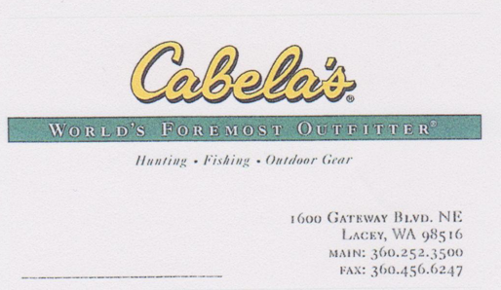
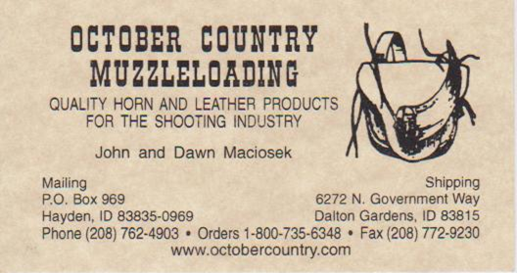

Check out the website for up to date information on the upcoming events.

25-29 Jan 2017 Washington Sportsmen’s Show
17-19 Feb 2017 Rain-Dee-Voo, Littlerock, WA
11-12 Mar 2017 Cascade Mountain Men Gun Show, Monroe, WA
25 Mar 2017 WSMA Fundraising Dinner

www.wamuzzleloaders.com

WSMA Booth at Puyallup Sportsmen’s Show
Volunteer List

Please contact Mike Moran at michael.moran248@gmail.com to volunteer. We need a minimum of three people per shift, more are certainly welcome!

Tues 24 Jan (set up - time TBD)
1. Mike Moran
2. Bill Daly

Wednesday, 25 January
12:00 to 4:00 (4 hrs) 4:00 to 8:00 (4 hrs)
1. 1.
2. 2.
3. 3.

Thursday, 26 January
12:00 to 4:00 (4 hrs) 4:00 to 8:00 (4 hrs)
1. 1.
2. 2.
3. 3.

Friday, 27 January
12:00 to 4:00 (4 hrs) 4:00 to 8:00 (4 hrs)
1. 1.
2. 2.
3. 3.
4. 4.

Saturday, 28 January
10:00 to 3:00 (5 hrs) 3:00 to 8:00 (5 hrs)
1. 1.
2. 2.
3. 3.
4. 4.

Sunday, 29 January
10:00 to 4:00 (4 hrs) 4:00 to 8:00 (4 hrs)
1. 1.
2. 2.
3. 3.
4. 4.

Washington State Muzzleloaders Association
www.wamuzzleoaders.com
APPLICATION TO JOIN WSMA
New Renew
____ ____ Individual Annual Dues ($10.00)
____ ____ Family Annual Dues ($15.00) (Head of house, spouse, children under 18, still living at home)
____ ____ Club Annual Dues ($10.00)
____ ____ Trader Annual Dues ($20.00). Business Name: ___________________________
Make check payable to WSMA and mail to PO Box 2913, Olympia, WA 98507
Name: ___________________________________Club: _______________________________
Mailing Address:_______________________________________________________________
City:__________________________________ State:__________ Zip:____________________
Phone:______________________________________________________________________
E-Mail:_______________________________________________________________________
Newsletters will be sent by email unless requested otherwise.

AREAS OF INTEREST AND PREFERENCES
Primitive: __________________ Flint Rifle: ____________________
Target: ____________________ Perc. Rifle: ___________________
Hunting: __________________ Pistol: _______________________
Historical: _________________ Shotgun: _____________________
Trader: ____________________ Trade Gun: ___________________
Gun Maker: _________________ Appraisal: ____________________

