Biology 101 Gene Regulation Brilakis
So what if you don’t need to produce a particular protein at a particular time? There has to be some way of turning on and turning off genes so that they are not constantly being expressed. How does a cell control the transcription and translation of a gene?
A. An example of how Prokatyots regulate their genes?
The Lac Operon:
There’s a great example of gene regulation found in prokaryots (bacterial cells). It is called the lac Operon. http://www.sumanasinc.com/webcontent/anisamples/majorsbiology/lacoperon.html
In order for E.coli bacteria to consume lactose (milk sugar), it needs to produce the enzyme (lactase) that is able to break down the lactose. If lactose is not present, the cells do not produce lactase. It would be a waste of time and energy to produce the enzyme to break down a sugar if the sugar isn’t present.
lactose -------------------------→ glucose + galactose
In front of the gene, there are areas of DNA that control the transcription of the gene. First, there is the regulator gene that produces a repressor protein. Next, comes the promotor area that serves as a load on point for the polymerase. Finally, there’s the operator that serves as an area of attachment for the repressor. When the milk sugar is absent, the repressor binds to the operator, preventing the polymerase from loading on and transcribing the gene by getting in the way. When lactose is present, it binds to the repressor, preventing it from binding to the operator…the polymerase is then able to load on and transcribe the gene. COOL!
See a picture at the website below:
http://ghs.gresham.k12.or.us/science/ps/sci/ibbio/chem/nucleic/chpt16/lacoperon4.gif

There are other prokaryotic operons that work in the reverse. When the protein coded for by the gene is already present, it binds to the repressor and activates it. In this way, the protein becomes self-regulating. The more protein present, the less is made by the cell. As the protein concentration decreases, the gene repressor is deactivated and the gene can be transcribed. An example of this is the tryp operon which regulates the production of tryptophan, an important amino acid.
B. Examples of how eukaryotes regulate their genes.
The nucleus found in eukaryotes makes regulation a bit more complicated. (Can you guess why?) there are four main ways that Eukaryotes control gene expression.
1. Transcriptional control:
A. Transcription factors are proteins that bind to the promotor site adjacent to a gene, attracting the polymerase to the gene. There are several combinations of transcription factors that can combine to initiate transcription. Without these transcription factors present, a gene cannot be transcribed.
B. DNA can either be somewhat loosely arranged or tightly packed into condensed chromosomes. Loosely arranged DNA can be transcribed easily but condensed DNA is too tightly arranged to be transcribed. Condensation of DNA involves the DNA coiling around proteins called histones. By adding certain functional groups like methyl or acetyl groups to the DNA, the condensation of a gene can be modified. Adding acetyl groups (COCH₃) to the amino acid lysine in the histones
reduces condensation as the picture below illustrates.
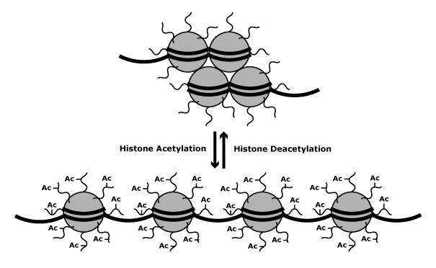
This encourages transcription because the polymerase has a better shot at accessing the DNA. Similarly, the addition of methyl groups (-CH₃) increases condensation which in turn decreases the ability of the polymerase to transcribe a gene. This form of control is called epigenetics. Epigenetics is when DNA expression is controlled by a molecule that alters gene activity without changing the DNA sequence. Epigenetic “tags” can be added to the DNA as a result of diet, smoking and even stress. Here’s a cool example. It’s called “good momma mouse”.
IA momma mouse licking its pup is linked to the ability of the pup to deal with stress later in life. How? The glucocorticoid receptor (GR) protein helps shut down the stress response by binding to the glucocorticoid hormone. which changes that is prioduced when . Well loved pups produce more GR. As adults they less stressed. Let’s check it out…
http://learn.genetics.utah.edu/content/epigenetics/rats/
Does this apply to humans?
http://www.ncbi.nlm.nih.gov/pubmed/19234457
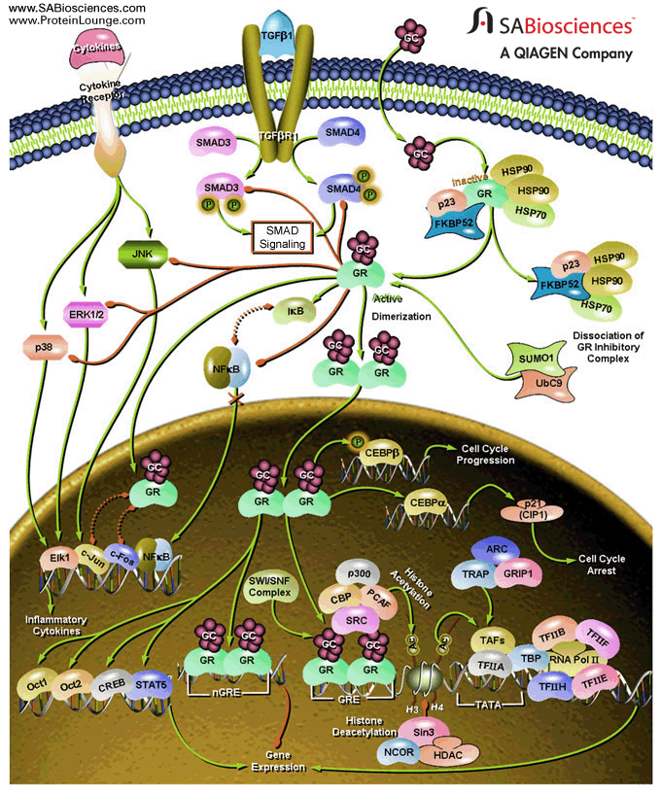

Here are some other examples:
Queen bees and worker bees are genetically identical. But queen bees are exclusively fed royal jelly, a protein source that the worker bees secrete and feed only to the designated queen larvae. Larvae fed the jelly develop ovaries and a big abdomen capable of carrying and laying eggs. The worker bees stay sterile and never develop queenly behaviors such as killing rivals or singing or flying out of the next looking for mates. Royal jelly down regulates or “turns off” the Dnmt3 gene. This gene codes for a regulatory protein that down regulates the expression of a wide variety of other genes, resulting in a worker bee. An active Dnmt3 gene in a larvae results in a worker bee while an inactive gene allows for all of the other genes to be transcribed and results in a queen bee! Here’s the catch…the queen has to eat this stuff her whole life to maintain her “queenness”.
An important regulatory gene is called the agouti gene. A mouse with an unmethylated agouti gene is fat, yellow and gets diabetes and cancer while a mouse with methylated agouti genes is skinny, brown and healthy even if the mice are genetically identical. If a pregnant yellow mouse is fed a methyl-rich diet, her pups were mostly brown and healthy for life.
http://www.pbs.org/wgbh/nova/body/epigenetics.html
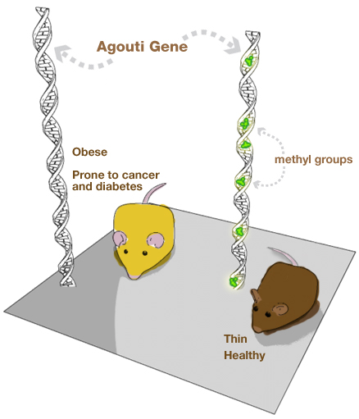
So, does what we eat influence gene expression? Absolutely!
As we eat, our body metabolizes the nutrients, making useful molecules out of the raw material. Methyl groups are epigenetic tags that are created from folic acid, and B vitamins. A diet rich in food containing these molecules can alter the expression of your genes, and if you are pregnant, your fetus’ genes. Methylation decreases the availability of the gene for transcription while demethylation increases transcription of the gene by decreasing condensation.
Check out this nutrition table:
http://learn.genetics.utah.edu/content/epigenetics/nutrition/table.html|
2. Post transcriptional control: After the mRNA is made, it is modified before it leaves the nucleus via alternative intron/exon splicing, and the addition of a poly-A tail and guanine cap. These alterations to the mRNA can be delayed. This reduces the amount of protein made in a given time period.
3. Translational control: Hormones are able to control the amount of time a mRNA is viable in the cytoplasm before it is degraded. The longer it’s in the cytoplasm, the more it can be used to make proteins. Ex. Lactation: Casein production vs prolactin hormone.
4. Postranslational control: Polypeptides, even after they are made, are not metabolically active. They need to fold into their 3D shape to be functional This process is enzymatically controlled.
Mutations
What are mutations? Why do they occur? Can they be repaired? What can happen if they are not repaired?
Mutations JUST HAPPEN
Think of the t shirt or button with a similar saying…
Mutations may form during replication. The DNA polymerase just makes a mistake.
They also may form during transcription. The RNA Polymerase just makes a mistake.
If the DNA has an error in its sequence, the mRNA that is made using that DNA as a template will also have an error in ITS sequence.
So that means the anti-codon of the tRNA that binds to the codon with an error in it might carry the wrong amino acid.
So that means if a wrong amino acid is added to the sequence of amino acids, the protein made won’t have the correct structure. Depending on where the wrong amino acid is located in the protein and how different the correct amino acid is from the incorrect amino acid, the protein may be non-functioning or perhaps function in such a way that it is harmful to the cell.
Ex.: Sickle cell disease
There is a single error in the DNA of someone with the sickle cell gene. This one error in the DNA causes an error in the mRNA. This mRNA error causes a wrong amino acid to be substituted in the protein that determines the shape of red blood cells. The wrong amino acid happens to be VERY different from the correct amino acid and is found in a very prominent place, making the whole protein act differently and unable to fulfill its function.
The different types of mutations are:
1. Point mutations…one nucleotide is wrong so an incorrect amino acid is added to the polypeptide chain made from the template.
2. Frameshift mutation…the three codon sequence is shifted by the insertion or deletion of a nucleotide.
Can mutations be fixed???
Usually, the cell has a correction mechanism that fixes mutations before they become an issue. BUT, sometimes, the repair mechanism misses one…if this mutation occurs in a gamete, the mutation will be passed on to the next generation. Future offspring will have this mutation in ALL of their cells. Scientists are currently trying to correct mutations at the genetic level.

