06/06/19
RLMC 7pm-7:45pm
Present: Bob Cerretti, Christine Kustra, Dan Madden, and Monika Jalowiecka
Absent: Dave Strom, Marty Nelson, Murrie Boston-Foy, Jeff Poynter, Ted Lohman and Tim Pasternak
New Business
- Monika reported that NASA (like the guys in the sky!) Reached out to RLB to install water gauge
  - Project is called Lake Observations by Citizen Scientists & Satellites Project
  - Monitoring lake volume changes in across N. America, Europe, and Asia
  - Monika sent on Monday 6/10/19 an email with full details to commissioners
  - Between 6/1 & 6/17 Round Lake will be measured via Satellite-
  - Location of gauge is in Round Lake Beach, east side of bridge at Lakefront Park at fishing pier, across boat launch
- Ponds and Lakes Management for Homeowners attended by Monika, found information useful, presented by ILM.
- Dan reported concern of extreme aquatic plant growth, Monika too has been contacted
  - Group discussed ways to assist if any
  - Known that Alpine Club has treated in the past
  - Army Corps of Engineers would be needed to reach out to, this would not be immediate however
  - A resident asked Dan to find out where Renwood Golf course runoff would spill into…is it to Round Lake? Christine to reach out to Sandy Bemis, Golf Grounds Manager of Renwood
- Dan reported on Youth Camp activities if extended swim area was okay-this on Southeast shore of Round Lake
  - National Waterways-Army Corps designation can provide property lines
  - Monika provided property lines
  - “The orange is an outline for the property and the three red lines are where I measured the length between the property boundary and the shore and are as follows starting from the northernmost point: 73 feet, 68 feet, and 60 feet (southernmost line).” Via email 6.10.19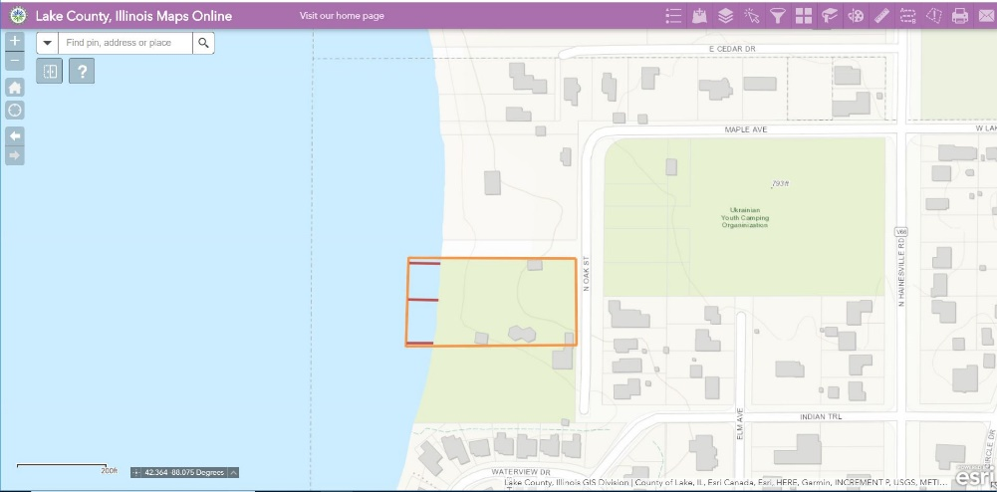
Continued Business
- Signage
  - Quote provided by Jeff Poynter previously is roughly $4,058.00
  - Group consensus to wait
  - Monika reported back the map provided (one directly off LCHD lake report) too blurry to work with for designers
- Fishing Backpack WDNR
  - Christine asked if we should go for this, approximate amount would be $121.00
  - Monika suggested we split backpacks up in age groups, younger and older individuals
  - Group was interested
- Finances
  - Bob said we had $5,918.02

NEXT MEEING AUGUST 1st as first Thursday in July is Independence Day

- Meeting ended around 7:45pm

