July 7, 2015
Greece – Compromise vs. Contagion

In recent days, the headlines have frequently been about Greece and the European Union and the big question - will they or won’t they reach an accord on debt payments so Greece can stay in the Eurozone, using the Euro as their currency, or will they leave the Euro currency and likely along with it, the European Union?
As the chart below shows, Greece enjoyed a golden period of low interest rates from the time the Euro was introduced until the financial crisis hit. Many feel this was a false situation and that Greece is just now getting back to where they should be based on their economy.
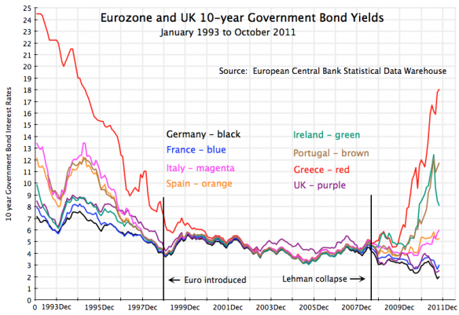
Desmond Lachman/American Enterprise Institute

During this period, Greece was able to get large loans at rates equivalent to those offered to low-risk German borrowers and used the funds to import goods from Germany and other Eurozone countries. Everybody was happy. When the financial crisis hit, Greece could no longer meet it’s debt obligations and eventually was offered additional loans so the major world banks would not have to write off the debt.

Now, those additional loans cannot be paid back either and the European Commission, the IMF and the European Central Bank (the Troika) are left with a difficult decision. Do they reach a compromise with Greece by either extending yet more loans with conditions attached (reform and more austerity) which it is impossible for Greece to repay, restructure the debt, i.e., write some of it off, or do they cut Greece loose from the Euro monetary system. Any of these choices may lead to a contagion among other countries in a similar situation. Is the Eurozone strong enough to stem such a contagion or would the entire experiment collapse?

Discussions are continuing between the Troika and Greece and the two sides are still far apart. The stakes are high. If an accomodation is found for Greece, then Italy, Spain, Portugal and possibly France will be in line demanding the same thing. If Greece leaves the Euro system and goes back to the drachma, those same countries may be more inclined to follow the Greek example and become again masters of their own fates.

A Grexit or Greek exit from the Euro will be very painful for the Greek people, but life has already become painful for them. The banks are closed and ATM machines are only dispensing EU$60 per day per person. There is a severe shortage of cash. Credit cards are useless and store shelves are emptying. The Greek recession is as bad as our own depression in the 1930s. Unemployment overall is at 25% and at 50% among the young. Conditions will worsen as food and supplies become scarcer.

The Greek economy is small. It is only about 2% of the overall Eurozone economy and was about equal in economic size to that of the greater Miami area in 2013 and likely smaller now. The impact Greece has on U.S. markets is more of a psychological one so far. As of September 2014, U.S. banks only held about $8 Billion of Greek debt so they are not heavily exposed to whatever happens.

The problem is that Greece is not alone in being seriously overextended on debt. It is a worldwide problem and there is a threat that the Greek situation will be reflected by a further contraction in the global economy as lenders become even more cautious and that this becomes the proverbial straw that broke the camel’s back sending the world into another deep recession.

We expect to see continued strength in the U.S. dollar as the Eurozone struggles. This should be reflected in continuing weakness in dollar-based commodity prices such as oil and copper which have fallen sharply recently. Gold is being supported by its role as an alternative currency although it is not finding strong buying. Our stock market is chopping sideways in a cautious mode. We are keeping a close eye on developments in Greece but an even closer eye on what is happening in China where stock market turmoil is pressuring those same commodities. Continue for a little more on China.

The Chinese stock market has fallen over 30% since mid-June following a gain of 117% over the past eight months. The Chinese government has tried to slow or contain the collapse by cutting lending rates and reducing reserve requirements for banks. The Central Bank is buying large-cap stocks, has cut trading fees and halted new IPOs. They are encouraging corporations, large stock holders and corporate executives to buy more stock in their companies. Brokerage companies pledged to buy over $19 Billion in stock. Over one-third of the stocks on the Shanghai and Shenzhen stock exchanges have halted trading which has frozen $1.4 Trillion. When these companies start trading again, a large portion of this equity will likely disappear.

Stock investment is more of a speculative activity in China than in the U.S. and does not play as big a role in household financial assets. However, because China is still a planned economy, the public expects the government to rescue the markets. Failure to do so could result in increased civil unrest which is the major fear of the Chinese government. Blame for the collapse is already being deflected to foreign short-sellers, notably the western banks. In true totalitarian fashion, phrases like “equity disaster” and “rescue the market” have been banned.

With China the largest growth economy in the world, trouble there is already spilling over into commodities such as crude oil and copper. So, is this a normal correction in an overextended market or the start of something more? Will Greece and the Eurozone be able to thread the needle on a solution? One thing is sure, the liklihood of a U.S. rate increase in 2015 is receding.

