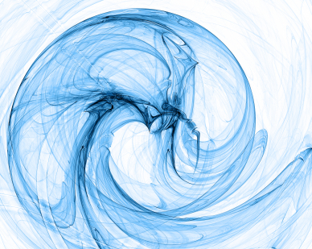  Everything is Energy!  How do you get started?  Energetic Flexibility is now being offered at  - Body of Santa Fe – Wednesday evenings from 7:15 to 8:45 (Drop-in or save with your class card or purchase of the series.).  - METHA of Santa Fe – Friday mornings at 11 am to 12 pm. Drop in or save with the purchase of a class card.) 1900 Chamisa St, Suite A. |  |  | Developed and Facilitated by:  Sue Bryan MA  Sue is a Mindset and Energy Mastery Coach with decades of experience in guiding people to know themselves as Spiritual Beings, to gain access to their natural power and to bring their dreams to life.  Contact Sue at Inward Journey  Phone: 818-497-4055  Email: imaginesue@inward-journey.com  Web: inward-journey.com  Beingtrulyhappy.com  Energetic Flexibility  Santa Fe, NM |  |  | Energetic Flexibility  - Because you are a holistic being

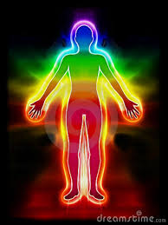  Everything is Energy  You work out your body…  You work out your mind…  But even though you are made of ENERGY, chances are good that you don’t have a clear idea of how to strengthen, and tone your energy body.  - A strong bio-energy system promotes wellness and well-being.  - Energetic Flexibility supports emotional resilience.  - Your Energy Practice promotes mental clarity and focus.  - A complete energy practice supports deep Spiritual development. |  |  | Features and Benefits:  - Gentle Body Movements which increase mobility and energy flow  - Cutting-edge Spiritual and Energy Psychology tools which open doors of perception  - Energy Exercises to strengthen and create resilience in the energy body – the chakras, meridians and aura  “Just wanted to thank you again for yesterday’s session. Wow! I got home and felt like I just got back from a vacation. Haven't felt sooo relaxed in a long time! I have been feeling Very centered and empowered ever since!!! Thank you for all the great tools and info.” Crystal  Each Energetic Flexibility Class is 60 to 90 min. (depending on venue) and includes:  - Gentle body movements – all abilities and ages are welcome  - Guided meditations and imagery to promote self-awareness and self-healing  - Energy exercises to strengthen the energy body and aura  - Exercises to increase flexibility and resilience of the mental/emotional planes.  . |  |  | When our energy is organized we are healed and powerful.  When we heal and empower ourselves we are making change at the deepest and most profound levels – for ourselves, for our loved ones and for the world.  Who Will Love this Class:  - Anyone interested in self-healing and energy healing  - Men and Women who want an alternative to strenuous Yoga or Dance but who want the benefits of feeling energized and powerful  - Clients recuperating from an injury  - Healers and Yoga teachers/students who want to add a nourishing hour to their weekly practice  .

