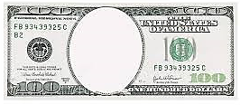
Whiskey
tax
Stamp
Act
Keynesian
Economic
theory
Federal
Reserve
Act
Underwood
tariff
16th
Amendment

