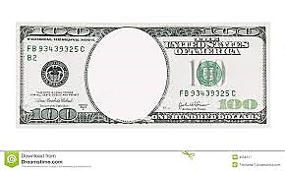

**Whiskey**

**tax**

**Stamp**

**Act**

**Keynesian**

**Economic**

**theory**

**Federal**

**Reserve**

**Act**

**Underwood**

**tariff**

**16th**

**Amendment**