THIS IS AN OPTIONAL BONUS ASSIGNMENT.
PRINT AND COMPLETE IN INK.
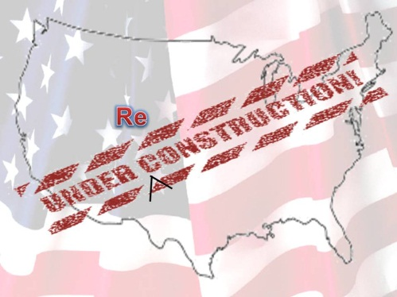

Name:_______________________________________

Class Period:____ Due Date:___/____/____

Guided Reading & Analysis: Reconstruction,
1863-1877 chapter 15- Reconstruction pp 291-304

Reading Assignment:
Ch. 15 AMSCO or other resource for Period 5.

Purpose:
This guide is not only a place to record notes as you read, but also to provide a
place and structure for reflections and analysis using your noggin (thinking skills)
with new knowledge gained from the reading. This guide, if THOUGHFULLY and
ACURATELY completed in its entirety BOP (Beginning of Period)
by the due date, will earn bonus points. The benefits of such activities, however,
go far beyond quiz help and bonus points. (graphic created by Rebecca Richardson using Microsoft clipart)
Mastery of the course and AP exam await all who choose to process the information as they read/receive.
This is an optional assignment. So… young Jedi… what is your choice? Do? Or do not? There is no try.

Directions:
- Pre-Read: Read the prompts/questions within this guide before you read the chapter.
- Skim: Flip through the chapter and note titles and subtitles. Look at images and read captions. Get a feel for the content you are about to read.
- Read/Analyze: Read the chapter. If you have your own copy of AMSCO, Highlight key events and people as you read. Remember, the goal is not
to “fish” for a specific answer(s) to reading guide questions, but to consider questions in order to critically understand what you read!
- Write Write (do not type) your notes and analysis in the spaces provided. Complete it in INK!

Key Concepts FOR PERIOD 5:
Key Concept 5.1: The United States became more connected with the world, pursued an expansionist foreign policy in the Western Hemisphere, and emerged as the destination for many migrants from other countries.
Key Concept 5.2: Intensified by expansion and deepening regional divisions, debates over slavery and other economic, cultural, and political issues led the nation into civil war.
Key Concept 5.3: The Union victory in the Civil War and the contested reconstruction of the South settled the issues of slavery and secession, but left unresolved many questions about the power of the federal government and citizenship rights.

Section 1 Guided Reading, pp 291-303

- Intro: Reconstruction, 1863-1877, page 291

Key Concepts &  Main Ideas | Notes
The Union victory in the Civil War and the contested Reconstruction of the South settled the issues of slavery and secession, but left unresolved many questions about the power of the federal government and citizenship rights. | Read the Frederick Douglas quote and first two paragraphs of the chapter on page 291.  Summarize the 5 main questions facing the nation at the end of the Civil War.  1)  2)  3)  4)  5)  What economic sectional conflicts remained in 1865?  Northerners wanted…  Southerners wanted…
Intro: Reconstruction, 1863-1877 Continued…

Key Concepts &  Main Ideas | Notes
The Union victory in the Civil War and the contested Reconstruction of the South settled the issues of slavery and secession, but left unresolved many questions about the power of the federal government and citizenship rights. | Why did the federal government focus more on political change in Reconstruction than economic assistance to freemen and aid for infrastructure in the devastated South (where most battles were fought)?  #AmericanIdentity!

- Reconstruction Plans of Lincoln and Johnson pp 292-294
REMEMBER…As you read the chapter, jot down your notes in the middle column. Consider your notes to be elaborations on the Objectives and Main Ideas presented in the left column and in the subtitles of the text. INCLUDE IN YOUR NOTES ALL SIGNIFICANT VOCABULARY AND PEOPLE. After read and take notes, thoughtfully, analyze what you read by answering the questions in the right column. Remember this step is essential to your processing of information. Completing this guide thoughtfully will increase your retention as well as your comprehension!

Key Concepts & Main Ideas | Notes | Analysis
The Civil War and Reconstruction altered power relationships between the states and the federal government and among the executive, legislative, and judicial branches, ending slavery and the notion of a divisible union, but leaving unresolved questions of relative power and largely unchanged social and economic patterns. | Reconstruction Plans of Lincoln and Johnson…  Lincoln’s Policies…  Proclamation of Amnesty and Reconstruction, 1863…  Wade-Davis Bill, 1864…  Freedmen’s Bureau, 1865…  Lincoln’s Last Speech…  Three days after Lincoln gave his speech at the White House, he and his wife attended a showing of Our American Cousin at Ford’s Theater, without his bodyguard, whom Lincoln had sent on assignment out of town. During the play, John Wilkes Booth entered Lincoln’s theater box and shot him in the head. Booth and his co-conspirators had originally plotted to kidnap Lincoln and ransom him for Confederate prisoners of war, after Grant refused to allow any further prisoner exchanges. However, as Booth understood that the Confederacy would lose the war, he changed his plan to an assassination in hopes that Lincoln’s death would rally the Confederates to continue the war. The group also planned to kill several other high-level officials in the U.S. government, including Vice President Andrew Johnson. Only Booth achieved his goal, though one of his co-conspirators seriously wounded Secretary of State William Seward. | How did Lincoln address the questions you summarized on page 1 of this guide?  1)  2)  3)  4)  5)  Identify the controversy in Lincoln’s plan as illustrated by the Wade-Davis Bill. What does this reveal about Northern-Southern relations?
Reconstruction Plans of Lincoln and Johnson continued…

Key Concepts & Main Ideas | Notes | Analysis
The Civil War and Reconstruction altered power relationships between the states and the federal government and among the executive, legislative, and judicial branches, ending slavery and the notion of a divisible union, but leaving unresolved questions of relative power and largely unchanged social and economic patterns.  The 13th Amendment abolished slavery, bringing about the war’s most dramatic social and economic change, but the exploitative and soil-intensive sharecropping system endured for several generations. | Johnson and Reconstruction…  Johnson’s Reconstruction Policy…  Southern Governments of 1865…  Thirteenth Amendment…  Black Codes…  Johnson’s Vetoes… | Support, refute, or modify the following statement: The Presidential Plans for Reconstruction reflected the belief that the primary goal post-war was to reunite the nation. Write a complete thesis, and then defend your answer with evidence.

- Congressional Reconstruction, pp 295-297

Key Concepts  & Main Ideas | Notes | Analysis
The Civil War and Reconstruction altered power relationships. | Congressional Reconstruction…  Radical Republicans… | Was Congressional Reconstruction more about racial equality or political power? Explain your answer.

Congressional Reconstruction continued…

Key Concepts  & Main Ideas | Notes | Analysis
Efforts by radical and moderate Republicans to reconstruct the defeated South changed the balance of power between Congress and the presidency and yielded some short-term successes, reuniting the union, opening up political opportunities and other leadership roles to former slaves, and temporarily rearranging the relationships between white and black people in the South.  The constitutional changes of the Reconstruction period embodied a Northern idea of American identity and national purpose and led to conflicts over new definitions of citizenship, particularly regarding the rights of African Americans, women, and other minorities. | Civil Rights Act of 1866…  Fourteenth Amendment…  Report of the Joint Committee…  The Election of 1866… | What was the primary purpose of the 14th Amendment?  By defining citizens as anyone born in the United States, how did this Amendment create future conflict?
The image at left was a two page spread in Harpers Weekly by artist Thomas Nast, printed in 1866. President Andrew Johnson was chosen as Lincoln’s Vice President in 1864 (National Union Party… not Republican or Democrat) to secure re-election at a time of waning support. He was actually a pro-Union Democrat from Tennessee who had seen his property, home, and slaves stolen by Confederates during the first year of the war. He became president in 1865 following Lincoln’s assassination. In 1866, Johnson led his “Swing around the Circle,” a 1966 campaign trip through the Midwest, attempting to win popular support for his lenient Reconstruction policy. He was battling the Radical Republicans who feared allowing ex-rebel Democrats would regain control of the South. They had prevented them from being seated in Congress in protest of the Southern Black Codes. On the Circle Tour… in one speech lasting an hour, the President referred to himself more than two hundred times. In another, he went so far as to imply that the murder of Abraham Lincoln had been part of God's plan to make him president. At a third event, he said that Rep. Thaddeus Stevens, the Republican majority leader, deserved to be hanged. (He said this after a heckler in the crowd said, “Hang Jeff Davis!”)

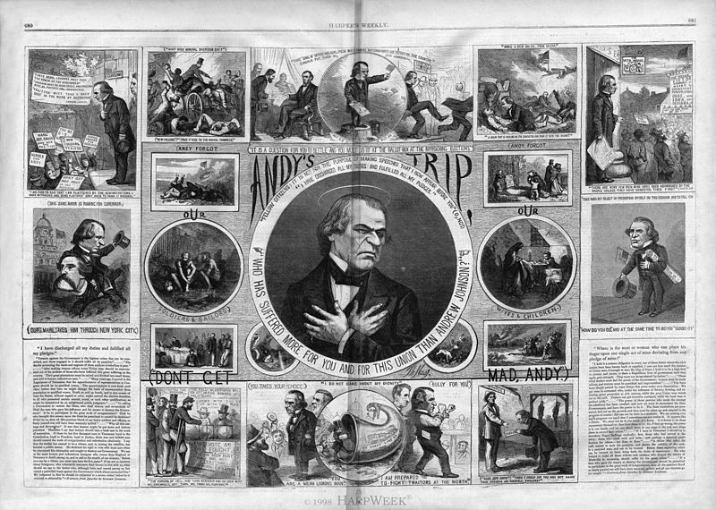

Johnson accused Radical Republicans of planting hecklers, inciting riots, including the New Orleans Riot, and of wanting to keep the nation divided rather than re-uniting it.
After Johnson compared himself to Jesus by saying that like the Savior, he too liked to pardon repentant sinners, his remaining speeches were drowned out by hecklers. State government officials refused to be seen with him. In the midterm elections that November, so disgusted were most Americans at Andrew Johnson that Republicans won two-thirds majorities in both houses of Congress. The GOP was then able to enact legislation to “rescue” southern states from the “neo-Confederate” Democrats. Thus began Radical Reconstruction.
Congressional Reconstruction continued…

Key Concepts & Main Ideas | Notes | Analysis
Efforts by radical and moderate Republicans to reconstruct the defeated South changed the balance of power between Congress and the presidency and yielded some short-term successes, reuniting the union, opening up political opportunities and other leadership roles to former slaves, and temporarily rearranging the relationships between white and black people in the South.  Radical Republicans’ efforts to change southern racial attitudes and culture and establish a base for their party in the South ultimately failed, due both to determined southern resistance and to the North’s waning resolve.  Although citizenship, equal protection of the laws, and voting rights were granted to African Americans in the 14th and 15th Amendments, these rights were progressively stripped away through segregation, violence, Supreme Court decisions, and local political tactics.  The Civil War Amendments established judicial principles that were stalled for many decades but eventually became the basis for court decisions upholding civil rights. | Reconstruction Acts of 1867…  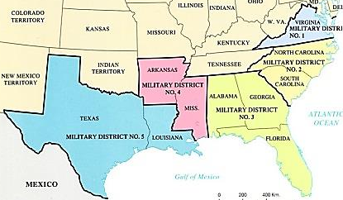  Impeachment of Andrew Johnson…  Reforms After Grant’s Election…  The Election of 1868…  Fifteenth Amendment…  Civil Rights Act of 1875… | Explain how the” Swing Around the Circle” affected Radical Republican attitudes toward Johnson.  Explain how Radical Reconstruction illustrated the continued conflict between contract and compact political theories.

- Reconstruction in the South, pp 298-300

Key Concepts & Main Ideas | Notes | Analysis
Efforts by radical and moderate Republicans to reconstruct the defeated South changed the balance of power between Congress and the presidency and yielded some short-term successes, reuniting the union, opening up political opportunities and other leadership roles to former slaves, and temporarily rearranging the relationships between white and black people in the South. | Reconstruction in the South… | Based on this information, explain why Texas did not rejoin the Union until 1873.
Reconstruction in the South Continued…

Key Concepts & Main Ideas | Notes | Analysis
Efforts by radical and moderate Republicans to reconstruct the defeated South changed the balance of power between Congress and the presidency and yielded some short-term successes, reuniting the union, opening up political opportunities and other leadership roles to former slaves, and temporarily rearranging the relationships between white and black people in the South.  Radical Republicans’ efforts to change southern racial attitudes and culture and establish a base for their party in the South ultimately failed, due both to determined southern resistance and to the North’s waning resolve.  The 13th Amendment abolished slavery, bringing about the war’s most dramatic social and economic change, but the exploitative and soil-intensive sharecropping system endured for several generations. | Composition of the Reconstruction Governments…  Scalawags and Carpetbaggers…  African American Legislators…  Evaluating the Republican Record…  Accomplishments…  Failures…  African Americans Adjusting to Freedom…  Building Black Communities…  Sharecropping… | Explain two forces that led to African American suffrage and public service despite Southern resistance.  Support, refute, or modify the following statement: Radical Republicans worked for positive change in the best interest of all citizens. Write a complete thesis and defend your answer!  To what extent was sharecropping an economic and social improvement for African American farm workers in the South? Defend your answer!
- The North During Reconstruction, pp300-302

Key Concepts & Main Ideas | Notes | Analysis
Efforts by radical and moderate Republicans to reconstruct the defeated South changed the balance of power between Congress and the presidency and yielded some short-term successes, reuniting the union, opening up political opportunities and other leadership roles to former slaves, and temporarily rearranging the relationships between white and black people in the South.  FROM PERIOD 6 CONTENT OUTLINE:  Gilded Age politics were intimately tied to big business and focused nationally on economic issues — tariffs, currency, corporate expansion, and laissez-faire economic policy — that engendered numerous calls for reform.  Corruption in government — especially as it related to big business — energized the public to demand increased popular control and reform of local, state, and national governments, ranging from minor changes to major overhauls of the capitalist system. | The North During Reconstruction…  Rise of the Spoilsman…  Corruption in Business and Government…  The Election of 1872…  The Panic of 1873… | FYI: The Grant years crossover between Reconstruction Era and its issues… to the Gilded Age and its issues. Some of the objectives for this section are going to be emphasized more in the next unit.  To what extent was the Panic of 1873 responsible for the end of Reconstruction. Defend your answer!

- The End of Reconstruction, pp302-303

Key Concepts & Main Ideas | Notes | Analysis
Radical Republicans’ efforts to change southern racial attitudes and culture and establish a base for their party in the South ultimately failed, due both to determined southern resistance and to the North’s waning resolve. | The End of Reconstruction…  White Supremacy and the Ku Klux Klan… | Nathan Bedford Forest State Park in Tennessee has been under attack as a movement to change its name is underway. Support or refute the assertion that historical monuments and parks named after racists should be removed or renamed. Defend your view.

Key Concepts & Main Ideas | Notes | Analysis
Radical Republicans’ efforts to change southern racial attitudes and culture and establish a base for their party in the South ultimately failed, due both to determined southern resistance and to the North’s waning resolve. | The Amnesty Act of 1872…  The Election of 1876…  The Compromise of 1877… | In his autobiography, U.S. Grant stated that his biggest regret was removing the military… that they pulled out too soon. Support or refute this viewpoint. Defend your answer!

- Historical Perspectives: Did Reconstruction Fail? pp 303-304

The William Dunning view… | The W.E.B. Du Bois, John Hope Franklin, and Kenneth Stamp’s view… | Modern Historians’ view, including Eric Foner…

Which viewpoint do you support most? Explain your choice.

In Review…
(fill in the blanks)
Radical Republicans were kept in line by the moderate Lincoln. His death let them loose under the weaker Johnson. Johnson was the only Southern Senator to stay in Congress after the secession of the South… which is why Lincoln chose him as VP in ______… but that did not mean he could handle the radicals.

_____________ continued Lincoln’s lenient plan, but radicals demanded the South be punished for slavery and secession.

Congress challenged Lincoln’s ___% Plan with the ___% Wade-Davis Bill. Lincoln pocket vetoed the bill.

Lincoln developed his ___% Plan in 1863 and begun re-admittance before the South surrendered at Appomattox in 1865.

Radicals ensured the _____ Amendment was ratified, ending slavery. Southerners resented growing power of freedmen. Race riots spread across the South to protest the _____________ Act.

Radicals had no opposition while taking over the reconstruction of the South. They passed the ______________ Act in 65. Johnson vetoed. Congress overrode veto. (first time in history)

Radical Republicans refused to seat______________ representatives… open
defiance of the Presidential
plan.

Johnson angered Radicals when he issued ________________ for all but those above the rank of colonel. He also allowed Southern states to hold elections
to Congress in late 1865.

Southern state governments were subject to Union military commanders. This second class status continued until they gave Black men the right to vote and ratified the ______ Amendment.

The __________ was treated as a foreign nation. Many lost the right to vote (again) as Congress started over with the process of readmitting states.

Johnson vetoed it, Congress overrode veto. The radicals then took over reconstruction of the south by _______________ occupation.

Congress clearly marked the end of Presidential Reconstruction when the passed the First _______________________
Act in 1867.

Grant suspended habeas corpus as he went after the _______ after the 1871
________________Act.

Southern states had to ratify the _______ Amendment giving the right to vote to all men. Resentment led to the rise of the ____________.

Many Freedmen voted while many Southern Whites couldn’t, resulting in large numbers of _________________
being elected.

Radicals took over the executive with their “bloody shirt,” bringing in
________________.

Johnson condemned the plan as harsh, but was silenced by Congress though ______________
__________ Act and ________________.

Breaking the Confederate spirit and forcing the social reformation of the South proved idealistic, and Northerners eventually gave up or lost interest.
The troops were removed following the _____________________, and the South rose again… re-implementing a racist culture with segregation and disenfranchisement.

How would you characterize the point of view of this review? How does it differ from your textbook?

Reading Guide written by Rebecca Richardson, Allen High School
Sources include but are not limited to: 2015 edition of AMSCO’s United States History Preparing for the Advanced Placement Examination, 2012 and 2105 Revised College Board Advanced Placement United States History Framework,
The Mental Floss History of the United States by Erik Sass , and other sources as cited in document and collected/adapted over 20 years of teaching and collaborating..

