 | Giving You the Access Advantage

ABOUT TRACEY AYERS AND HEALTH E-SCHEDULER
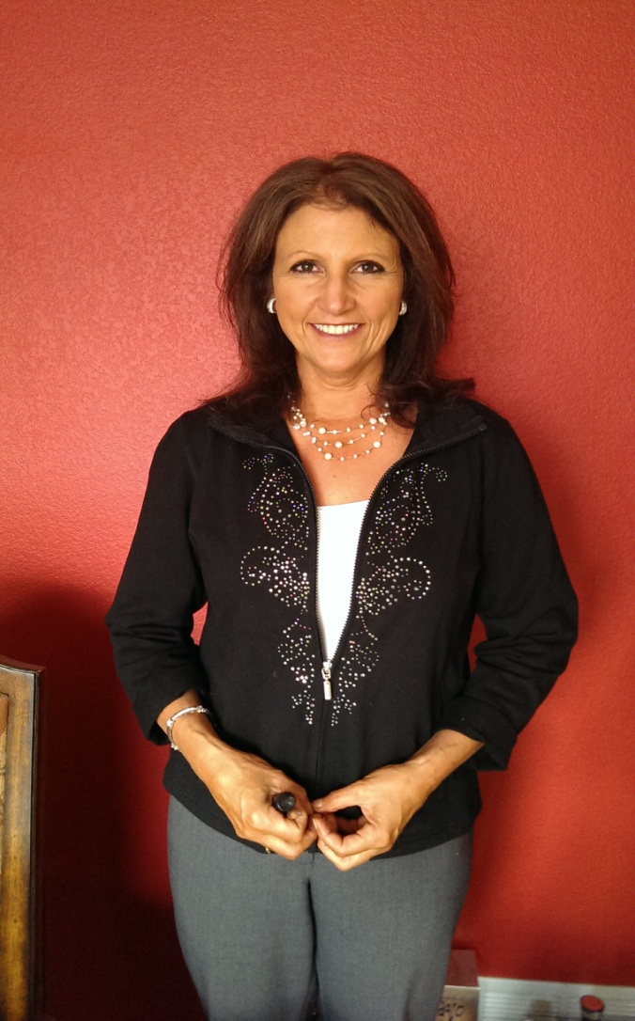

As with many new businesses, Healthe-Scheduler grew out of necessity. Tracey Ayers is the Co-Owner of mental health therapy group practice that needed another means of scheduling to keep up with having a successful, high volume agency. The receptionist could only deal with the calls during business hours. Virtually, 90% of new customers were scheduling through the receptionist and the "after hours" and voicemail messages requesting rescheduling were becoming overwhelming. Literally, hours were being spent trying to reach potential new customers to set first appointments and current customers to reschedule appointments. Something needed to be done!
In 2005, with the help of a web programmer, an online scheduling system was created that was easy to use and didn't require any software. In a matter of months, the live receptionist scheduling of appointments dropped from 90% to approximately 10%. The system was also freeing our group’s contractors from spending hours calling and rescheduling appointments. To top it off, customers (sales representatives to accountants to attorneys) of the agency began requesting if they could purchase the system for their own use. After much deliberation and consideration, the system was made available to the public. Tracey's agency is going on a very successful 10-year anniversary of using the Healthe-Scheduler system.

Healthe-scheduler Inc. is located at:
7800 S. Elati Street, #230
Littleton, CO 80120
(303) 654-4355

© 2014 Healthe-Scheduler. All rights reserved. Read our Privacy policies.

