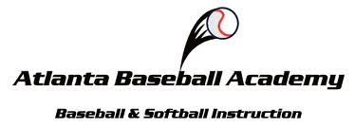
Social Media and Group Text Policy
Atlanta Baseball Academy uses social media and Group Text to advertise and communicate to parents and players. Social Media and Group Text is not to be used to complain or degrade other players, parents, coaches, umpires, or assistant coaches. Any and all violations of this policy will have an adverse effect on your child’s spot on an ABA Travel Team at the time of the violation and in the future going forward. Please deal with your teams coaches directly and not in any open forum. The ABA Executive Board will have complete decision making power on the consequences for violating this policy, which may include player suspension, parent suspension from games or practices, or dismissal from the said team.

By signing this form, you agree to adhere to the ABA Social Media and Group Text policy. You also understand the consequences of violating this policy.

Parent Signature Date

