Patient Information Form

Date: ____/_____/_____

Patient Name: _________________ _________________ ____ Date of Birth: ____/____/____ Age: ____ Sex: M F
Last First MI

Home Address: ______________________________________ City/State: ________________________ Zip: _____________

May we leave a message?
Home Phone #: (_____) _____-________ Yes No

Work Phone #: (_____) _____-________ Yes No

Cell Phone #: (_____) _____-________ Yes No

E-mail: _____________________________________ Yes No

Primary Language: __________________________

Race:___________________________________________ Ethnicity:____________________________________

Do you have a legal guardian or healthcare power of attorney? Yes No
If yes, Name: ____________________________ Relationship: _____________ Phone #: (_____) _____-_______

Emergency Contact: ____________________________ Relationship: _____________ Phone #: (_____) _____-_______

Primary Care Doctor: ___________________________________________ Phone: __________________________________
Pharmacy: _____________________________ Location: __________________________ Phone #: (_____) _____-_______

Is there a family member or other person you would like for us to share your medical information?
______ Yes Name(s) ___________________________________________________________________________________

______ No

Who is responsible for payment? ______________________________ Relationship to patient? ________________

Address: ________________________ City/State: _________________ Zip: _________ Phone #: (_____) _____-______

Who Referred You To Us?___________________________________________________________________________________

Insurance Information

Primary Insurance Company Name: _________________________________________________________________________

Address: ________________________ City/State: _________________ Zip: _________ Phone #: (_____) _____-______

Insured Name: __________________________ Date of Birth ______________ Employer ___________________________

Contract # __________________ Group # ____________________

Secondary Insurance Company Name: _______________________________________________________________________

Address: ________________________ City/State: _________________ Zip: _________ Phone #: (_____) _____-______

Insured Name: __________________________ Date of Birth ______________ Employer ___________________________

Contract # __________________ Group # ____________________
Please list all medications you are currently taking (Include prescriptions, over-the-counter meds and herbal supplements):
Name Dose How often do you take?
_______________________________________________________________________________________________________________________________________________________________________________________________________________________________________________________________________________________________________________________________________________________________________________________________________________________________________________________________________________________________________________________________________________________________________________________________________________________________________________________________________________________________________________________________________________________________________________________________________________________

Please list all prior surgeries:
Type of Surgery Date Type of Surgery Date
________________________________________________________ ______________________________________________________
________________________________________________________ ______________________________________________________
________________________________________________________ ______________________________________________________

Please list all prior hospitalizations (other than for surgery):
Reason For Hospitalization Date Reason For Hospitalization Date
________________________________________________________ ______________________________________________________
________________________________________________________ ______________________________________________________
________________________________________________________ ______________________________________________________

Social History
Marital Status:  Single  Married  Partnered  Separated  Divorced  Widowed

Use of Alcohol:  Never  No longer use  History of alcohol abuse
 Current USE - Type __________________  Rare  Occasional  Moderate  Daily

Use of Tobacco:  Never  Quit – how long ago? _________  Smoke ____ packs/day for ____ years

Use of Recreational Drugs:  Never  Quit – How long ago? _________ Type _______________________

 Current USE - Type _______________  Rare  Occasional  Moderate  Daily

Employer: _______________________________________ Occupation: ____________________________________________

How much are you on your feet at work?  10%  25%  50%  75%  100%

Do others depend upon you for their care?  Children–age(s) _______  Pet(s)–what kind? ________
 Elderly or disabled family member  Other ____________________________________________

Exercise:  Never  Rare  Occasional  weekly  Several times a week  Daily

Types of exercise: _____________________________________________________________________________________

Family History
Do you have a family history of:  Diabetes: Type 1 or Type 2  Cancer  Heart Disease
 High Blood Pressure  Stroke  Coronary Artery Disease  Thyroid Disease
 Rheumatoid Arthritis
 Other _______________________________________________________________________________________________

Your Medical History
Allergies:  Medications ______________________________________________________________
 Anesthesia _________________________________  Foods ____________________________________
 Tape  Latex  Shellfish  Iodine  Other _______________________________________
 None Known

Have you ever had any of the following?
Acid Reflux | Y | N |  | Fibromyalgia | Y | N |  | Neuropathy | Y | N
Anemia | Y | N |  | Gout | Y | N |  | Open Sores | Y | N
Arthritis | Y | N |  | Heart Attack | Y | N |  | Pneumonia | Y | N
Asthma | Y | N |  | Heart Disease/Failure | Y | N |  | Polio | Y | N
Back Trouble | Y | N |  | Hepatitis | Y | N |  | Rheumatic Fever | Y | N
Bladder Infections | Y | N |  | HIV+/AIDS | Y | N |  | Sickle Cell Disease | Y | N
Abnormal Bleeding | Y | N |  | High Blood Pressure | Y | N |  | Skin Disorder | Y | N
Blood Clots | Y | N |  | Kidney Disease | Y | N |  | Sleep Apnea | Y | N
Blood Transfusion | Y | N |  | Liver Disease | Y | N |  | Stomach Ulcers | Y | N
Bronchitis/Emphysema | Y | N |  | Low Blood Pressure | Y | N |  | Stroke | Y | N
Cancer | Y | N |  | Migraine Headaches | Y | N |  | Thyroid Disease | Y | N
Diabetes: Type 1 or Type 2 (circle) | Y | N |  | Mitral Valve Prolapse | Y | N |  | Tuberculosis | Y | N
Other Conditions:

Current Problem
What specific problem brings you to our office today? __________________________________________________

Where is the pain/problem located? Please mark on the pictures below.

Left Foot Right foot
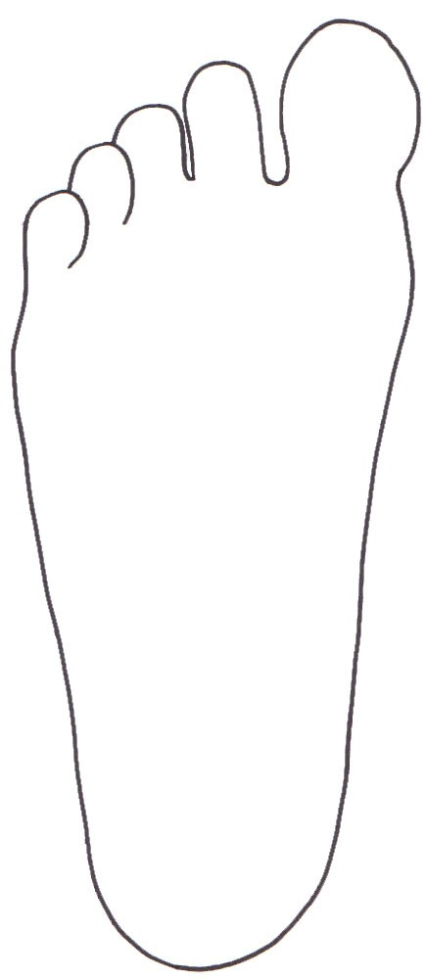
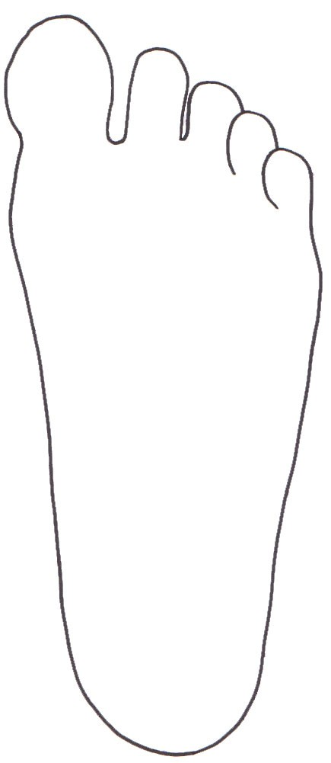
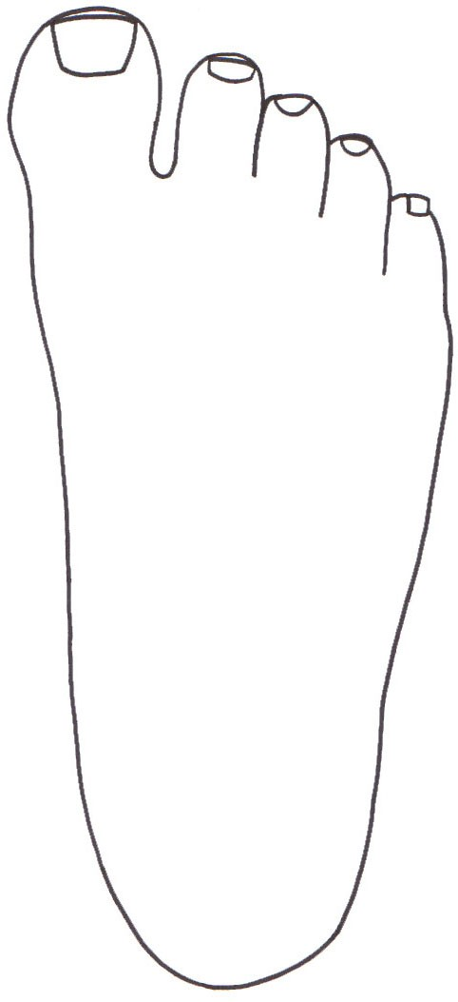



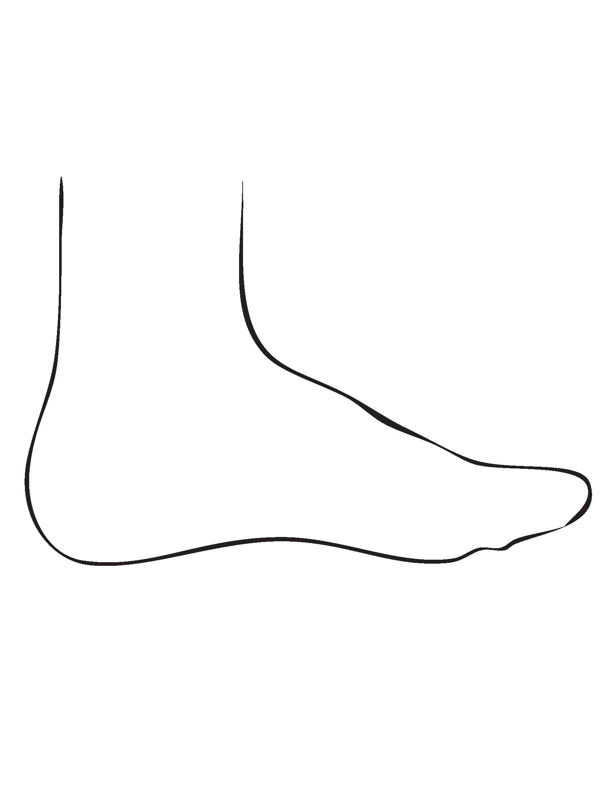
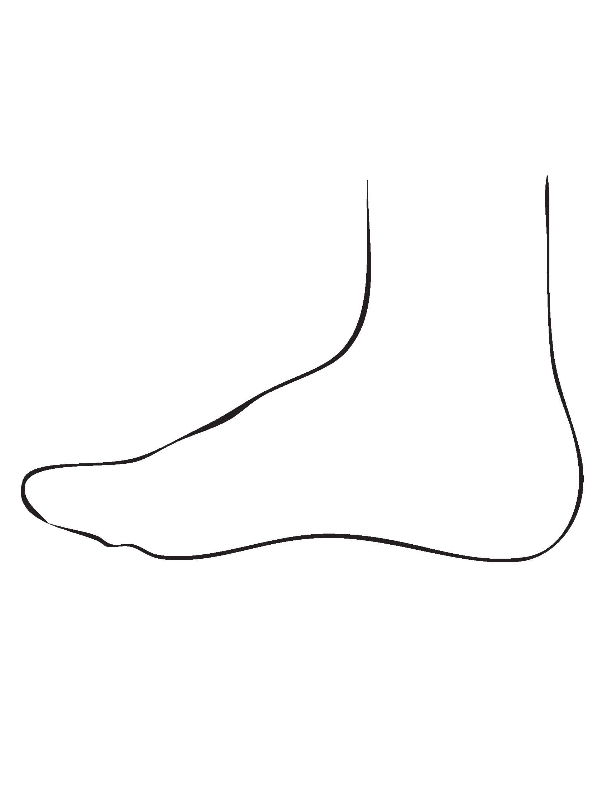

Top of Foot
Bottom of Foot
Bottom of Foot
Top of Foot

Inside of foot
Outside of Foot
Outside of Foot
Inside of foot

How long ago did this problem first start? __________ Days / Weeks / Months / Years

Did your pain or problem:  Begin all of a sudden  Gradually develop over time

How would you describe your pain?  No pain  Sharp  Dull  Aching  Burning
 Radiating  Itching  Stabbing  Other ________________________________________________

How would you rate your pain on a scale from 0 to 10? (please circle)
(no pain) 0 1 2 3 4 5 6 7 8 9 10 (worst pain possible)

Since the time your pain or problem began, has it:  stayed the same  become worse  Improved

What makes your pain or problem feel worse?  Walking  Standing  Daily activities
 Resting  Dress shoes  High heels  Flat shoes  Any closed toe shoe
 Running  Other ________________________________________________________________________________

What makes your pain or problem feel better? ____________________________________________________________

What treatments have you had for this problem? _________________________________________________________

How has this problem affected your lifestyle or ability to work? _______________________________________

Was this problem caused by an injury?  Yes (describe) _________________________________________  No

If yes, was it a work-related injury?  Yes  No

To the best of my knowledge, I have answered the questions on this form accurately. I understand that providing incorrect information can be dangerous to my health. I understand that it is my responsibility to inform the doctor and office staff of any changes in my medical status.

I hereby consent and give my permission to the doctor to administer and perform such procedures upon me as the doctor deems necessary.

___________________________________________________
Print name of patient, parent or guardian
___________________________________________________ ___________________________________________________
If other than patient, relationship to patient Date

____________________________________________________
Signature

