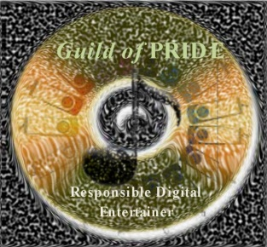

The Guild of PRIDE

Steps for Elite Membership Status

The following is a simple list of the steps that must be followed by all Elite members of The Guild of PRIDE. These steps must be used to review all music that you use in teaching and entertaining to insure that it has been obtained and is maintained in a manner which properly compensates the artists and producers responsible for its creation and distribution. Continue to follow these steps to obtain and maintain your music while not allowing others to copy or use copies of this music as long as you retain personal ownership.

- Review your entire music collection and identify any tunes you use (but do not own the original) when you teach or entertain. There might be a few that are unique commercial titles. Once you have identified any music that may fall into this category, purchase a “legal” copy of them.

- Review all music you use when you teach or entertain, or are intending to possibly use now and/or in the future to make sure you have purchased each piece of music and that you have a receipt for its purchase.

- Keep a current, updated file with copies of all receipts and/or purchase information for music you use. This file should contain as many past purchased receipts as possible, and receipt information for all future music purchases. You may have a paper file, a digital file, or both

- If you are transferring, have transferred to another mode, or obtained music for performing that was purchased in the past, keep the original copy as proof of purchase and prevent others from copying your single user license source.

- If copies of music or edited music have been obtained from sources that you cannot confirm the purchase of or authenticate an original, buy another copy or procure the original and place the receipt in your file.

- Confirm by signing the attestation on the Elite Member Application that you have read and understand the most current list of “Do’s and Don’ts” in this package and/or online at: www.GuildofPRIDE.org.

- Confirm by signing the attestation on the Elite Member Application Form that you have read and understand the most current list of “Scenarios” in this package and/or online at: www.GuildofPRIDE.org.

- There are legitimate instances of complimentary copies of music that are exchanged between the producers, distributors, and performers. This type of legitimate music exchange is perfectly acceptable and qualifies for a single user license. This exchange should be able to be confirmed by the artists and producers responsible for its creation and distribution.

- Sign the Elite Member Application of Professional Recorded Instrumental Digital Entertainers and keep your membership fee current in U.S. funds to receive your lapel pin and to cover the cost of administration and website maintenance.

- By signing the Elite Member Application, and accepting the invitation to join The Guild of PRIDE, you agree that you are prepared to accept any inquiry into your professional conduct resulting from an allegation of impropriety regarding music ethics.

Elite Members of The Guild of PRIDE will take the action shown above to comply with the “Professional Statement” that is shown below:

PROFESSIONAL STATEMENT
I have taken the time to ensure that every piece of music that I have available to use when I teach or entertain is “Paid-In-Full” (all copyright owners have received full payment for the rights to use the music).

NOTE: It is the responsibility of the producer of any piece of music to obtain the distribution rights from the writer(s) and publisher(s). It is the responsibility of the performer to use only music for which the producer has received payment-in-full and to obtain a performance license to use the music at venues open to the public.

