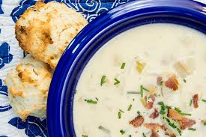

Chowder &

Fritters

***Music by T. Ray at 6:30***

**Tickets available for purchase at the bar**

**4:00 pm-closing weekdays**

**noon-closing on weekends**

***Call 860-537-2550 for more details***

## **Advanced ticket price: $12.00 per person**

## ($15.00 at the door)

**friday, august 4, 2017**

**4:00 pm to 7:00 pm**

# St. Joseph’s Polish Society * 395 South Main Street * Colchester, CT 06415

# Visit our website at [stjoespolishclub.com](http://stjoespolishclub.com)