
The City of
OLD TOWN




Application for Employment

OLD TOWN PUBLIC SAFTETY
150 Brunswick Street
Old Town ME 04468
(207)827-3984

“We are an equal opportunity employer and service provider”

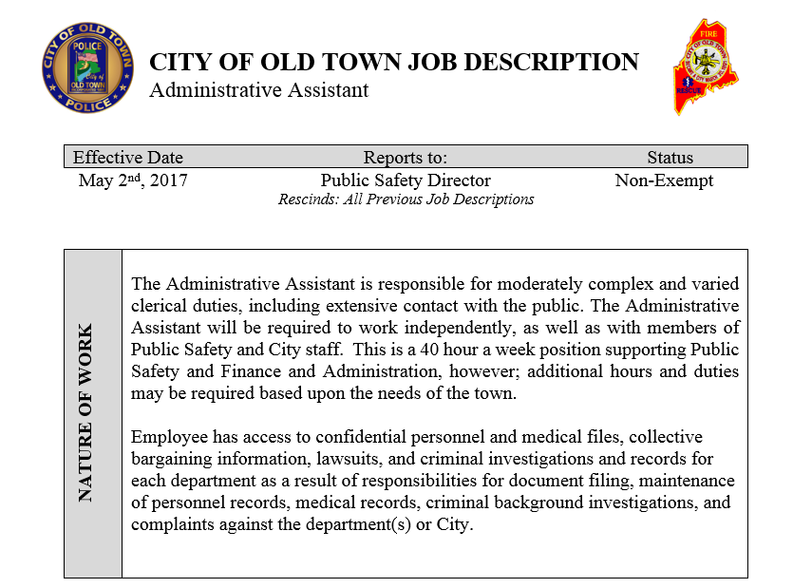
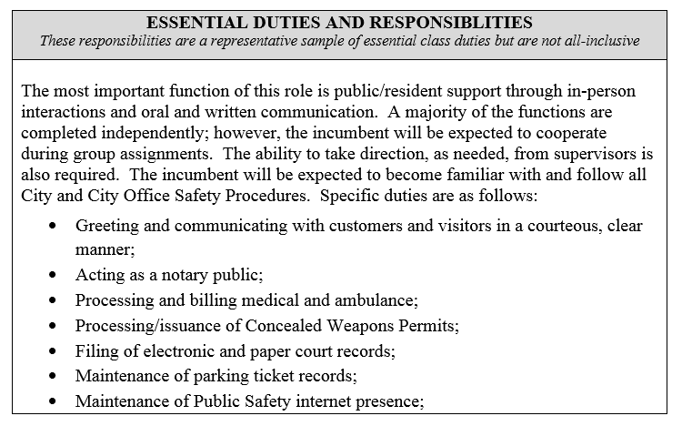
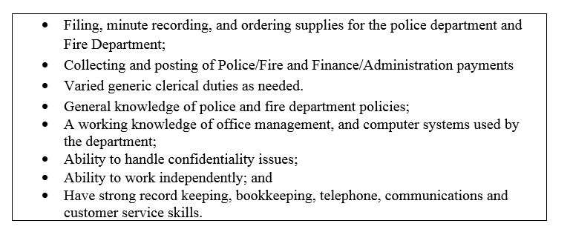
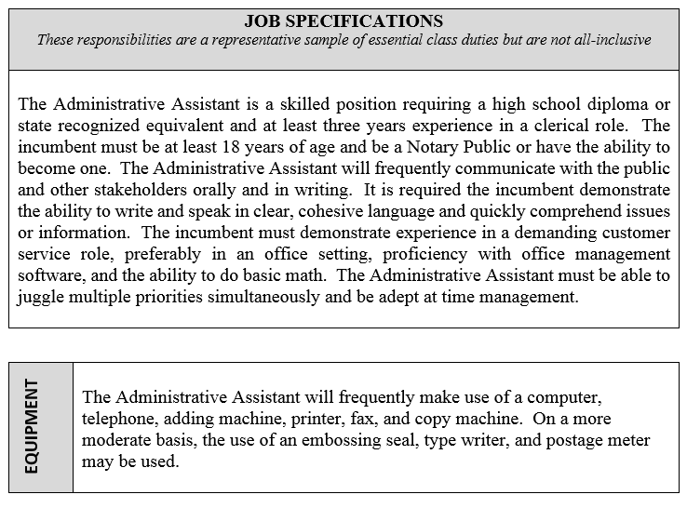
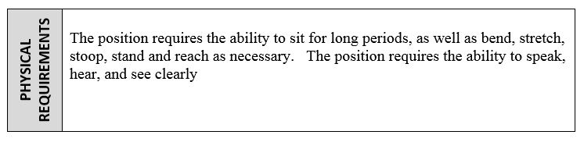
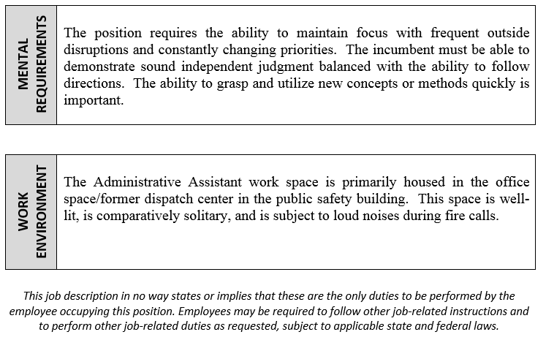

City of Old Town

APPLICATION FOR EMPLOYMENT

We consider applicants for all positions without regard to race, color, religion, creed, gender, or national origin, age, disability, marital or veteran status, sexual orientation, or any other legally protected status.

PLEASE PRINT/TYPE:
Position(s) applying for: |  | Date of  Application

Last Name |  |  |  |  |  |  | First Name |  |  |  |  |  |  | Middle
Street Address |  |  |  |  |  | City |  |  |  |  | State |  |  | Zip Code
Telephone Number |  |  |  |  |  |  |  | Social Security Number

If yes, where?
Are you currently employed? Yes No

May we contact your present employer? Yes No

Are you eligible to be lawfully employed in the U.S.? Yes No
On what date could you begin work?

Have you filed an application here before? Yes No
When
When

Have you ever worked for the City before? Yes No

Can you work (circle all that apply): Full Time Part Time

Have you had any motor vehicle violations in the last 5 years? Yes No

Have you ever been convicted of a felony? Yes No
If yes, please explain:

Education:

 | Elementary | High School | College/University | Graduate/Professional
School Name
Years Completed | 4 5 6 7 8 | 9 10 11 12 | 1 2 3 4 | 1 2 3 4 5+
Diploma/Degree
Course of Study
Specialized Training

Veteran of the US Military Yes No If yes, what branch and rank:

Describe any job-related training received in the US Military:

Qualifications and Specialized Training

Employment Experience

From |  |  |  |  | To |  |  |  | Employer
Address
Phone # |  |  |  |  |  |  |  | Job Title
Supervisor |  |  |  |  |  |  |  |  |  | Job Title
Reason for Leaving

From |  |  |  |  | To |  |  |  | Employer
Address
Phone # |  |  |  |  |  |  |  | Job Title
Supervisor |  |  |  |  |  |  |  |  |  | Job Title
Reason for Leaving

From |  |  |  |  | To |  |  |  | Employer
Address
Phone # |  |  |  |  |  |  |  | Job Title
Supervisor |  |  |  |  |  |  |  |  |  | Job Title
Reason for Leaving

You may attach a separate sheet of paper if you need more space or if you feel you need to explain something about one of the other questions. Please feel free to attach a resume, if available.

State any additional information you feel may be helpful to us considering your application.

References:

Name |  | Phone
Name |  | Phone
Name |  | Phone

After reading the attached job description do you think you are capable of performing in a reasonable manner, with or without a reasonable accommodation, the activities involved in the job or occupation for which you have applied? Yes No

Applicant’s Statement

I certify that answers given in this application are true and complete to the best of my knowledge. I authorize the City of Old Town or any of its agents to investigate all statements contained in this application for employment as may be necessary in arriving at an employment decision.
This application for employment shall be considered active for a period of time not to exceed 45 days. This application will be considered only for the position listed and will not automatically be considered for any other position that may occur. Any applicant wishing to be considered for employment beyond this time period or for the other vacant positions should inquire as to whether or not applications are being accepted at this time.
I hereby understand and acknowledge that, unless otherwise defined by applicable law, any employment relationship with the City of Old Town is of an “at will” nature, which means that the Employee may resign at any time and the Employer may discharge Employee at any time with or without cause. It is further understood this “at will” employment relationship may not be changed by any written document or by conduct unless such change is specifically acknowledged in writing by an authorized executive of this organization.

In the event employment, I understand that false or misleading information given in my application or interview(s) may result in discharge. I understand, also, that I am required to abide by all rules and regulations of the City of Old Town.

_________________________________ _____________________________
Signature of Applicant Date

