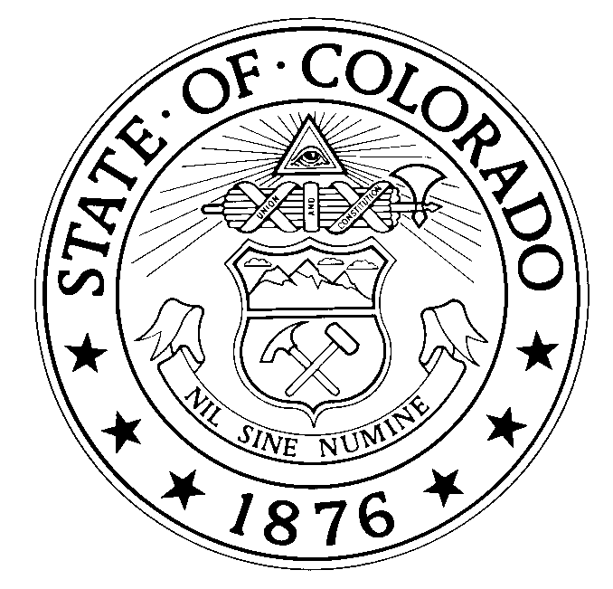
COLORADO AIR NATIONAL GUARD
140TH WING
BUCKLEY AIR FORCE BASE, AURORA, COLORADO

12 Oct 2018

MEMORANDUM FOR: Buckley Undergraduate Pilot Training Applicant

FROM: Buckley Pilot Hiring Board

SUBJECT: Buckley Prospective Pilot Letter

Thank you for your expressed interest in the Colorado Air National Guard. In order to determine your basic eligibility for appointment in the Air National Guard, the documents below must be submitted to the hiring board contact found at www.buckleypilotjob.com:

____ Birth Certificate (copy acceptable)
____ Certified College Transcripts (copy acceptable)
____ Copy of Flight Certificates (if possessed/pilot license not required)
____ Resume of Work Experience and Education
____ 3 letters of recommendation (from former employers, instructors, friends)
____ Current Physical (FAA 2st Class Medical)
____ Air Force Officer Qualification Test Scores (AFOQT)
____ Test of Basic Aviation Skills (TBAS)
____ Pilot Candidate Selection Method Score (PCSM)
____ Form 18
____ UPT PowerPoint Summary
____ Recent 3x5 photograph

Please submit all of the above documents in one packet. Do not send them separately. Incomplete packages will not be considered.

If you have not taken the AFOQT, contact MSgt Jorge Gonzalez (COANG recruiting) at 720-847-9457 to schedule testing. The AFOQT is administered once per month. Typically it takes 2 weeks to receive test scores so arrange to take it soon.

If you have any prior military service, please forward copies of DD form 214 and\or a summary of reserve points earned.

Applicants must meet ALL of the following requirements in order to be considered:

- 20/70 vision, correctable to 20/20, and be free of color blindness
- Meet Air Force height and weight requirements
- Bachelors Degree
- Applicant must be physically fit and able to run 1 ½ miles in under 12 minutes
- Under the age of 30 prior to beginning Flight training

BANG!

Buckley Pilot Hiring Board

120th Fighter Squadron

