A CPD course providing 4 hours of verifiable activity that describes and explains the new Greater Manchester Saving Smiles guide – helping practitioners to manage dental trauma. Key to the CPD is the Saving Smiles document that you should read in addition to the material presented in the course.

Please see the process including images below to register and undertake the saving smiles training to receive your certficate as outcome

go to this site - https://www.dental-referrals.org/course/saving-smiles/

Saving Smiles
12 Lessons

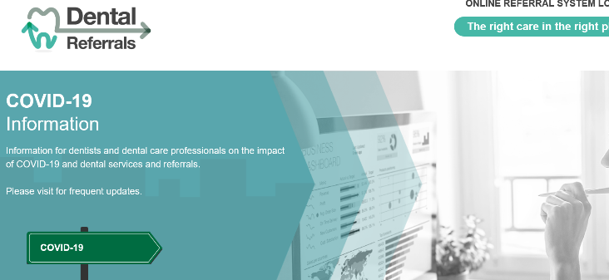

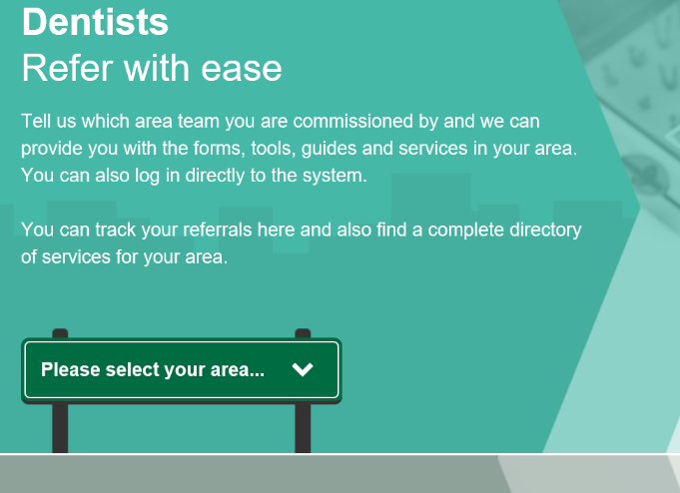

Choose Greater Manchester

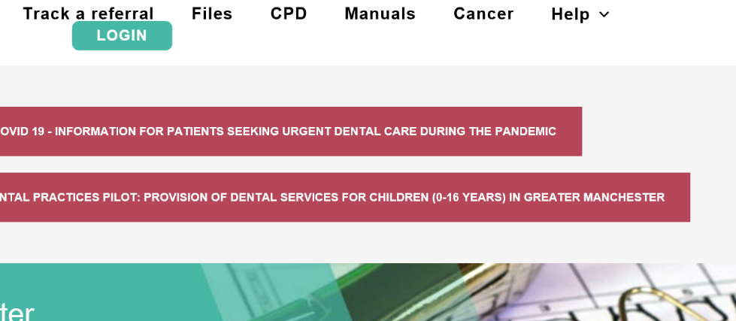

Select CPD

You will need to register to take CPD regardless if you subbmited referals previously

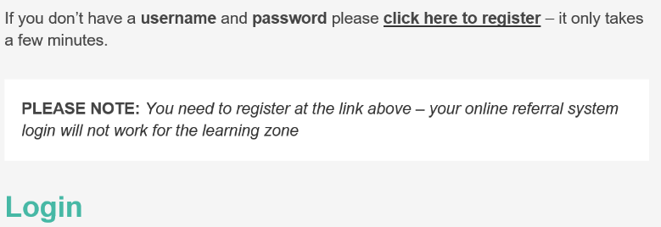
Once registered to undertake CPD once registered and logged in select saving smiles and undertake the training course online.

Once each section of the above is completed you will be awarded your saving smiles certficate upon completion please send this evdience to dental@cpgmhealthcare.co.uk as part of the healthy Living dentsty requirments of Level 2

https://www.dental-referrals.org/course/saving-smiles/

