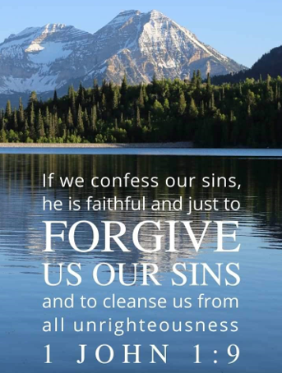

August 29, 2021

14th Sunday after Pentecost

Carson City United Methodist Church

10:00 am
Prelude/Greeting
*Indicates stand as you are able

Call to Worship
From Psalm 27

L: The Lord is our light and our salvation—
whom shall we fear?

P: The Lord is the stronghold of our life—
of whom shall we be afraid?

L: One thing we ask from you Lord, this only do we seek:

P: That we may dwell in your house Lord
all the days of our lives,

L: To gaze on your beauty Lord and to seek you in your
temple.

P: For in our days of trouble the Lord will keep us safe in his dwelling, he will hide us in the shelter of his sacred tent and set us high upon a rock.

*Hymn: Standing on the Promises UMH 374

Opening Prayer: (unison)
O Gracious and Holy God, give us diligence to seek you, wisdom to perceive you, and patience to wait for you. Grant us Lord, a mind to meditate on you; eyes to behold you; ears to listen for your word; a heart to love you; and a life to proclaim you; In Jesus, precious and Holy name who lives and reigns with you in unity with the Holy Spirit we pray. AMEN.
*Hymn: Less Like Me (Zach Williams)

Pastor spoke about the bombing in Kubul

THE MESSAGE

Children’s Song: Every Where I go, I go with YOU (VBS)

Sharing of our joys and concerns

Call to Prayer: Turn Your Eyes Upon Jesus
UMH 349

Pastoral Prayer

Offering/Offertory Prayer

Doxology UMH 95

*Hymn: Sent Forth by God’s Blessing UMH 664

BENEDICTION

CCUMC – Announcements

========================================
Nursery returns on Sunday, 9/12/21. The schedule will be posted on the Nursery window at the
end of August.
========================================
***Important update***
Effective Sunday, 9/12/21, we will continue with one Worship Service, but it will start at 10:30 am.
=========================================
Come join the fun on Sun, Sep 12th @ 9:15 am for lots of activities to welcome back our Sunday “Cool” Hour. Kids, Teens, are invited. Adults are invited to help.
=========================================
Upcoming UMW Soup Luncheons: Sep 17th & Oct 15th.
=========================================
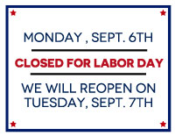

Sunday Worship | 9/12 starts @ 10:30 am
Nursery | 9/12 during Worship Svcs
Women's Group | 9/12 from 6:30-8:00 pm
A.R.K. | 9/15 from 6:30-8:00 pm
Sundays Cool Hour | 9/19 from 9:15-10:20 am
Euchre | 10/2 from 5:00-7:30 pm
Dorcas | 10/4 starts @ 10:00 am

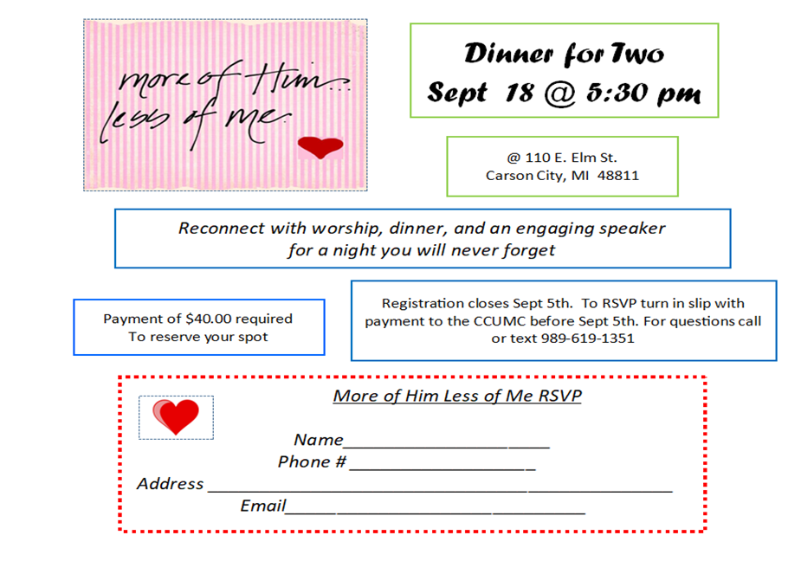
Payment for above can also be made on the Vanco eservice online.
You’re Invited

Serving and Supporting Sunday Worship
Audio/Video: Pat Monroe

Joys, Concerns & Prayer Request
For those battling cancers: Wendy Crawfis,
Beth Grienke, Kale Litwiller, Jim Dunlap,
Carolyn Nykerk, & Ray Seaman

For everyone who needs support,
guidance or has health concerns.

Monthly Giving
8/1 $2095.57 8/8 $4197.57
8/15 $2070.57 8/22 $3825.57

Coming Up
9/01 UMW Leadership mtg 10:00 am
9/06 Labor Day – Office Closed

Our Church in Ministry This Week

Mon 6:30 pm | Personal Transformation Class

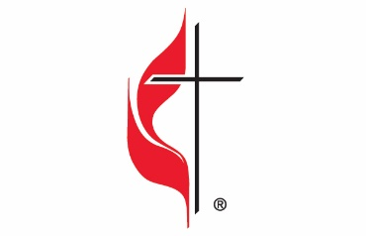

Carson City United Methodist Church
Location: 119 East Elm St., Carson City, MI
Mail: PO Box 298, Carson City, MI 48811
Phone: 989-584-3797 Email: carsoncityumc@gmail.com
Website: carsoncityumc.com
Office Hours: Monday-Thursday, 9:00 am-12:00 pm
After hours by appointment
Pastor: Ian McDonald 906-322-5318
Secretary: Bonnie Seaman 989-763-1674

Weekly Sunday Bulletin now available on our website
@ www.carsoncityumc.com

“Jesus, may Your love and grace be evident in my words and deeds today”

