PUBLIC HEARING/
REGULAR MEETING
JULY 16, 2014

A Public Hearing and the Regular Meeting of the Town Board of the Town of Hampton, County of Washington and the State of New York was held at the Town Hall, 2629 State Route 22A, Hampton, New York on the 16th day of July, 2014.

PRESENT: David K. O’Brien----------Supervisor
Tamme Taran--------------Councilwoman
David Jensen---------------Councilman
Donald Sady----------------Councilman
Andrea Sweeney-----------Councilwoman
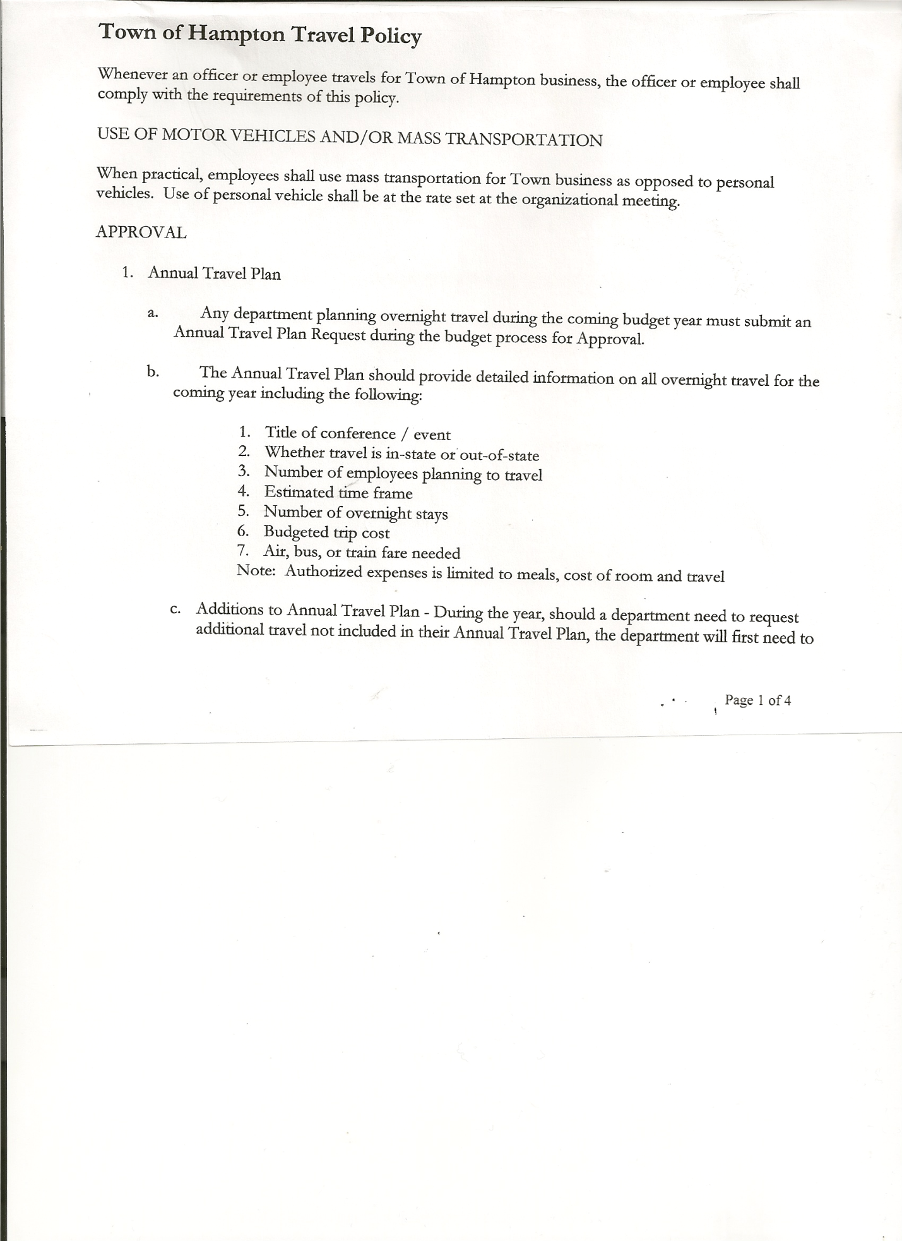
Rebecca Jones--------------Town Clerk
Camilla Shaw---------------Tax Collector/Deputy Town Clerk
Herbert Sady, Jr.------------Highway Superintendent

Planning Board Member(s): Bonnie Hawley, Chair; Joe Panoushek, Heather Gale, Frank Baker & Dianne Sofie

Also present: Artie Pratt and Leonard Reed

The Public Hearing (regarding proposed Local Law 4 of 2014, regulating Mobile Homes outside of Mobile Home Parks) was called to order by Supervisor O’Brien at 7:15pm followed by the Pledge of Allegiance. Location of Fire Exits were given.

Rebecca Jones, Town Clerk read the Legal Notice of public hearing (copy is attached). Supervisor O’Brien asked for comments on proposed Local Law 4 of 2014.

Resident Leonard Reed asked what the differences were compared to Local Law 2 of 1989 (present local law). Bonnie Hawley, Chair of the Planning Board explained some of the highlights of the new law
- Needs to be inspected by Washington County Code Enforcement before being
brought into Town
- Lot size needs to be at least one (1) acre
- Needs to be set back at least 75’ from center of road and 25’ from the adjoining property line(s)
County Code Enforcement and Town Attorney have both reviewed the proposed local law. The Planning Board is working on an application form and the fee would be $50.00 to the Town.
All persons desiring to be heard, having been heard, the Public Hearing was closed at 7:31pm.

REGULAR MEETING
The Regular Meeting was called to order by Supervisor O’Brien at 7:32pm.

RESOLUTION NO. 61-2014
APPROVAL OF THE MINUTES
On a motion of Councilwoman Taran, seconded by Councilman Jensen, the following resolution was
ADOPTED: Ayes 5 O’Brien, Taran, Jensen, Sady, Sweeney
Nays 0
RESOLVED that the Regular Town Board Minutes for June 18th, 2014 are approved.

TOWN BOARD MEETING
July 16, 2014 PAGE 2

Planning Board Report…Bonnie Hawley, Chair gave report
- Site Plan Application received and approved for used car lot for Dave and Shawn Camara on their Route 22A property
- Next Planning Board Meeting will be Tuesday, July 22nd, 2014 at 7:00pm at the Town Hall

RESOLUTION NO. 62 - 2014
MOTION BY: Councilwoman Tamme Taran
SECONDED BY: Councilman Donald Sady
RESOLUTION AUTHORIZING THE ADOPTION OF PROPOSED LOCAL LAW NUMBER 4 OF 2014, A LOCAL LAW REGULATING MOBILE HOMES OUTSIDE OF MOBILE HOME PARKS IN THE TOWN OF HAMPTON

WHEREAS, through resolution 56 of 2014, duly adopted by the Town Board, a public hearing was scheduled to be held before the Town Board on July16, 2014, at 7:15 p.m. at the Offices of the Town of Hampton to hear all interested parties on proposed Local Law No. 4 of 2014 of the Town of Hampton which provides for the regulation of Mobile Homes Outside of Mobile Home Parks in the Town of Hampton; and

WHEREAS, notice of said public hearing was duly posted and then published in the official newspaper of the Town, pursuant to and in conformance with the Municipal Home Rule Law; and

WHEREAS, said public hearing was duly held before the Town Board this 16th day of July, 2014 at 7:15 p.m. at the Offices of the Town of Hampton and all parties in attendance were permitted an opportunity to speak on behalf of or in opposition to the local law.

NOW, THEREFORE BE IT

RESOLVED, the Town Board hereby finds the consideration and proposed adoption of this Local Law is an action under the New York State Environmental Quality Review Act (SEQRA). The Town Board hereby declares that this action is an unlisted pursuant to SEQRA and declares that the action does not have a significant impact on the environment and the action is hereby precluded from further environmental review; and be it further

RESOLVED, the Town Board, upon due deliberation of the Local Law finds that the adoption of the same is in the best interests of the Town; and be it further

RESOLVED, that Local Law 4 of the Year 2014 is hereby adopted; and be it further

RESOLVED, pursuant to and in accordance with the Municipal Home Rule Law, the Town Clerk is hereby directed to enter this Local Law into the minutes of this meeting and file the same with the Office of the Secretary of State of the State of New York.

RESOLVED, this resolution shall take effect immediately.

TOWN BOARD MEETING
June 18, 2014 PAGE 3

DATED: July 16, 2014 Supervisor O’Brien AYE
Councilman Sady AYE
Councilwoman Sweeney AYE
Councilman Jensen AYE
Councilwoman Taran AYE

Tax Collector submitted Tax Collector Report for June 2014.
Board Members reviewed and signed bank reconciliation statement dated June30th, 2014.

Dog Renewals and Dog Enumeration….First letter to let them know an enumeration will be taking place and to register their dogs. Second letter with a date to have dogs registered by or face fines. Need to decide on an enumeration fee and person to do the enumeration. Suggestion was made to have a Rabies Clinic in town and register dogs at the same time.

Larry Carman, Dog Control Officer submitted his report, which was read by Supervisor O’Brien… copy of report is attached for June.

Supervisor O’Brien spoke about the July 3rd storm that hit our area. Highway Department/Fire Department and local residents were out and helping clear trees out of roadways. Thanked everyone for their help.

Herbert Sady, Jr., Highway Superintendent gave his report: (a copy is attached)
- July 3rd and 4th Clearing brush and trees from roadways
- Mowing town road sides
- A different Alternative Sentencing person helping town highway crew
- Paving on South Road (CHIPS project) done
- Mowing County Roadsides in exchange for winter sand.

RESOLUTION NO. 63-2014
APPROVAL OF SUPERVISOR’S MONTHLY REPORT
On a motion of Councilman Sady, seconded by Councilwoman Sweeney, the following resolution was ADOPTED Ayes 5 O’Brien, Taran, Jensen, Sady, Sweeney
Nays 0
RESOLVED that the Supervisor’s Monthly report be accepted as submitted for JUNE 2014.
05/31/14 06/30/14
ACCOUNT BALANCE RECEIPTS DISBURSEMENTS BALANCE
General Fund $ 75497.94 $ 737.81 $ 5262.35 $ 70973.40
Highway Fund $115711.56 $ 9.35 $ 7440.02 $ 108280.89
Equipment Reserve $ 85102.64 $ 6.99 $ 0.00 $ 85109.63
Fire #1 $ 31985.00 $ 0.00 $ 15992.50 $ 15992.50
Fire #2 $ 4724.00 $ 0.00 $ 0.00 $ 4724.00
Totals $ 313021.14 $ 754.15 $ 28694.87 $ 285080.42

All Board Members present signed Supervisor’s Report.

OLD BUSINESS:
Municipal Banking….further discussed changing from Glens Falls National to Citizens Bank, to save mileage costs.

TOWN BOARD MEETING
July 16, 2014 PAGE 4

Further discussed…Property Maintenance on several properties on Greenfield Lane, which are bank owned.

NEW BUSINESS:
Health Insurance….proposed for 2015, up 7.1%

Other Communications received:
- Tax Rate charts comparing rates in area
- NYS Property Tax Freeze Credit Guidance & Fact Sheet

Public/Council Comments…Resident Arthur Pratt asked how door window on the loader got broke…Highway Superintendent Sady responded that it was broke by a stone.

The Town Clerk’s report for June 2014 was submitted to the Board. The Town Clerk had Board Members review and sign bank reconciliation statements for the Town Clerk Account and Special Town Clerk Account dated June 30th, 2014.

RESOLUTION NO. 64-2014
EXECUTIVE SESSION
On a motion of Councilwoman Taran, seconded by Councilman Jensen the following resolution was ADOPTED Ayes 5 O’Brien, Taran, Jensen, Sady, Sweeney
Nays 0
RESOLVED the Town Board enter into Executive Session at 8:34pm to discuss performance of an employee.

RESOLUTION NO. 65-2014
RETURN TO REGULAR SESSION
On a motion of Councilwoman Taran, seconded by Councilman Sady the following resolution was ADOPTED Ayes 5 O’Brien, Taran, Jensen, Sady, Sweeney
Nays 0
RESOLVED the Town Board return to regular session at 9:09pm.

AUDIT OF CLAIMS
On a motion of Councilman Sady, seconded by Councilwoman Taran the following resolution was ADOPTED Ayes 5 O’Brien, Taran, Jensen, Sady, Sweeney
Nays 0
RESOLVED that the bills have been reviewed by the Town Board and are authorized for payment in the following amounts.
General Fund No. 95 through No. 112 $ 19799.02
Highway Fund No. 70 through No. 81 $ 52659.11
Total both funds $ 72458.13

On a motion of Councilman Sady, seconded by Councilwoman Taran, the meeting adjourned at 9:31pm. All in favor Aye.

Respectfully submitted,

Rebecca S. Jones, RMC
Town Clerk

