Theatre & Kids and Onstage & Off, Inc. presents…
Starlight Summer Show Camp
Pennbrook Middle School
July 6 - 25, Grades 3 - 12
featuring The Broadway & Film Smash

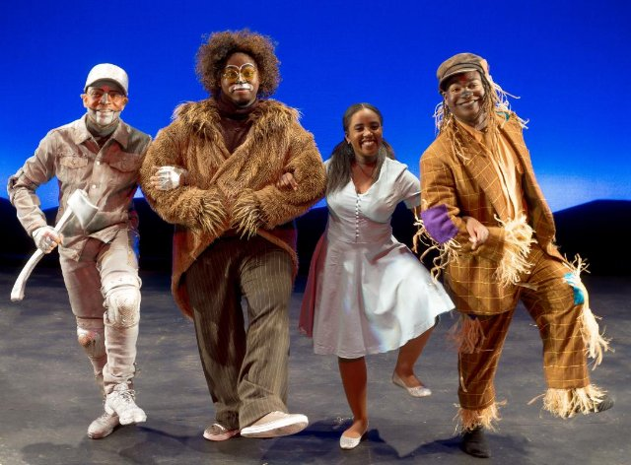

THE WIZ!

BIG CHANGES, BIG OPPORTUNITIES, BIG FUN! For 36 years, Will and Suzy Liegel and Theatre & Kids have produced a wide variety of opportunities for area children and their families. Summer performing arts camps drew hundreds, Saturday mornings brought diverse classes, and Cantabile Children’s Choir traveled around the globe. Our apprentice program trained high school kids in leadership and the arts and each Spring brought a multigenerational extravaganza. However, looking at how the interests and needs of families have changed, T & K and the Liegels began offering something brand new: A combination of all we do rolled into three exciting summer weeks.
2019 was a huge success with a full camp, a great show, and memories to last a life-time.

Our new Starlight Summer Show camp includes the very best of our:
Theatre & Kids Show Camp – A great show staged in just three weeks. Auditions on Day One and then a disciplined, relaxed, productive rehearsal schedule ending in a stage-spectacular. Professional staffers who love kids, spacious facilities and outside grounds and many daily opportunities for growth, learning, and friendship.
Theatre & Kids Performing Arts Camps –The show is added to with a dozen varied elective classes, an elective demo, snacks, lunch break, guest artists, rec times, openings and closings, and daily games, prizes, and fun.
Starlight Summer Theatre - Full scale productions allow for kids to truly experience the wonder of theatre. The biggest shows - polished, professional, and acclaimed. . Our recent Annie, Music Man, and Little Mermaid were terrific!

Daytimes 9am to 4pm - No evenings or weekends other than the two performances, Saturday, July , 27 2& 7pm.
(8am early arrival option)
Tuition Price only slightly higher than last year
$875 (Sibling Discounts $50 - Early Bird Registration Discount by April 15 - $25) Note: Limited enrollment (75)
(As always, Theatre & Kids will provide full costumes, sets, lighting, and orchestrations at no extra cost.)

THE WIZ! Our SECOND production of this Super Soul Musical gem. The fantasy story allows for most roles to be male or female and ALL are tremendous. Many characters and songs, wild sets, choreography, and costumes. A DLEIGHT!

Tickets for the actual show will be $10 each with two free tickets for each participant. Show will be open to the public.

Camp Staffing will include returning T&K teachers, Road Show staff, and new faces as directors, choreographer,
costumer, stage manager, and teachers, all with full clearances and all eager to mentor young performers.

The Facility is perfect for our needs. Air conditioned! Spacious stage, 500-seat auditorium, large studios, cafeteria.

Apprentice Program continues for grades 10 - 12. Full participation in the show with added opportunities and
mentoring duties: New York theatre trip, Talent Showcase, and Advanced Classes. Discount tuition, $725.

INFO, SCHEDULES, BROCHURES, REGISTRATION? - WRITE US AT wliegel@phil-mont.com or call at 215-858-9528
AND CHECK US OUT ON THEATREANDKIDS.ORG

