2ND ANNUAL

ROSWELL RANCHERS SELECT SALE
Presented by Roswell Livestock Auction
SATURDAY, APRIL 8, 2017

FEATURING:
26 - HORSES
39 - CHAROLAIS BULLS
BRED HEIFERS, COWS & PAIRS
REPLACEMENT HEIFERS
FRESH ROPING CATTLE
FRESH ROPING CALVES
4 – STOCK DOGS
SCHEDULE OF EVENTS:
8:30 A.M. – 1:00 P.M – All cattle will be available for preview at
Roswell Livestock Auction
8:30 A.M. – Horse and Stock dog preview at Eastern New Mexico State Fair Grounds, Bob Crosby arena
1:00 P.M. – Sale starts at Roswell Livestock Auction
ORDER OF SALE:
Bred heifers, cows & pairs
Charolais Bulls
Horse Sale
Stock Dog Sale
Fresh Roping steers and heifers
Fresh Roping Calves
INDEX
Lot # | Owner’s Name | Animal
BRED HEIFERS, COWS
& PAIRS
1-25 | BILL KING RANCH, MORIARTY, NM | 25 CHAROLAIS BULLS
26-30 | GRAU RANCH – GRADY, NM | 5 CHAROLAIS BULLS
31-39 | BILL SIMS – EUNICE, NM | 9 CHAROLAIS BULLS
1 | KY STUDDARD | HONKY TONK
2 | ROSENDO APODACA | GRADE
3 | JR. JUDD | TOPPER
4 | MCNEILL RANCH | LEFTY
5 | JUSTIN QUIZENBERRY | GOOSE
6 | JOE JACKSON | CAJOS STRIKER DEE
7 | KRAYTON DUTTON | RAINBOW STARLITE
8 | LARRY BENTON | DIAMOND MAC GO TE
9 | ELLISON CARTER | APACHES BLUE BOY
10 | JOLENE WOOTEN | SOCKS
11 | CHARLES E. JUDD | IKE
12 | CATHY F. GARTON | ROAN LEONA HANCOCK
13 | CECILIA APODACA | SILVER
14 | CALI QUINZENBERRY | SMART A SURE INCE
15 | DON STUDDARD | JOHN HENRY
16 | KATHLEEN PETERSON | ROYAL LAREDO ROAN
17 | BILLY JOE DELLIS | MCK ROCKIN ROMEO
18 | KOLYN DUTTON | MISS POCO PEP OLENA
19 | DARYL SKILES | BAR D MR GUNRUNNER
20 | JIM BOB CATTLE | TURBO
21 | NATHAN CARTER | DRIFTWOOD JAY PEPPY
22 | DENNIS KLINGHAGEN | BOSS
23 | GARY GIESE | GRADE
24 | CORD CROWSER | MORE LIABILITY
25 | EDMUNDO QUINONEZ | GRADE
26 | BOB MARTIN | DRY PEPPY PRIDE
1 | EDMUNDO QUINONEZ | MAX - BORDER COLLIE
2 | HEATHER BRANDNER | ETD WINSTON BORDER COLLIE
3 | BRAD ODER | BEAR -STOCK DOG
4 | RICKY MUELLER | JAKE - BORDER COLLIE
 |  | FRESH ROPING CATTLE
 |  | ROPING CALVES

CHAROLAIS BULLS
Sale Order will be available on sale day

Lot 1 - 25 25 CHAROLAIS BULLS BILL KING RANCH
Moriarty, NM

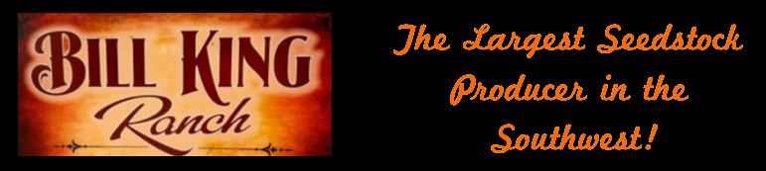

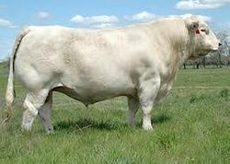
Lot 26 - 30 5 CHAROLAIS BULLS GRAU RANCH
GRADY, NM

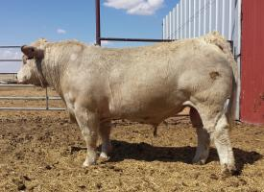

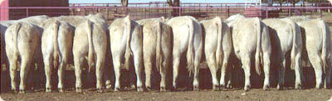
Lot 31 - 39 9 CHAROLAIS BULLS BILL SIMS
EUNICE, NM

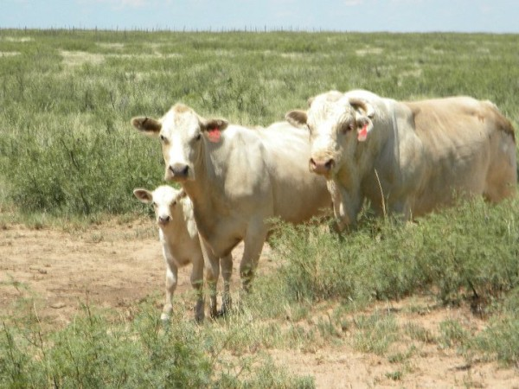

HORSE SALE

HORSE AND STOCK DOG PREVIEW
AT
EASTERN NEW MEXICO STATE FAIR GROUNDS,
BOB CROSBY ARENA
8:30 AM.

SALE STARTS AT
ROSWELL LIVESTOCK AUCTION
AT 1:00 PM.
HORSES AND DOGS TO FOLLOW
THE CHAROLAIS BULLS

1 HONKY TONK GRADE
7 Yr Old Sorl Geld KY STUDDARD

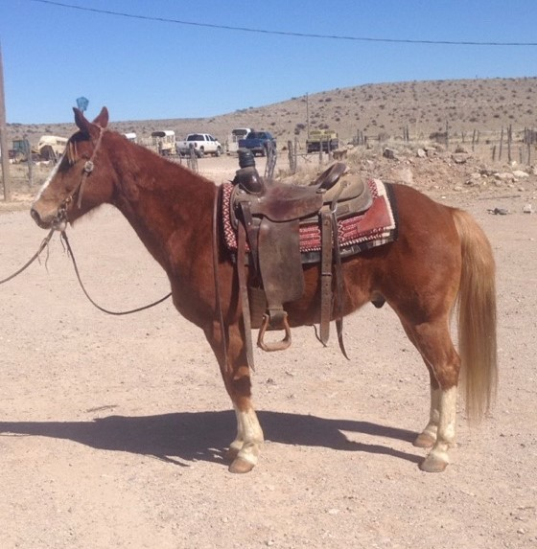

Honky Tonk, 7 year old, 13 hands tall, gelding is the perfect little horse for kids that need a roping or ranch horse. Has been used on the ranch and in the arena. Sound in the box, plenty of speed, does breakaway and can heel on him. He has had lots of calves drug to the fire and roped in the pasture on him.

2 GRADE GRADE
2011 BRN GELD ROSENDO APODACA

Right On Tivio
Right On Rondo
Price Flicka Leo
FANCY KING RONDO
3271272
Kens King
Pj Prophets Jack
Js Beauty

Obvious Prophet
Pj Prophets Jack
Tee J Sugar Babe
NOT JUSTA LARK
4893804
Larks Smokey Berry
Larks Smokin Rose
Tardees Della Rose

Ridden in feedlot for 2 years. Been used outside for doctoring. Easy to catch. Gentle for anyone. 100% sound.

3 TOPPER GRADE
15 YR OLD Bay Geld JR. JUDD

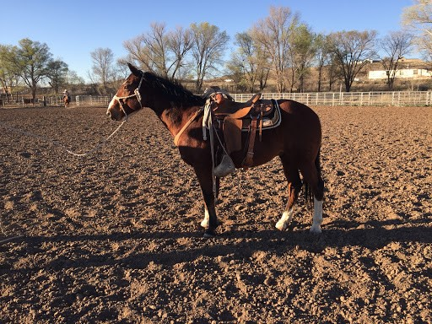

Had Topper since he was 4 years old. Can do anything on him. Good running walk. Can cut cows on him in pen and pasture. He has lots of cow. Rope anything on him will hold a rope when you get off of him in pasture to doctor or brand a calf or yearling. Trailers good. Good about his feet. Worming is current. Has lots of experience in anything you do on a ranch. Been rode by other cowboys who have helped from time to time. 14.3 hands and 1100 lbs. Sound and Gentle

4 LEFTY GRADE
2007 Sorl Geld MCNEILL RANCH

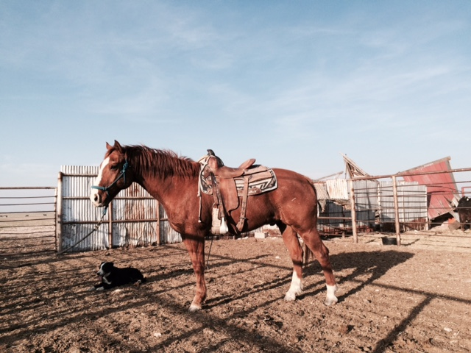

This horse has been used in everyday cowboy work his whole life. Steered and used him as one of my main horses from California, to Wyoming, then to New Mexico. He has done everything there is to do, in every kind of terrain. I've roped big bulls, wild cows, and doctored countless calves on him. He is also good in the arena as a head or heel horse. He has a nice stop and turn and is very gentle.

5 GOOSE GRADE
10 Yr old JUSTIN QUIZENBERRY

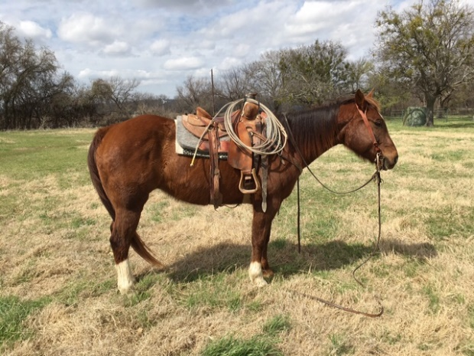

Goose is a 10 year old grade rope horse. Gentle but big motor. Runs hard to a cow, stout by the horn, and good stop. Doctored yearlings on him, drug calves, rode sale barn alleys. Use him all day and still be able to head and heel all night. Very seasoned money earner that knows his job.

6 CAJOS STRIKER DEE 4660680
2005 Brn Geld JOE JACKSON

Rocket bar
Rocket Wrangler
Go Galla Go
CAJO
2973617
Jet's Pay Day
Jet Weeto
Miss Wee Folk

Jackie Bee
Tee J Joe Boy
Tee Jay Diamond Jo
DOUBLE D PENNY
2895504
Panama Badger 22
Pennys Badger 222
Golddigger Jo
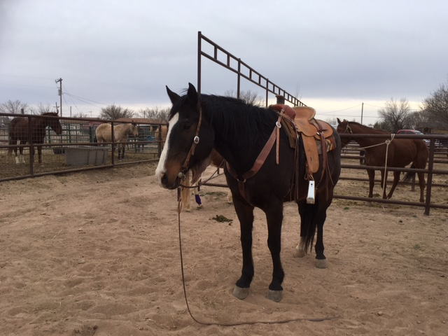
Gentle, Good with feet, loads. Used to gather, big motor and has been trained on barrels. Lots of handle for a big horse.

7 RAINBOW STARLITE 4856402
2006 Gray Geld KRAYTON DUTTON

Peppy San Badger
Grays Starlight
Doc's Starlight
BAY STARLITE
3289852
Doc's Sug
Sugs Scarlet
Nugget's Compact

Docs Decka
Docs Decka Cat
Talented Scat Cat
MISS RAINBOW BUDA
3024050
Docs Budha
Cradle Baby
Royal Grey Bar 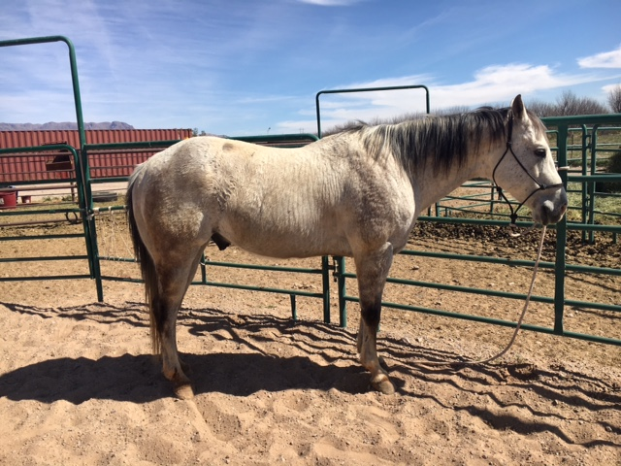
Trip, is an eye catcher. He's been there and done that in all ranch work. I've used him on wheat during the winter, drug calves to the fire, caught lots of stuff outside on him, and led cattle out on him. He's one that will be the same every day. He goes from Dark to Dark, and will never quit you. 100% sound and 100% gentle.

8 DIAMOND MAC GO TE 4506501
2004 Bay Geld LARRY BENTON

Te N' Te
Sonny Go Te
Lucky Machine
DIAMOND GO TE
2447892
Thermoledo
Bunny Bee Gold
Kid Bunny

Zippo Pat Bars
Zip Montana Bars
Ms Montana Pine
MONTANARAMA
3407894
Frontier Mac
The Fronteier Miss
Mickey's Roberta 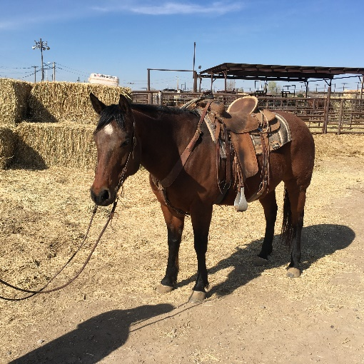
We bought “Buddy" 6 years ago here at RLA, when our Granddaughter was 9 years old. She has ridden him the whole time gathering cattle, running barrels & penning back cattle at the Roswell Ranch Rodeo. Nothing has ever rattle him. He's also been used doing all kinds of ranch work, roping and sorting cattle & dragging calves. He is "Old Man" & Kid gentle. He takes care of business & whoever is riding him. He stands still when you get on, is easy to shoe & is an easy keeper.

9 APACHES BLUE BOY 4988072
2007 Sorl Geld ELLISON CARTER

Doc's Prescription
Blue Boy Doc
Vivific
APACHE BLUE BOY
3424340
Boston Apache
Apache King Miss
Sue Hired King

Smokey Duster Too
Smokeys Gray
Texie Bee McKee
SMOKEYS BLUE GIRL
3945167
Mr Capital Gain
Miss Miscap
Miscap 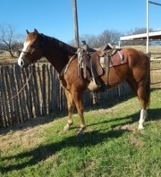
Abe is a 10 year old sorrel, bald face, stocking legged attractive, gentle gelding. Rope either end. Nice to use outside in all aspects of ranch work from the branding pen to sorting. Abe is a little Cinchy at first, but his only bad habit. Sire, Apache Blue Boy was Reserve World Champion Super Horse, AQHA World Champion Head/Heel in Open and Amateur.

10 SOCKS GRADE
2010 Sorl Geld JOLENE WOOTEN

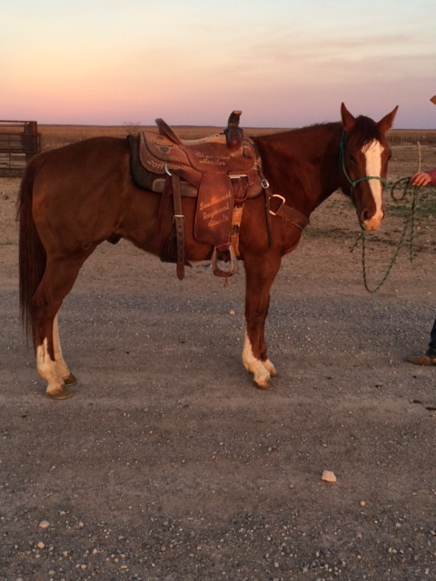

Socks is a really classy and flashy sorrel. He has been used on the ranch for the last 4 years. You can head and heel on him. Drag calves to the fire. Very gentle. He is an all-around horse that anyone can get along with. 100% sound. No Buck.

11 IKE GRADE
6 YR OLD Brown Gelding CHARLES E. JUDD

Ike has a good running walk, has lots of cow, can rope anything on him. Rope calves in branding pen or outside in pasture get off and do what you need to do. Trailers good. Good about his feet. Up to date on worming. 15 hands 1100 lbs. Sound and Gentle.

12 ROAN LEONA HANCOCK 4988796
2007 Red Roan Mare CATHY F. GARTON

Wild Horse Breezy
Wagon Creek Crow
Bogie Babe
BUENOCREEK HANCOCK
4524398
Bueno Bueno Doc
Kat Lady Twist
Shadows Rose Twist

Vaccaro
Red Joe Hawk
Stana
GO REDY JOE
2819636
Go Man Kue
Go Mans Leona
Flying Leona
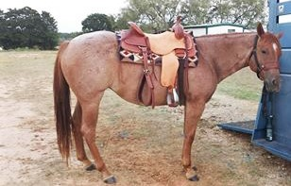
This mare has been used several years to gather and sort cattle on the Havens Ranch in Pinon, NM. She has been hauled to several ACTHA events and was quite successful completing the various obstacles. She has been ridden on many trail rides through Texas.

13 SILVER GRADE
2012 PALO GELD CECILIA APODACA

Ridden in feedlot for 2 years. Gentle for anyone. 100% sound. Been used outside for wheat cattle doctoring. Easy to catch.

14 SMART A SURE INCE 5113839
2008 Bay Geld CALI QUINZENBERRY

Doc's Hickory
Eatin Out
Docs Kingetta Chex
SMART MOUTH
3395061
Smart Little Lena
Smart Moria
Moria Sugar

Doc O'Lena
Doc O Dynamite
Gay Bar Dixie
OAKS LENA DYNAMITE
3621522
Doc's Oak
Oaks Baby Jane
Gay Bar Jane 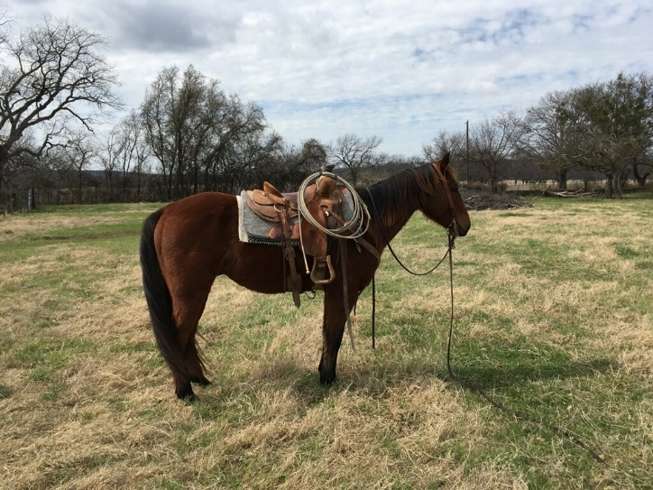
Cap is a gentle 9 year old registered bay gelding. Really nice in the gate. Drug lots of calves, caught wild cattle of the river, and doctored thousands of yearlings. Been hauled to many ranch rodeos and a few jackpots on the heel side. There has been kids ride him but I would not consider him a kid horse.

15 JOHN HENRY GRADE
5 Yr Old Sorl Geld DON STUDDARD

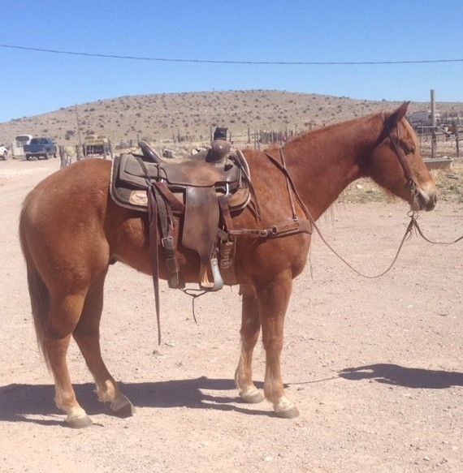

John Henry is 5 year old, 16 hand, 100% sound and gentle. Has been used on the ranch to drag calves and rope cattle outside. Started in the arena. Sound in the box. Rope both ends very good. Young using horse.

16 ROYAL LAREDO ROAN 4322505
3 Yr Old Gray Geld KATHLEEN PETERSON

Peppy San Badger
Haidas Little Pep
Docs Haida
LAREDO ROAN
4190410
Royal Tincie
Royal Blue Boon
Boon Bar

Doc O Lena
Lenas Jewel Bars
Freckles Royal
LENAS GOOD NUS
3095660
Nu Bar
Hollywood Nus
Hollywood Sally 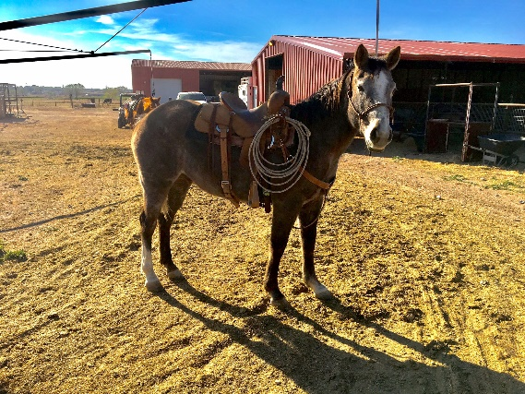
Broke and gentle 3 year old gelding. We have roped off of him, gathered cattle on him, and turned back off of him. No bucking or spooking. He is ready for a ranch job. Lots of cow, just wants to work.

17 MCK ROCKIN ROMEO 5042703
2007 Sorl Geld BILLY JOE DELLIS

Dry Doc
Dry Doc Bob
Cutter's Dorrie
DDB CAYENNE PEPPER
3509044
Peppy's San Badger
Peppys Plain Jeans
Carlos Jean

Ima Dandee Bar
RL Win I Can
Faster I Can
BOX C FELICITY JEWEL
3824745
Pokeys San Man
Joanie Freckles
Knee Prescription
"Cajun" is a 14.1 really shapy little horse with a big motor. Super gentle and really rides around. Been used in big country at sale barn, prowling grain fields and has had some cattle heeled on him in the arena. Big horse in a small package.

18 MISS POCO PEP OLENA 5468935
2012 BUCK MARE KOLYN DUTTON

Frostys War Chief
Seneca Buckshot
Mjh Smarty Marty
BUCKSHOT PERL DOCTOR
4720330
Cowie Kid
Cowgirl Lucille
Mjh I Love Lucy

Peppy San Badger
Coke Olenas Pep
Miss Coke Olena
BUENO PEPPY OLENA
4659054
Docs Cowboy Bar
Chessy Doc Bar
Chessy Imp

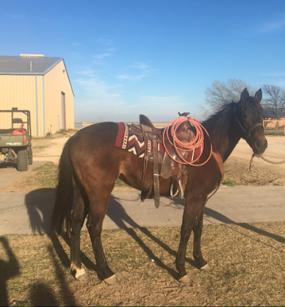
Libra, is one sharp looking mare with lots of color. Been using her at College in Clarendon. Been using her outside some, but more as a potential Ranch horse for the Collegiate shows. 100% sound and 100% gentle. Don't miss out on a mare with lots of shine and try.

19 BAR D MR GUNRUNNER 4683132
2005 Gray Geld DARYL SKILES

Freckles Playboy
Playgun
Miss Silver Pistol
PG DRY FIRE
3725537
Dry Doc
The Dry Look
Miss Telstar

Freckles Playboy
Young Gun
Lenaette
BAR DEE MISS GUNNER
3411496
Dee Cee Doc
Bar Dee Diana
Bar Dee Dipper
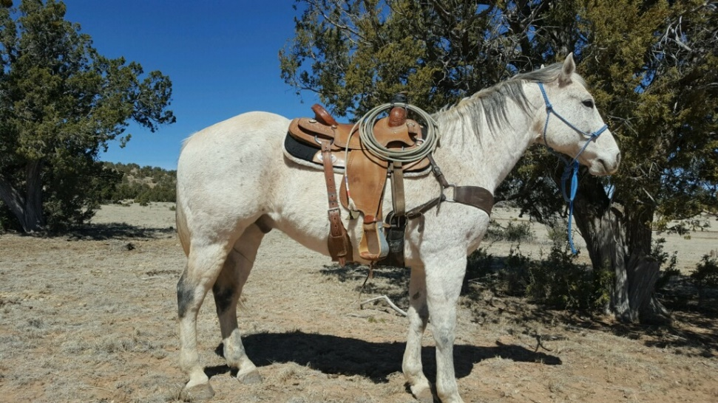
This is a stout made gelding with a lot of shape. As done whatever you need to do on the ranch as far as roping, sorting, and gathering. But certainly does not have a be a ranch horse would make a nice Team Roping horse or just ride him down the road.

20 TURBO 5280222
2009 Sorl Geld JIM BOB CATTLE

Peppy San Badger
Grays Starlight
Docs Starlight
SOULA JULE STAR
3638436
Docs Okie Quixote
Bella Coquette
Oakalola

Texano Gin
Shot O Gin
La Osa Blue Hoo
GINNIN BABA
2602431
Badger Mel
Baba
Miss Cee Bars 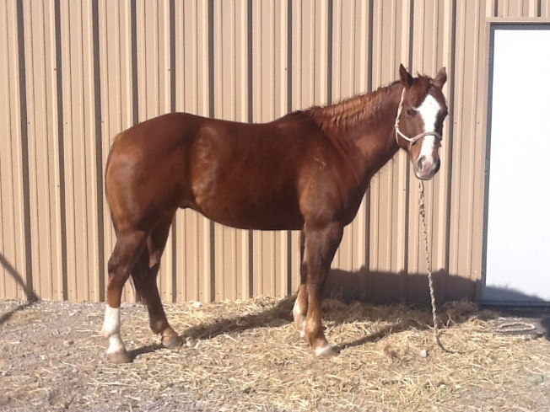
Outstanding ranch horse that is very cowy & can really turn around. Is gentle & easy to shoe, never tried to even hump up with me. Roped outside cattle & a few in the arena, will drag one in the trailer. Turbo is really good to sort & drag calves to the fire on. He is cleaned limbed & sound. Turbo has been in the rough country & can handle the rocks. He has a lot of heart & can go all day.
21 DRIFTWOODS JAY PEPPY 5236669
2009 Palo Geld NATHAN CARTER

Rowdy Blue Man
John Blue Hancock
Ceoilita Hancock
PLAYBOY JAY PEPPY
4370563
San Perdiz
Playboy Perdiz
Playboys Pepsie

Lone Drifter
Speedy Wood Ike
Speedy Chula
T F YELLOW DOLL
4696879
Fast Commander
Drifts Fast Doll
Drifts Doll 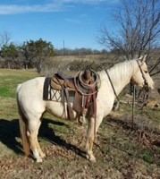

Jay is 8 year old Palomino gelding. Jay has done all aspects of ranch work. You can drag calves to catch yearlings on him. He is gentle and easy to be around. No hump or bad habits. Really wants to ride and is ready to go to work. Sells 100% sound.

22 BOSS GRADE
10 Yr Old Blue Roan Geld DENNIS KLINGHAGEN

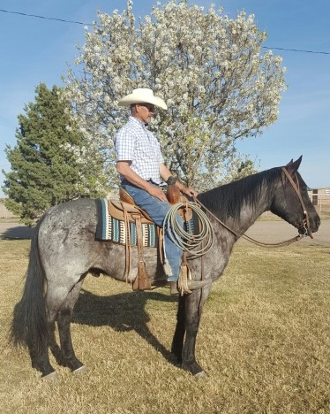

If you are looking for a Ranch horse deluxe then "Boss" is the horse for you. He will get down & dirty on a cow & put you in the spot you need to be when roping, every time. Boss has been used for every job imaginable. His athleticism & desire to work a cow makes him great to sort on in the corral or outside. He is very fast & makes for catching cattle outside easy. He would make a great head horse. Lots of bone & foot, Boss can trot a big circle all day long. He's got the build, a great disposition & the Cowboy color everybody wants. Sells 100% Sound.

23 GRADE GRADE
9 Yr Old Gray Geld GARY GIESE

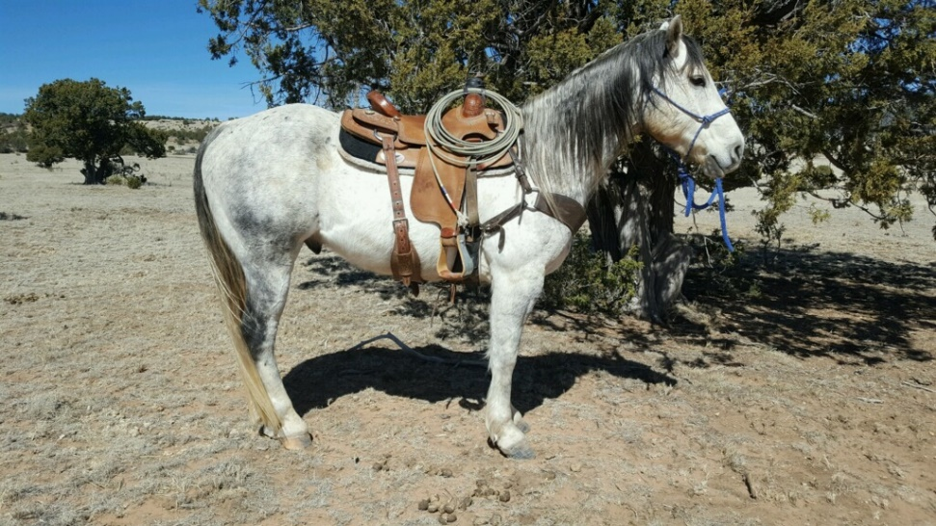

This gelding is really attractive as well as nice broke and a good ranch horse. He has also had a few roped on him, just getting started on the heads.

24 MORE LIABILITY 5047381
2007 Bay Geld CORD CROWSER

Zippos Mr Good Bar
Good Asset
Miss Rebel Rita
ABSOLUTE ASSET
3537179
The Big Investment
Investment MS
Leo King Babe

The Big Investment
Custom Investment
Miss Splendor
LIBEL TO INVEST
3484768
La Garita Bar
Ima Liberated Lady
Miss Tough Gal 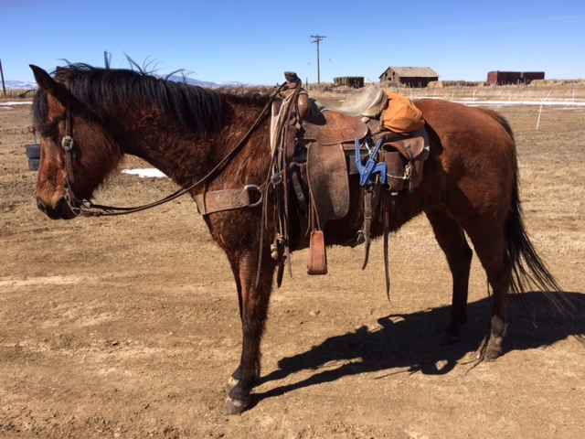
Big Bay Gelding. Been used on the ranch and started team roping in the arena. Gentle for about anyone. No hump or buck.

25 GRADE GRADE
8 Yr Old Bay Geld EDMUNDO QUINONEZ

Can head and heel, both. Really gentle. Sound. Really smart. Stout to the saddle horn. Has a good stop.

26 DRY PEPPY PRIDE 4456926
2003 Bay Geld BOB MARTIN

Peppy San Badger
Sen San Badger
Sen Bars Doll
MAMMAS LAST CHANCE
3946970
Dry Doc
Peachex Dry
Peachex Doors

Mr Senbar
Mr Sen Tivio
Cheeta Tivio
MISS TIVIOS PRIDE
3331867
El Leo's Pride
Pride's Miss Red
Miss Red Cabbage
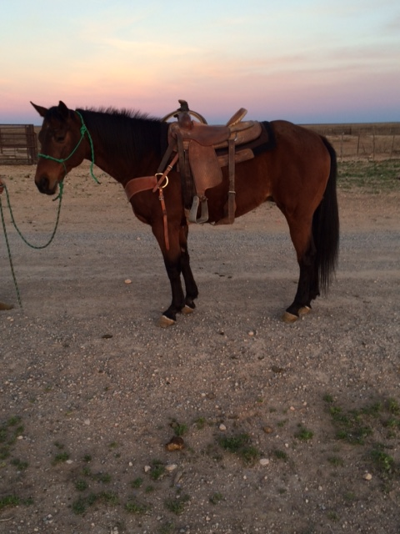

Digger is gentle gelding. You can use this horse in any phase of ranch work or in the roping pen. Digger is a super broke and super gentle. He has been an old man’s horse for the last 7 years. 100% sound. Has No buck.

STOCK DOGS
1 MAX BORDER COLLIE
2012 Male EDMUNDO QUINONEZ

Imp Tysswg Ben
Bob
Imp.Nan
BANDIT
ABC 303857
Chip
Pearl
Karmie

B.J.
Rosco
Sue
DAISY
ABC 276487
Paul
Demi
Panda Bear
Finished. Can work Sheep and Cattle. Been working a lot of cattle. Trial in Iowa 2 years ago, took 2 place.

2 ETD WINSTON ABCA #427952
2015 Rd / wht Male HEATHER BRANDNER

Ben
Bear
Brin
BEAST MODE
ABCA# 413664
L Riderreuben
Tazz
J & L Sasha

Taff Isds
Imp.Rocky
Bonnie Isds
EVA
ABCA # 367178
Jet Black Gabe
Cloudy
Blaze
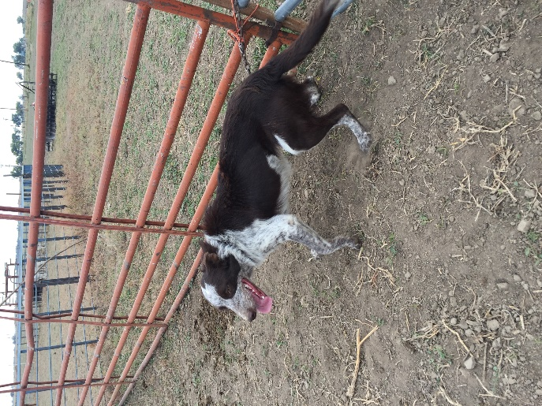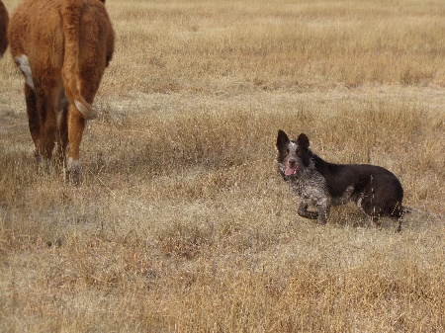
Red and White Freckled, Medium Coat - Male intact. Registered American Border Collie Association

3 BEAR
1 YR OLD BRAD ODER

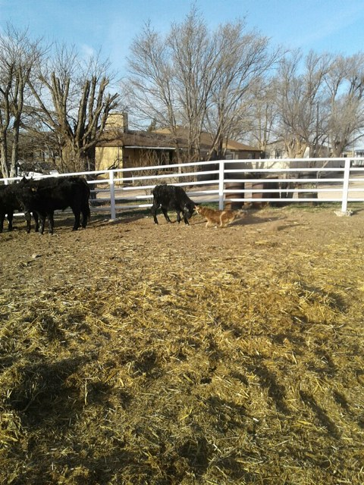

Bear is a year old. I bought him when he was 6 weeks old. I started him on goats when he was 6 months old. He has a lot of stock sense. I will have him at the dog trial. He will fetch cattle back to you and drive cattle.

4 JAKE Border Collie
2015 Blk/wht Male RICKY MUELLER

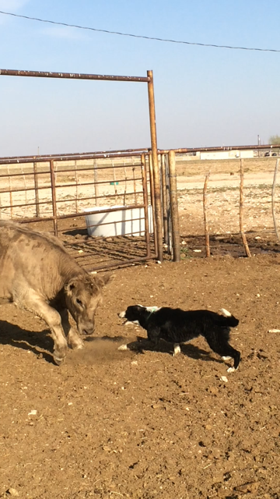

RINGO

MAGGIE

This pup’s parent are both very accomplished working dogs. His mother is the smartest dog I ever raised. His dad, I purchased as a puppy out of Idaho and is a very strong correct working male. Jake is still young but shows a lot of star power. He bites both ends and has good balance. His mother side, I have owned every dog going back to the early 90's and believe this cross is the best of what I've been trying to create. Slick haired, extreme stamina, tight feet, hard bite and brains. The complete package for a working ranch dog.

