[PHOTO OF 2019 GRANT WINNERS]

HLAA2020 NATIONAL CONVENTION GRANT
FOR HLAA WESTCHESTER MEMBERS

The Westchester Chapter has established an annual grant to help defer the costs to attend the HLAA2020 convention. The grant has been made possible by the Westchester/Rockland Walk4Hearing. HLAA2020 takes place from June 18-21, 2020 in New Orleans, Louisiana.
See www.hearingloss.org for more information on the HLAA2020 convention.
Who is eligible? The HLAA Westchester grant is available to all current members of the chapter who have never attended a National HLAA Convention. The applicant must also be a HLAA National member.
Criteria for application: Anyone who has not previously attended a national convention is eligible, but they must file an application. The applicant does not have to be a new member; however, priority will be given to new members. Applicants can apply every year but once an applicant receives a grant they cannot apply again.
Value of the grant: The $750.00 grant for 2020 may be applied to convention-related costs such as convention registration, lodging, meals and airfare. Any expenses exceeding that amount are the responsibility of the grant recipient. Please note that the Early Bird Discount for registrations expires March 2, 2020. The grant recipient must attend the convention and meet other reporting requirements or return the $750.00 to HLAA Westchester

Submission Date: Applications may be emailed to the grant coordinator no later than February 22, 2020. Applications received after February 22 may still be considered, but the recipient must meet strict deadlines for convention registration to avoid an increase in costs.
Award Announcement: The selection of the grant recipient will be announced no later than February 27, and the recipient will be notified by email or phone. We will then arrange to mail them the grant check.

[CLICK FOR APPLICATION]

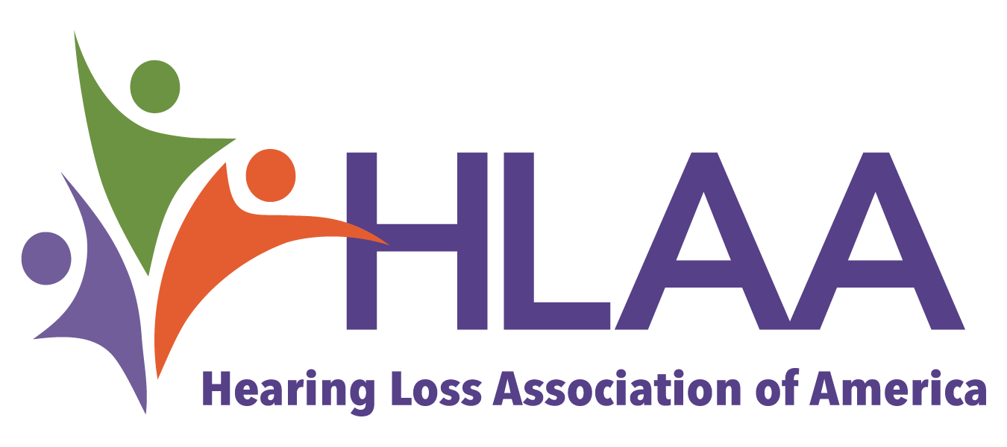
HLAA WESTCHESTER CONVENTION GRANT APPLICATION
Date Submitted: Name:
Mailing Address:

City: State: Zip Code:

Home Phone: Cell Phone: Email:

How long have you been a member of HLAA Westchester?

Are you a HLAA National Member? Number of Years:

Have you ever attended a HLAA National Convention? If no, why?

Do you have a hearing loss? Hearing Aid? Cochlear Implant?

Please write a brief description about yourself and what you hope to learn by attending the HLAA National Convention (use back if necessary)

Should you receive this grant, would you be willing to give a short presentation or write about your convention experience and what you learned to other chapter members?

This grant is intended to help reimburse you for the costs of the HLAA2020 convention, which may include convention registration fees, hotel, meals and airfare. If selected, you will be responsible for all costs above the $750.00.

When completed, please return this application to Karen Ratner by email no later than February 22. Applications received after February 22 may still be considered for the convention grant, but you may miss the Early Bird Registration Deadline of March 2, 2020.

Return to: Karen Ratner, email: klratner@aol.com

