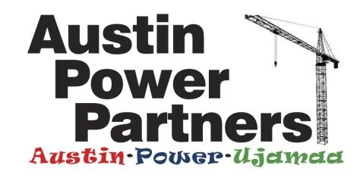

Section 8. Trade Specific Prequalification Questions

Trade Package 5: Structural Steel

- Provide the percentage of total field workforce directly hired by your firm in each of the following trades:

• Insert Trade Name: _____%
• Insert Trade Name: _____%
• Insert Trade Name: _____%
• Insert Trade Name: _____%
• Insert Trade Name: _____%

Indicate the percentage of your firm’s annual revenue generated by self-performing work of this Trade Package: (Trade Name): _____%

- Does your firm qualify as a small business for government contracting purposes? YES / NO
Review: https://www.ecfr.gov/cgi-bin/retrieveECFR?gp=&SID=7780ee089107f59ef3f78b938e2282b7&r=PART&n=13y1.0.1.1.17#se13.1.121_1201 and;
Visit https://www.sba.gov/size-standards Use the Size Standards Tool to determine if you may qualify. Paste the results into this document and upload into the Section 8 of the Questionnaire.

For more information regarding Small Business (SBI) and Medium Business (MBI) Bid Incentive Programs, see: https://chicago.gov/content/dam/city/depts/dps/Outreach/GuidetoBidIncentivesPrograms_110117.pdf

- Applicant hereby acknowledges that prequalification is predicated upon Subcontractor’s execution of the Master Subcontract Agreement: https://app.box.com/s/f1efmknw7m4qlvguvjwznkgqnasjm2b7

_________________________________
Signature

_________________________________
Name & Title (Company Officer)

Save and attach this document along with other requested attachments to the Prequalification Questionnaire in Section 8, as noted.

